TASKS ON MONITORING
TITLE:
Enable cloud_trail monitoring and store the events in s3 and cloudwatch log events
Objective
Enable AWS CloudTrail monitoring and configure delivery of audit logs to Amazon S3 and CloudWatch Logs for secure storage, analysis, and real-time monitoring.
Prerequisites
- AWS Account
- Cloud Trail
- Cloud watch
- S3 Bucket
- IAM role
Step-by-Step Implementation
Step 1: Navigate to Cloud trail in your console and enter the name of TRAIL NAME and select to create trail
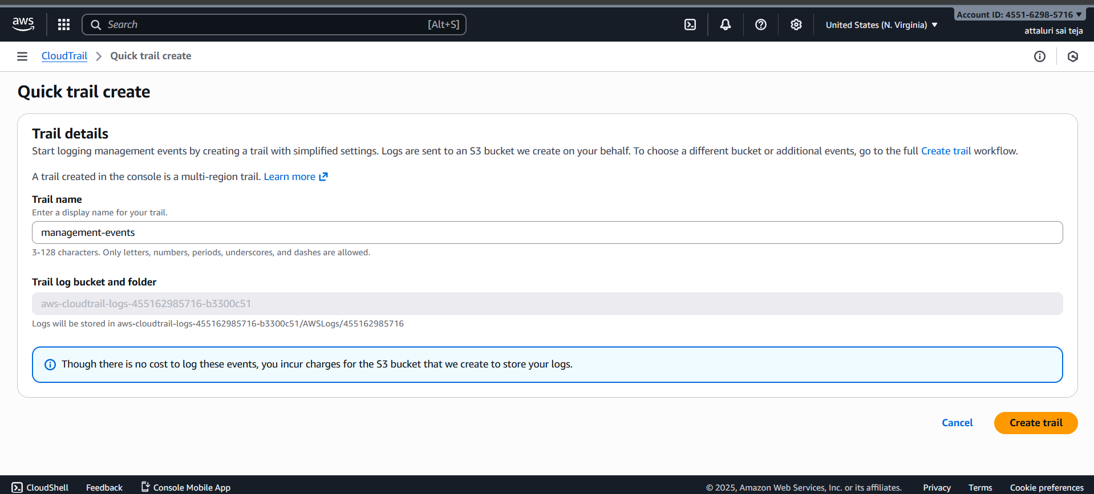

Step 2: Navigate to inside of the created trail by clicking on name
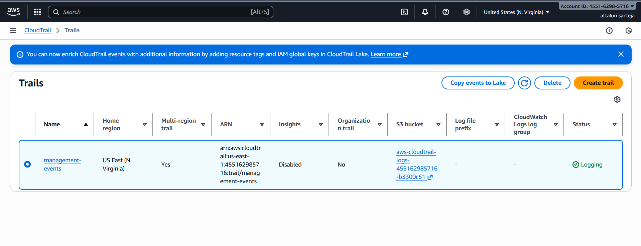
Step 3: After going inside of trail then select on edit button in cloud watch logs section
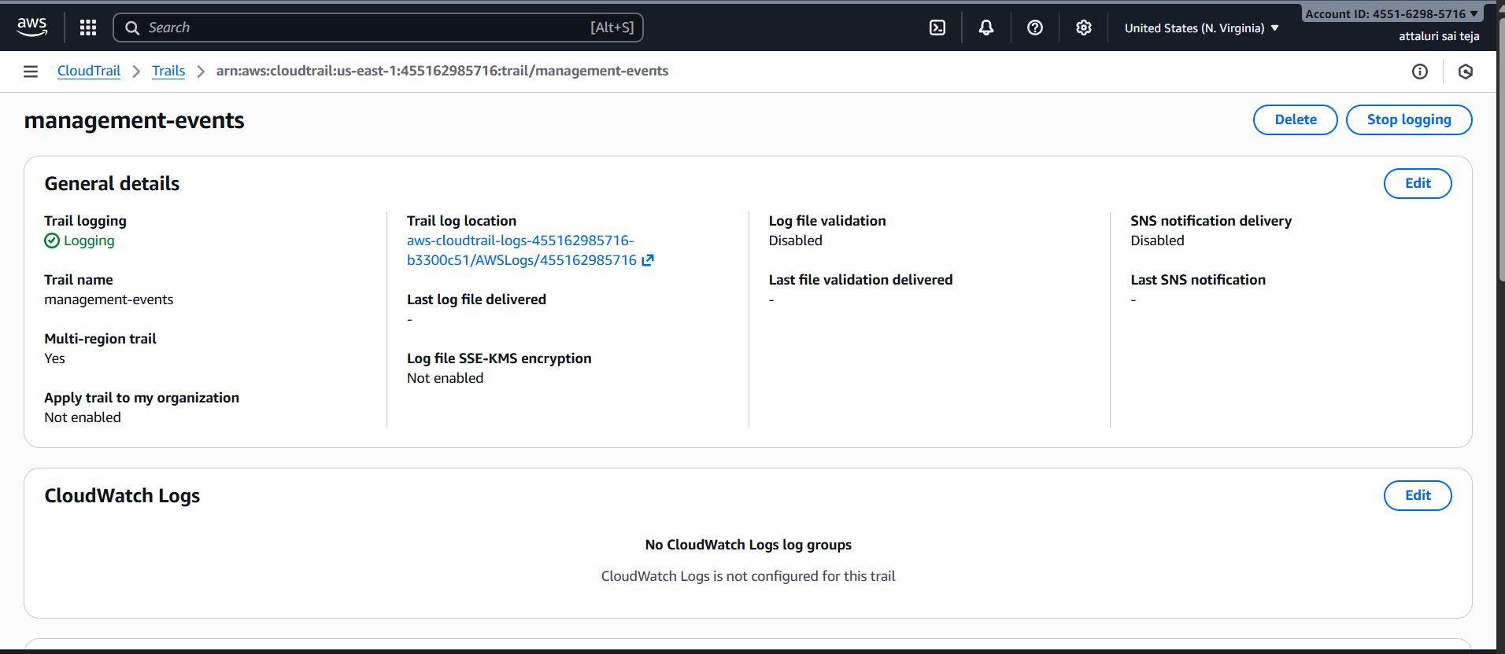
Step 4: Enable the cloud watch logs and Provide a name to log group
And create a IAM role or Select existing role and provide a role name
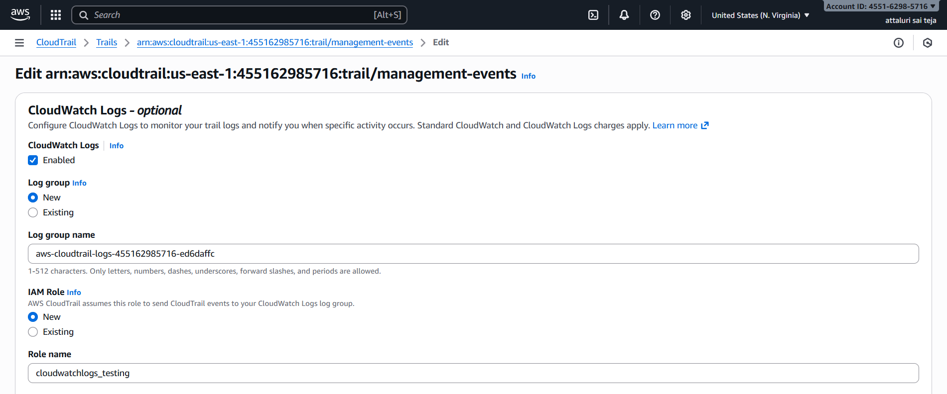
Step 5: Check the JSON script and proceed to save changes
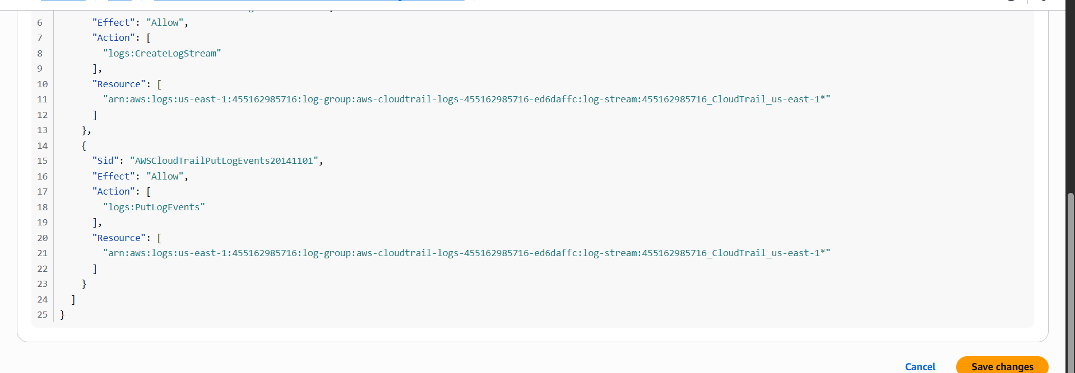
Step 6: Navigate to log Management group in logs section and verify that cloud trail has been created or not and click on it
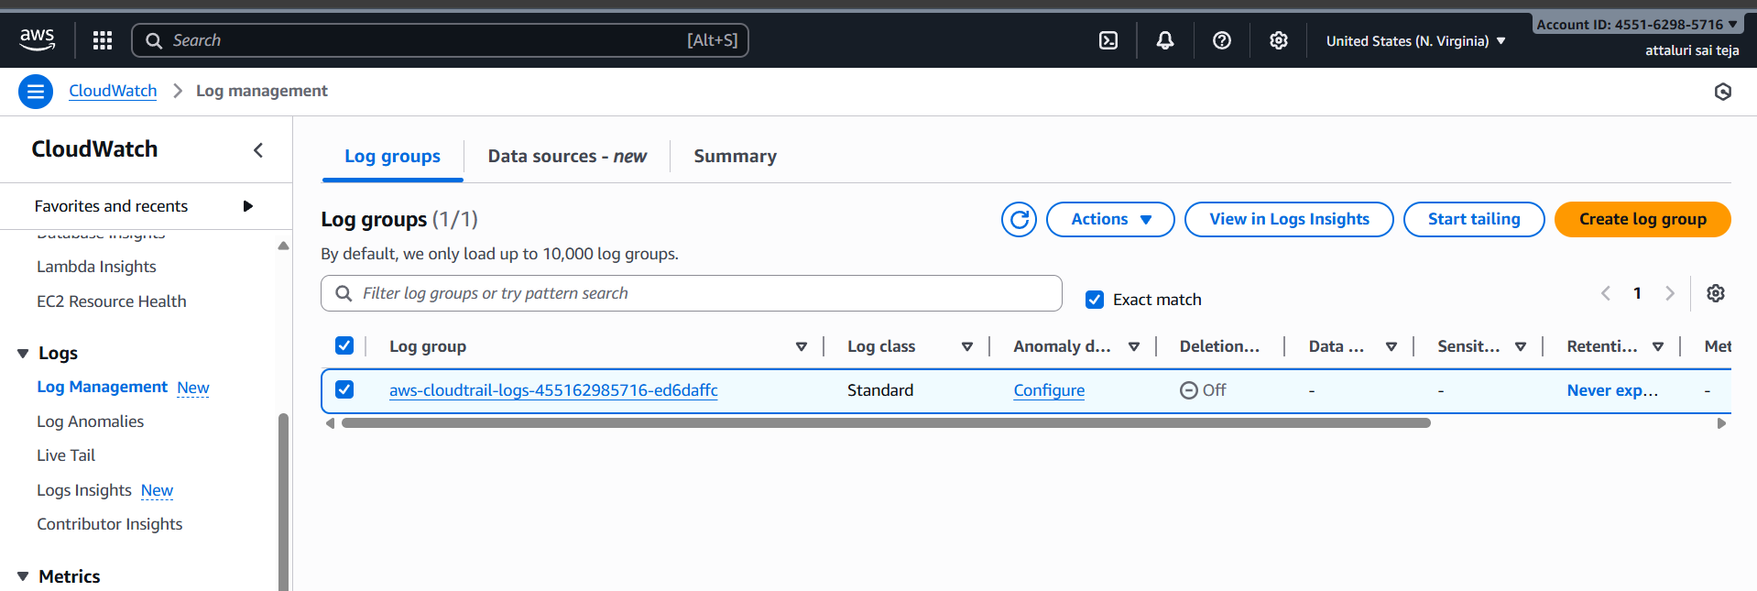
Step 7: Select the Log Streams and click on it to view the logs
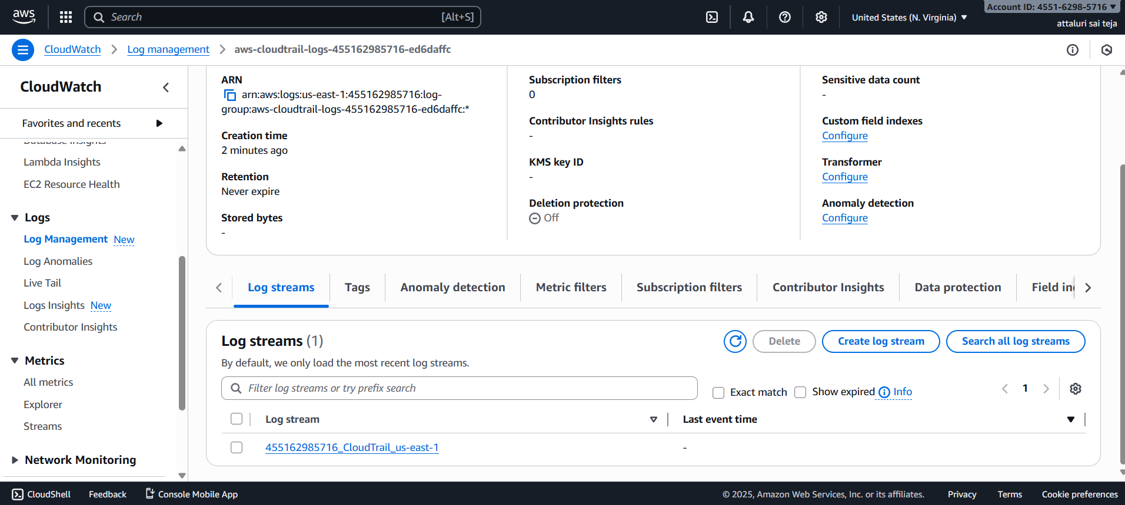

Validation Steps of cloud watch:
Step 1: Click on any one of the log to verify or display the logs and we can display the logs by mentioning the time frame
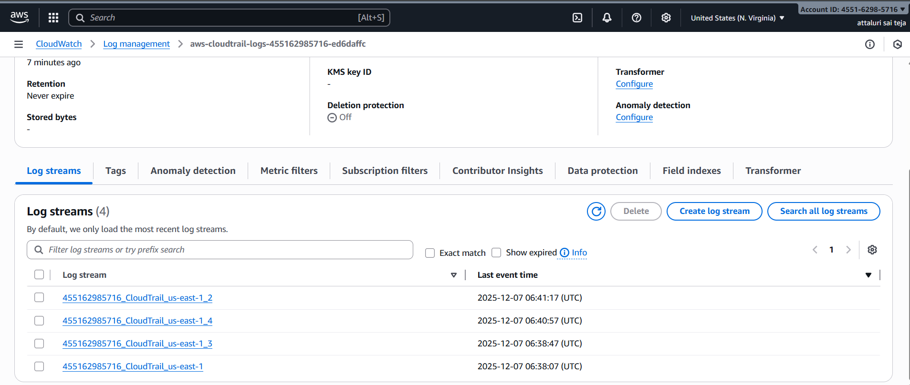
Step 2: Now you’re able to see the logs in cloud watch
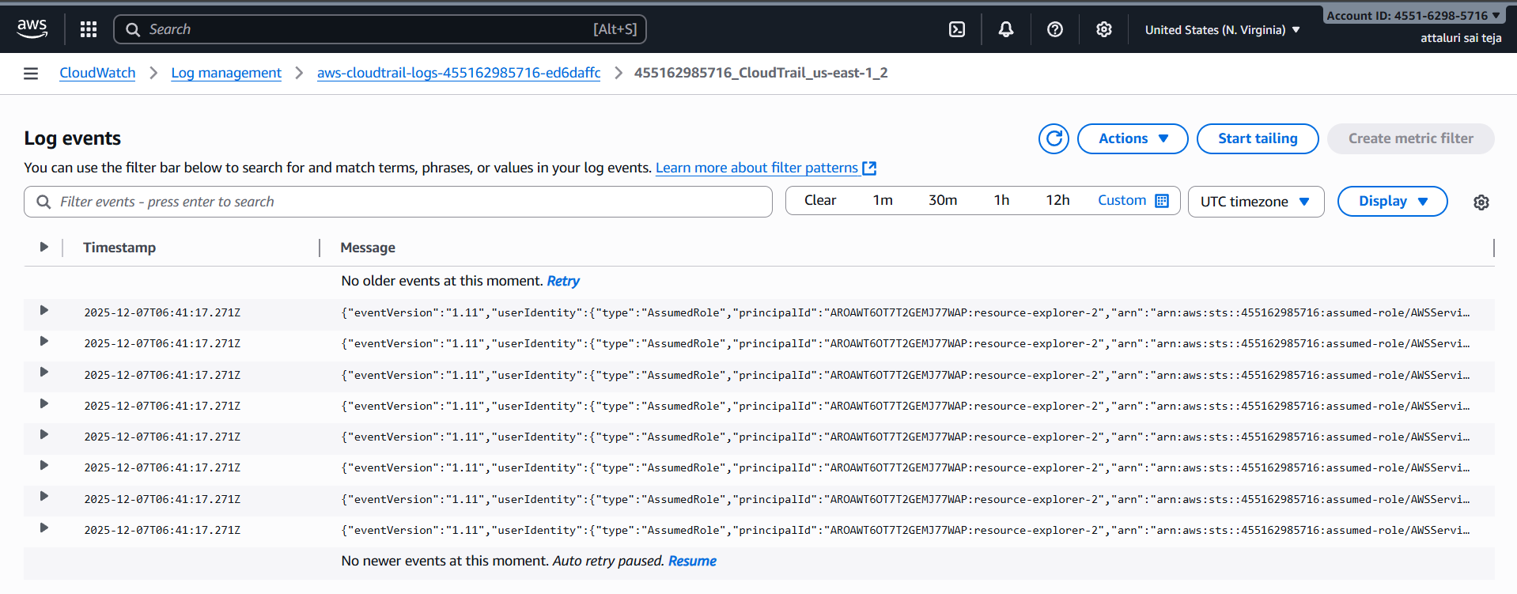
We successfully watched the logs in cloud watch lets move to S3 bucket to watch logs

Validation Steps of S3 bucket:
Part 2: logs in S3 bucket
Step 1: Navigate to S3 bucket in your AWS Console and a S3 bucket is created when you configured cloud trail a new bucket is created on providing access or permission
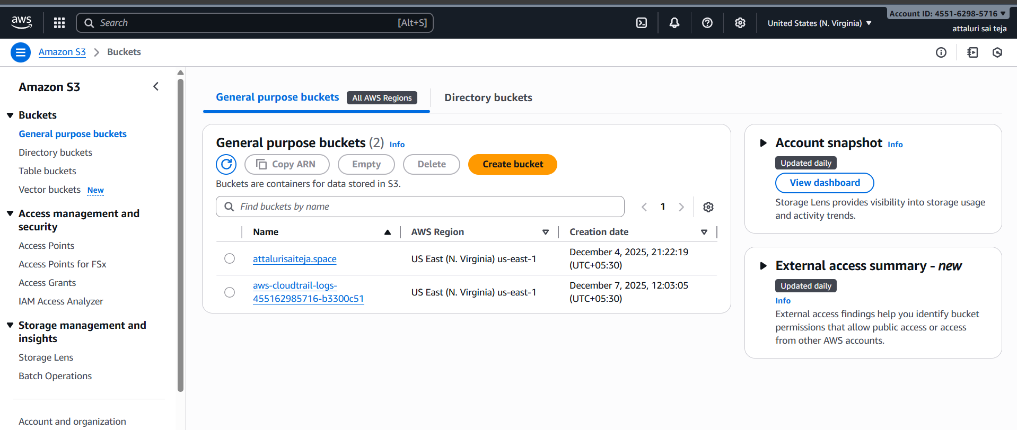
Step 2: Navigate into s3 bucket and click on logs and go inside of it as you can see the PATH
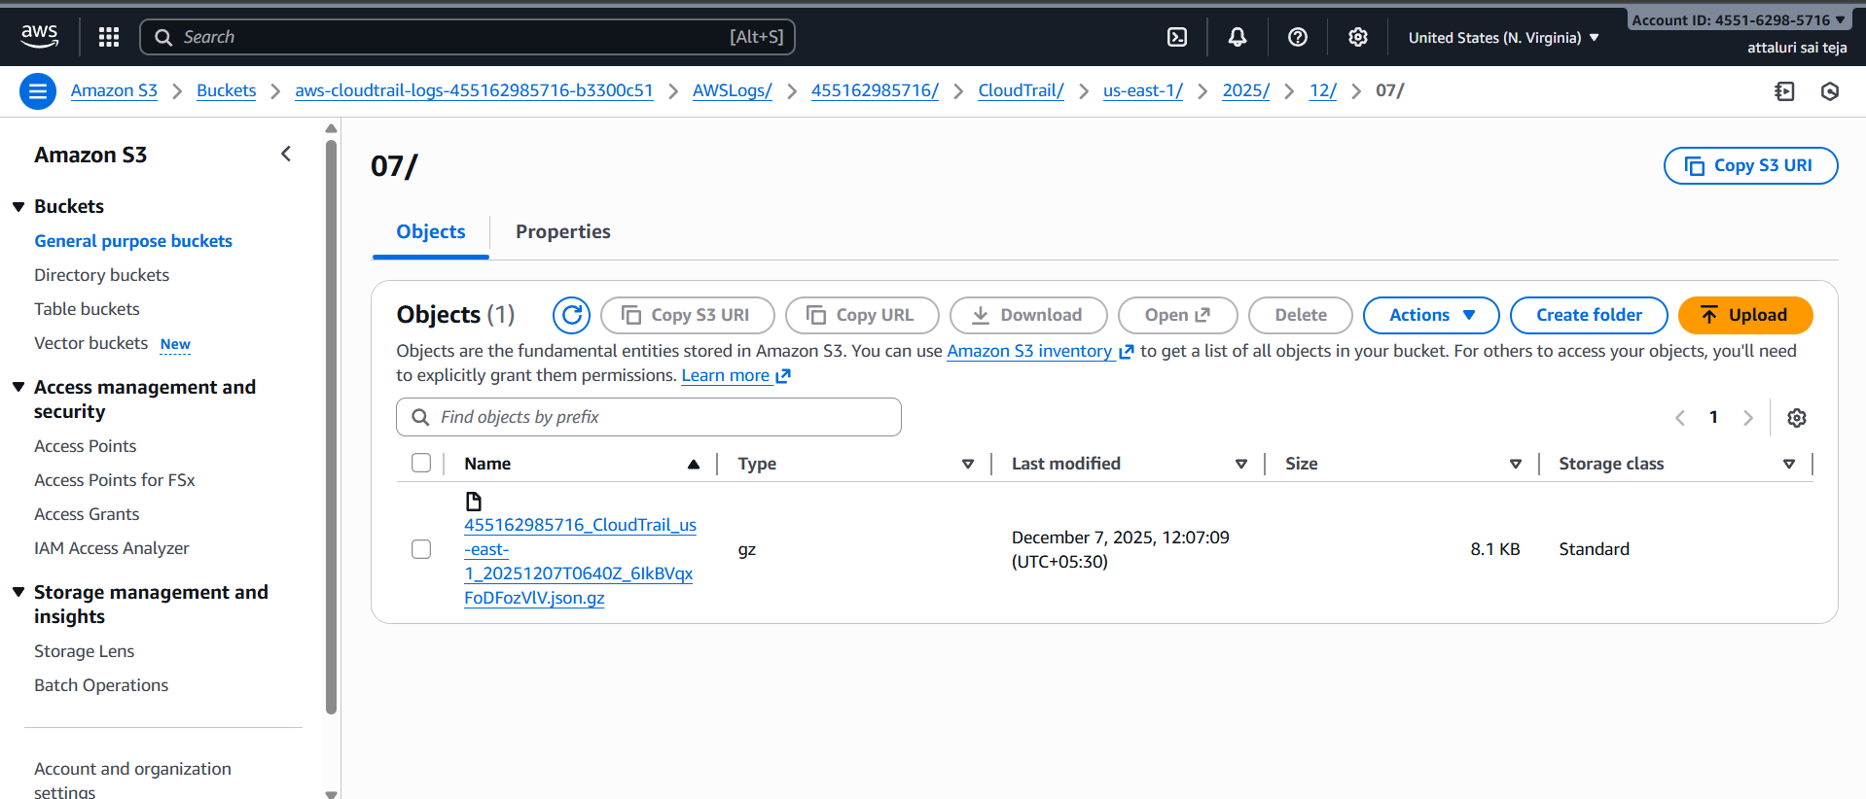

Step 3: Then select Properties section in the bucket and select the OPEN link to see in website it is secure and only in private.
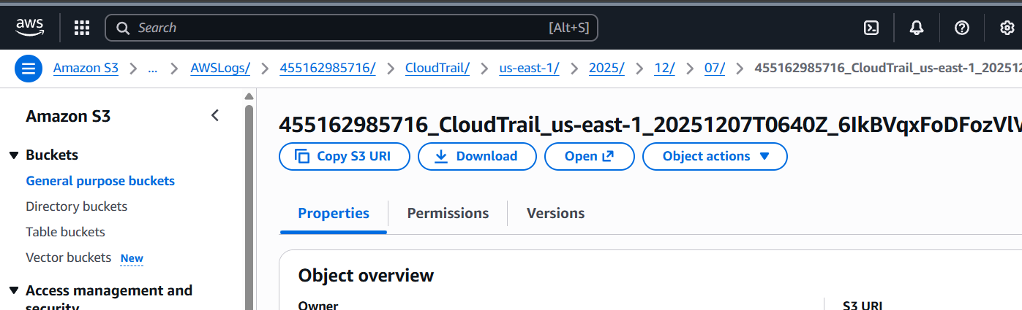
Step4: select the log which you needed and read which activity was done
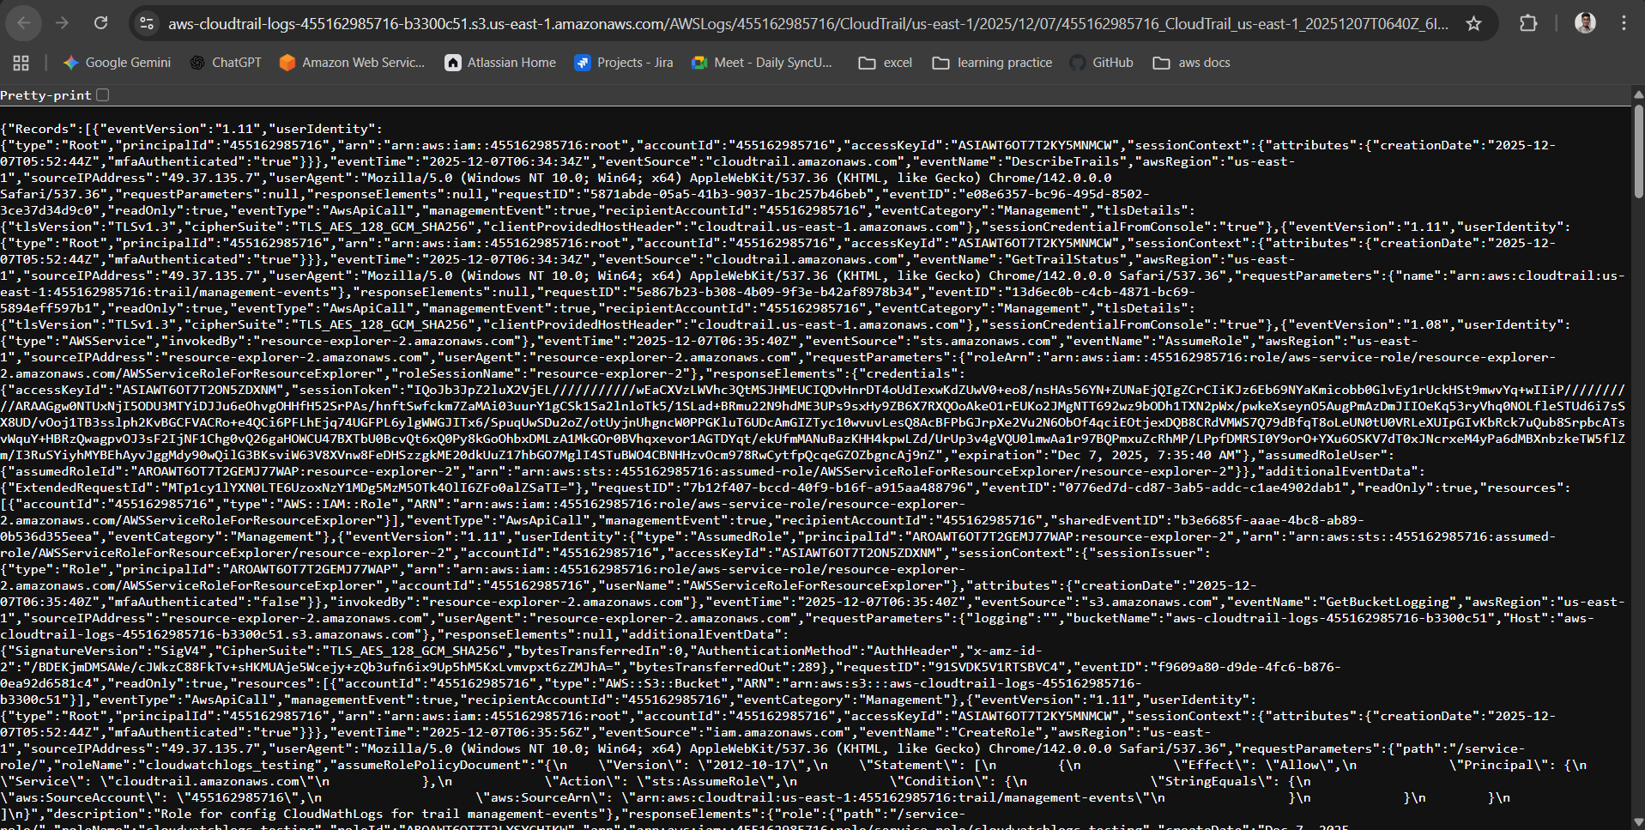
Step 5: I selected the one log from all the logs
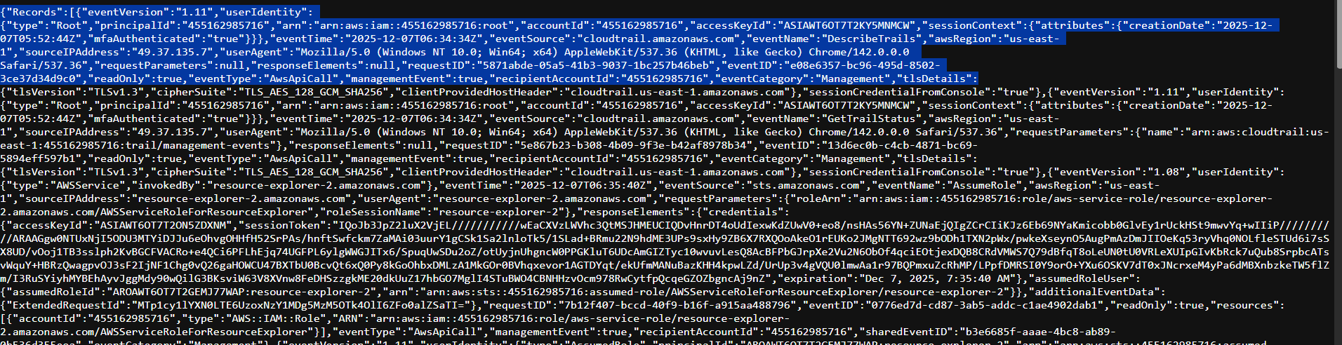

ERRORS:
I faced the error while opening the logs in the browser
I selected the link and tried to open then it throwed a error message as you can see in 2nd picture
CONCLUSION OF ERROR:
Only Authorized access (private) can witness the logs not every one because I mentioned the S3 bucket in private so that I got an Error
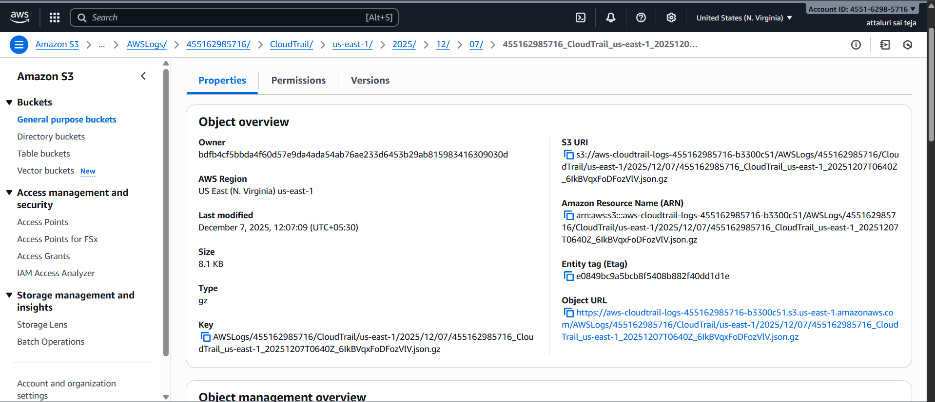
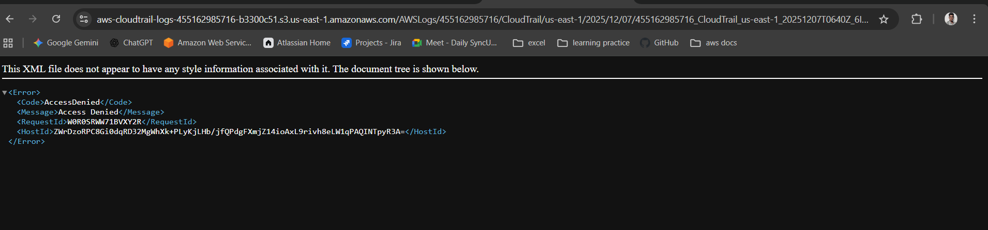
Issues Faced:
I Faced the issue regarding the time to get the logs and a latency in collecting the logs after some minutes the logs were recorded.
Conclusion of the TASK:
The logs are safely stored in S3 for long-term backup and also sent to CloudWatch Logs so you can easily search and set alerts.
This helps you monitor changes, improve security, and track what’s happening in your AWS environment.
TITLE:
Enable SNS for cloudtrial to send alert on email.
Objective:
Enabling the SNS (Simple Notification Service) for getting alerts on EMAIL for any unfamiliar activity
Prerequisites :
- Cloud trail
- Email ID
- SNS service
Step by step Implementation:
Step 1: Navigate to Cloud trail resource in AWS cosole and click on Trails and select a Trail
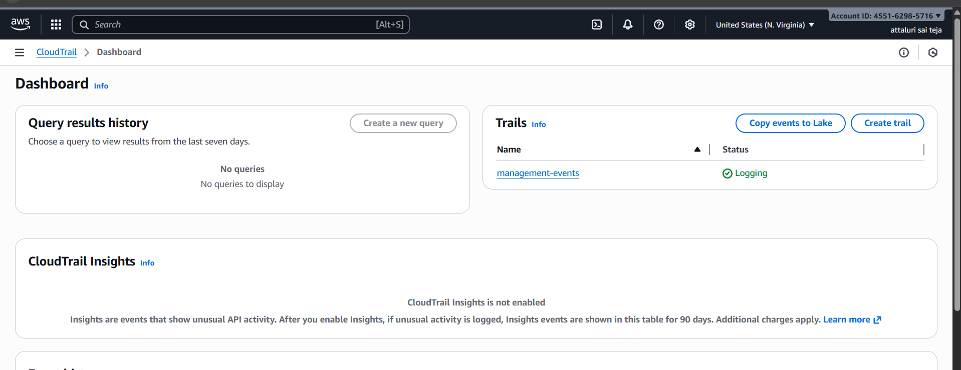

Step 2: Click on the EDIT option and go inside of it
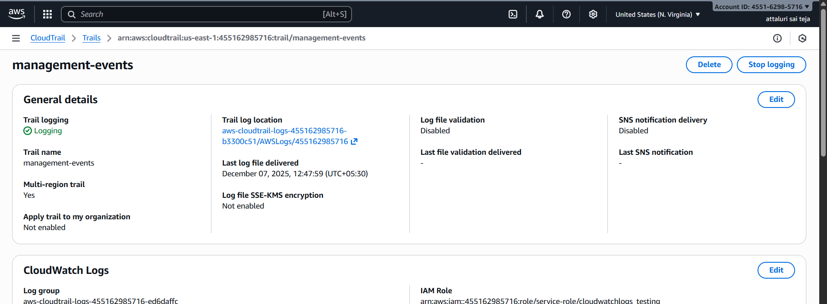
Step 3: Scroll down to get the additional options and enable the SNS topic and provide a topic name
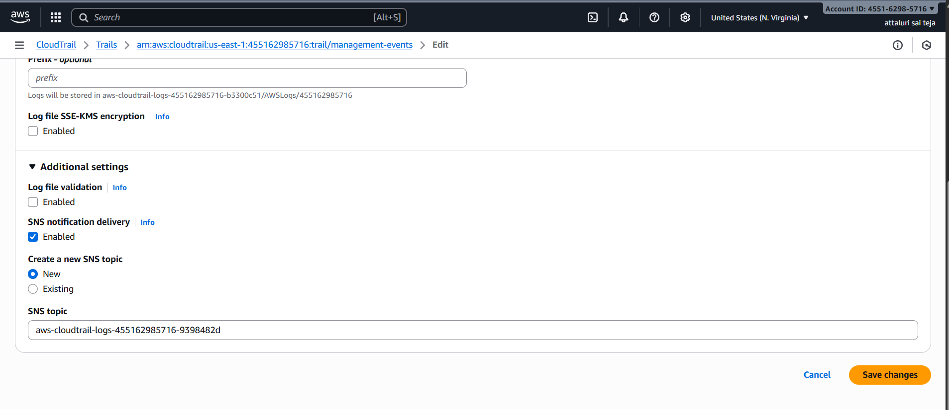
Step 4: Now you can verify the SNS service has been enabled successfully
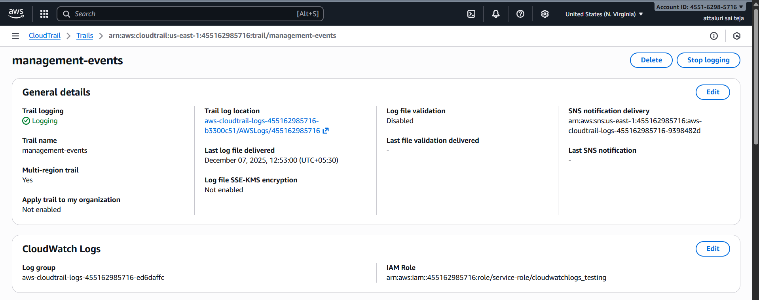
Validation steps:
Step 1: Navigate to SNS service in CONSOLE and get in to it
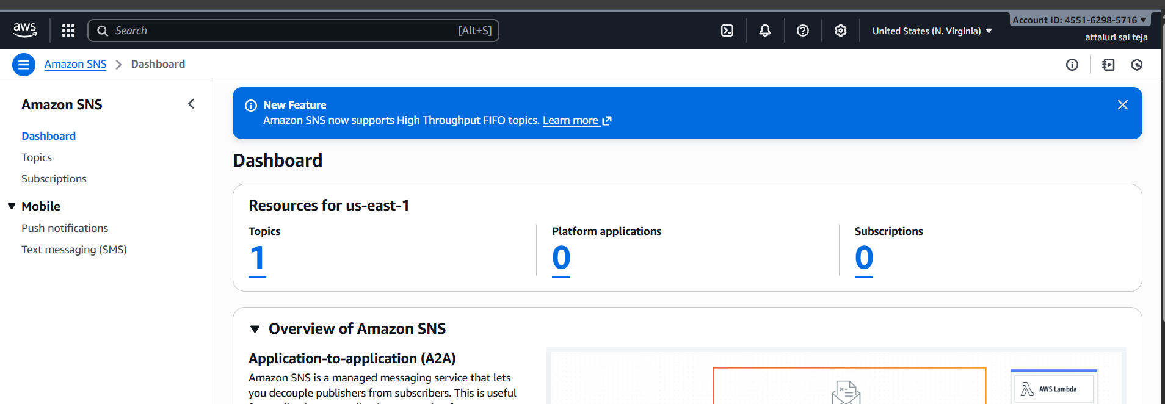
Step 2: Select the Topic which we created earlier and click on it
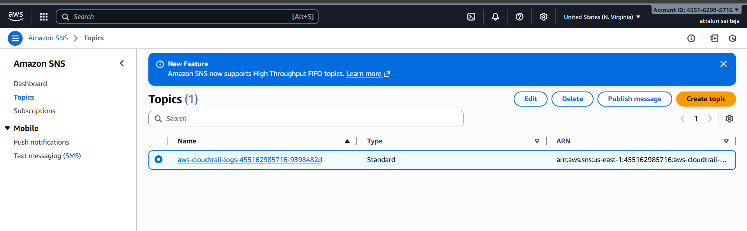
Step 3: Click on Create Subscription to attach the email id
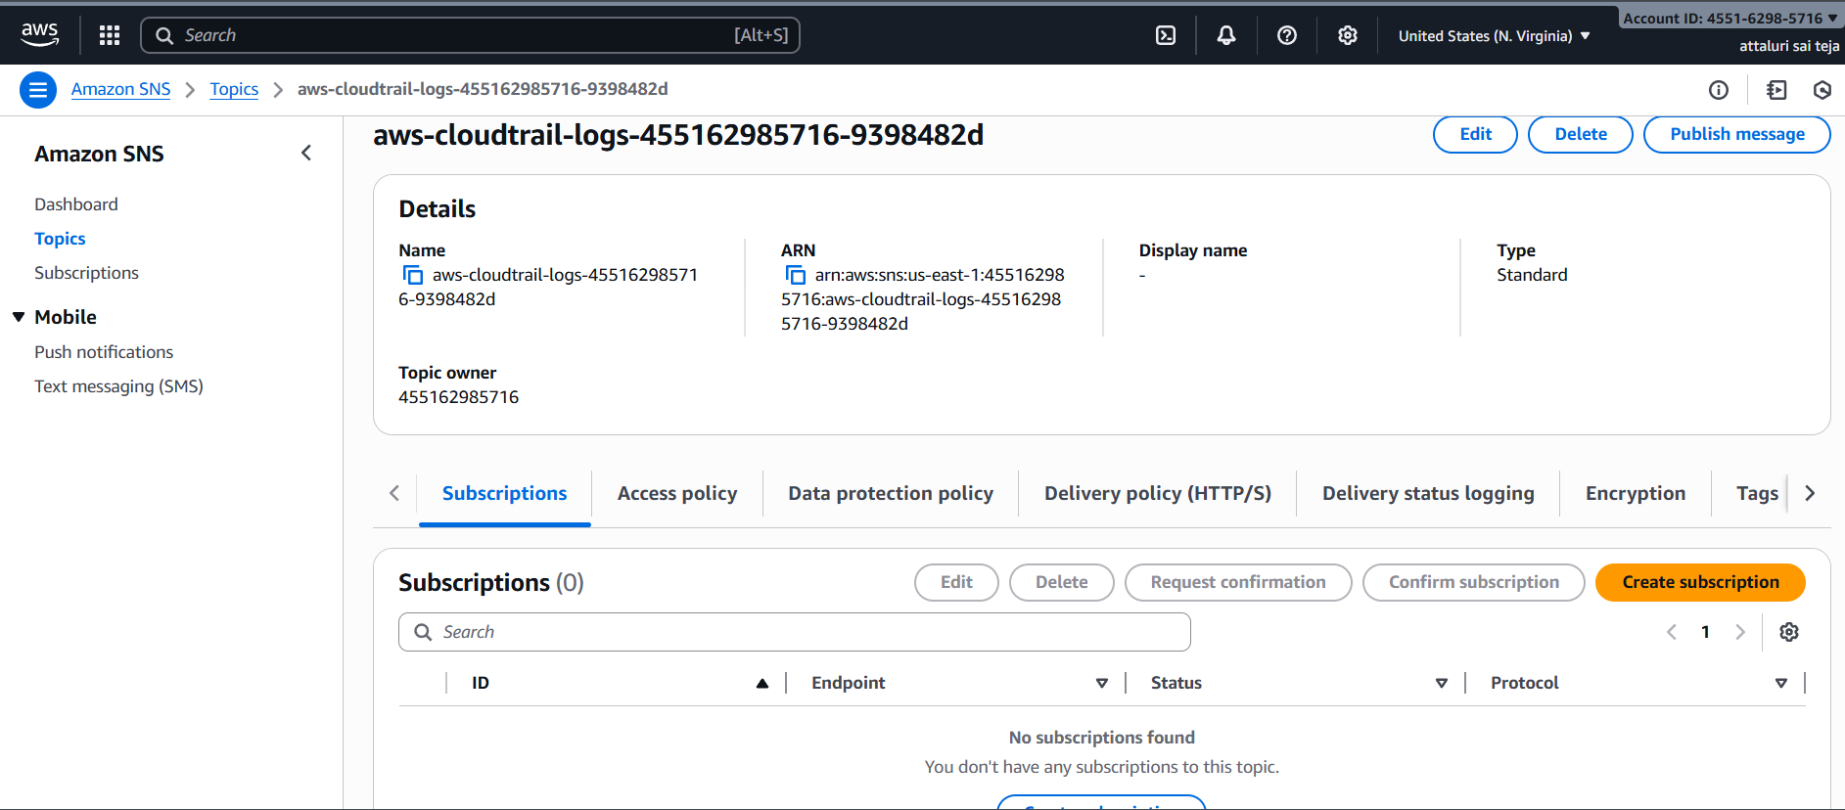

Step 4: Provide the topic name and Select the protocol as your requirement in my case I preferred EMAIL and provide email id
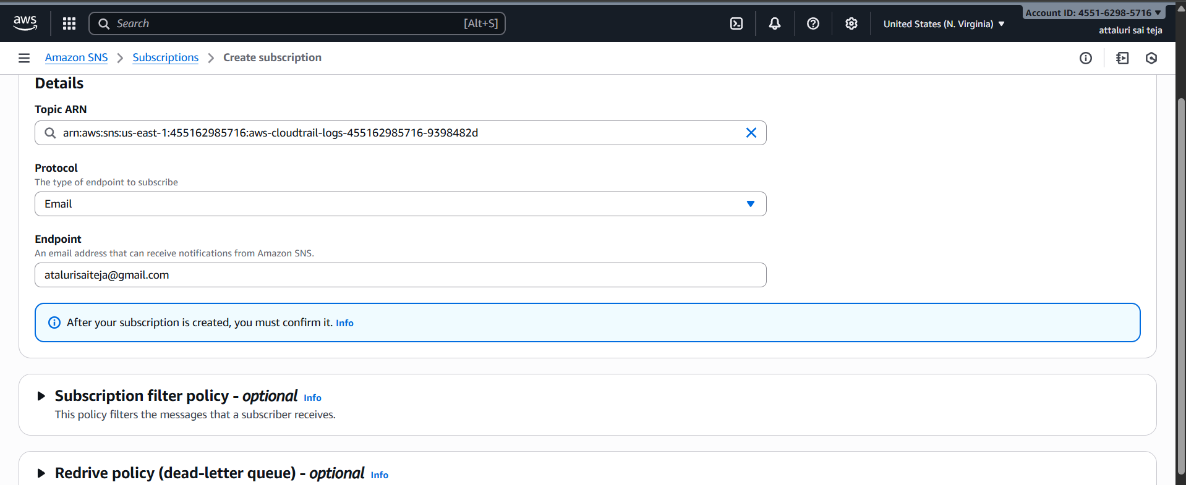
Step 5: The email has been Attached with SNS topic and we need to confirm from our end
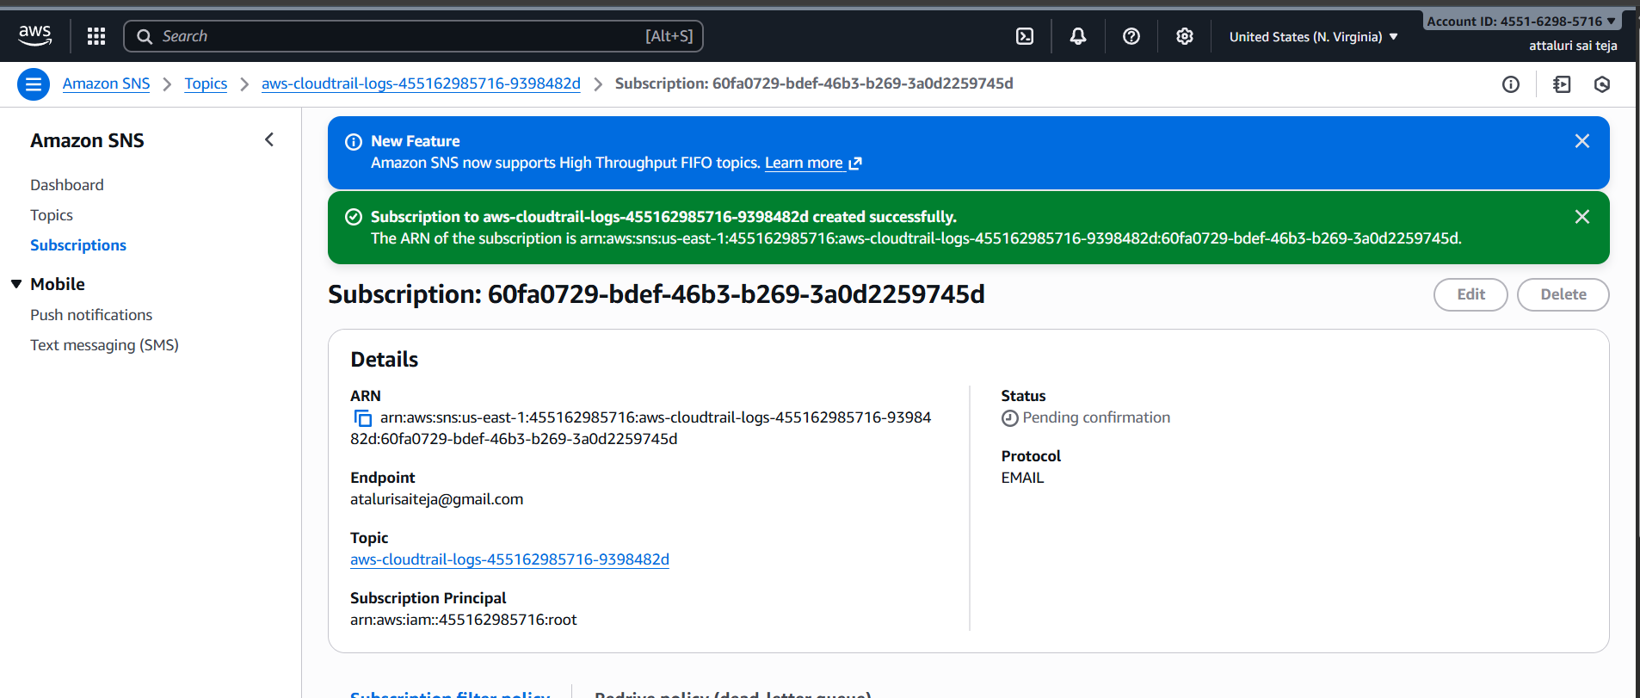
Step 6: Now Open your Email id and check you’ve received an email from AWS and click the link
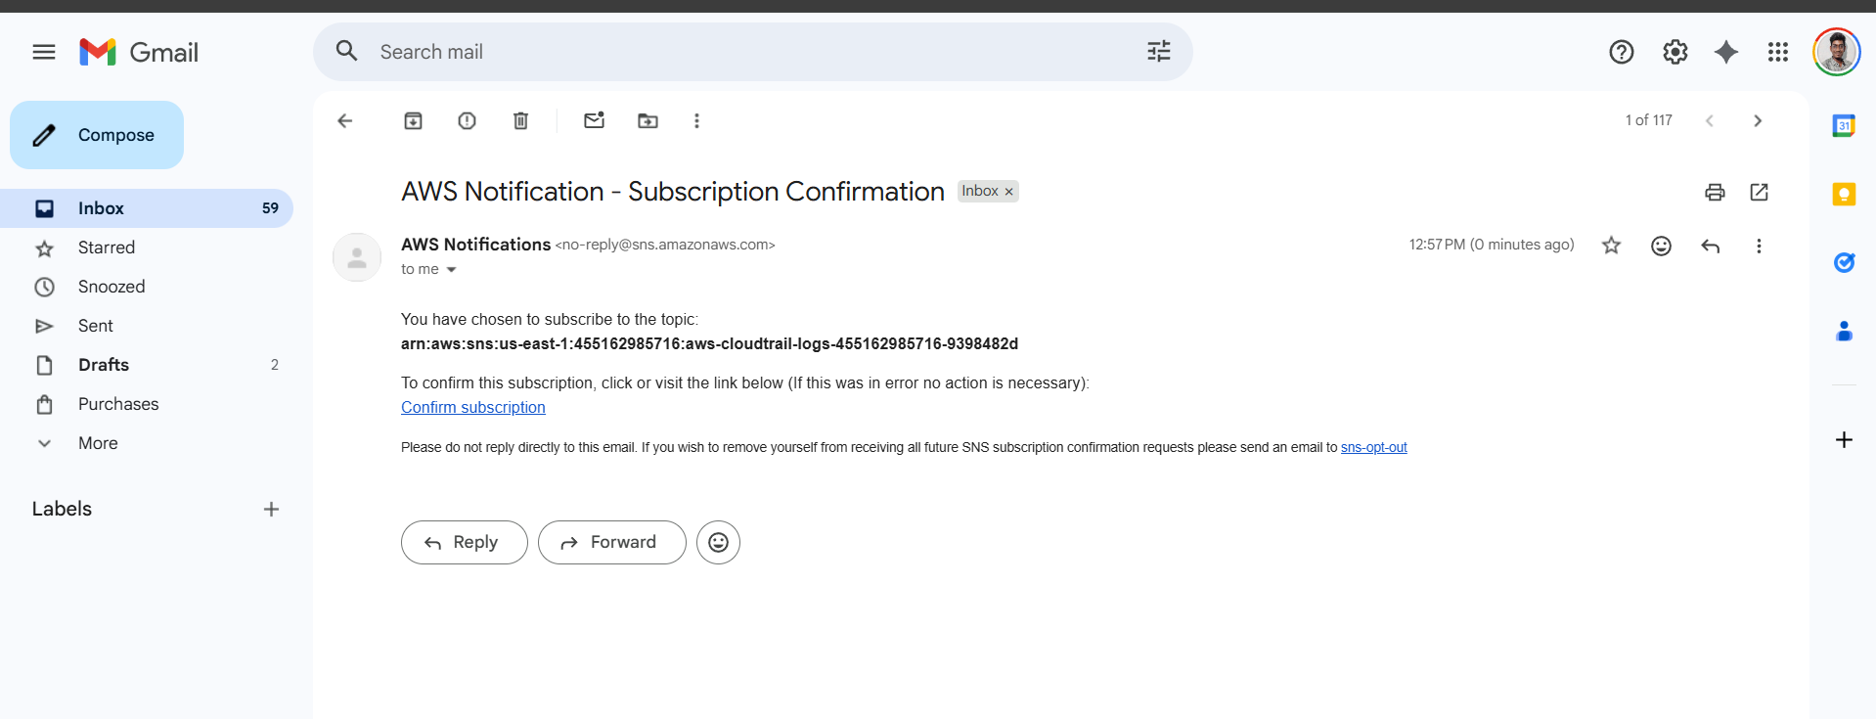
Step7: Now Your email has been successfully verified and you will get a popup message like in the below picture
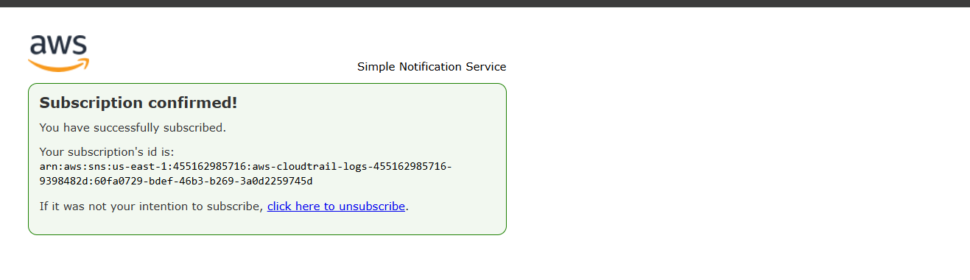
Step 8: Now Again Navigate to SNS topic and witness that STATUS has been in confirmed state
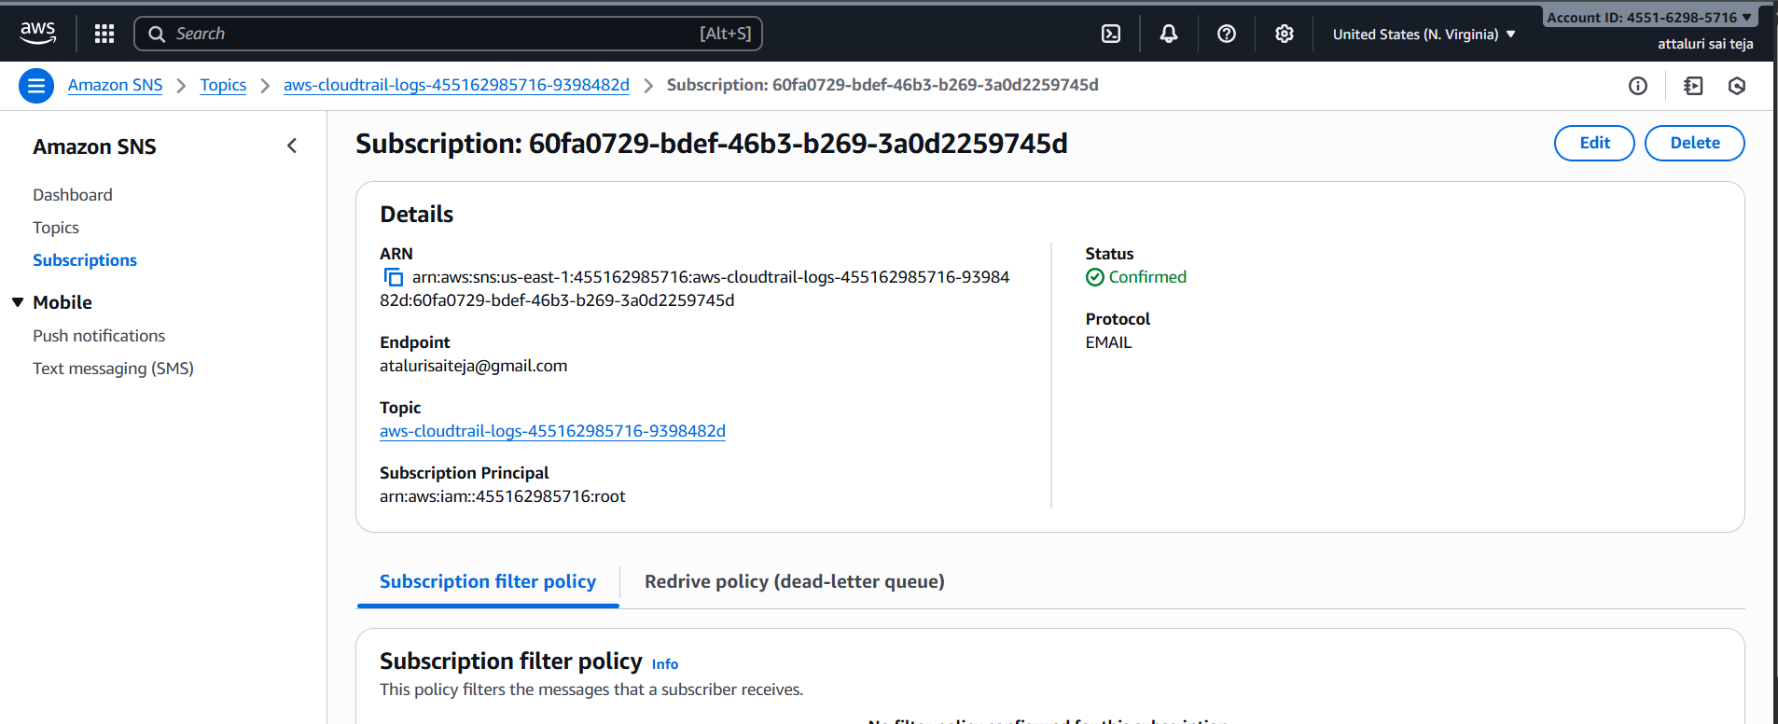

VALIDATION EMAILS AFTER CONFIGURING:
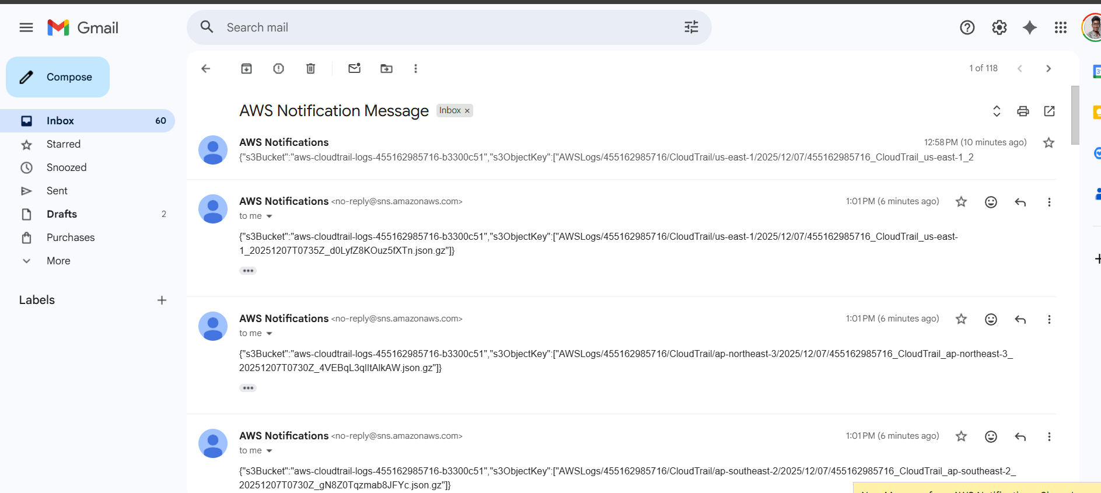
ISSUES FACED:
Some time the email will arrive late so be calm and wait or redo the process
Conclusion :
By successfully Configuring the SNS service which helps by providing notifications related to AWS activity like uncertain ,CPU , MEM utilization

TITLE:
Configure cloud watch monitoring and record the cpu utilization and other metrics of ec2.
Objective :
Capturing the metrics of CPU utilization and EC2 using CLOUD WATCH
Prerequisites:
- Cloud watch
- EC2
Step by Step Implementation
Step 1: Launch one EC2 Instance in your AWS Console
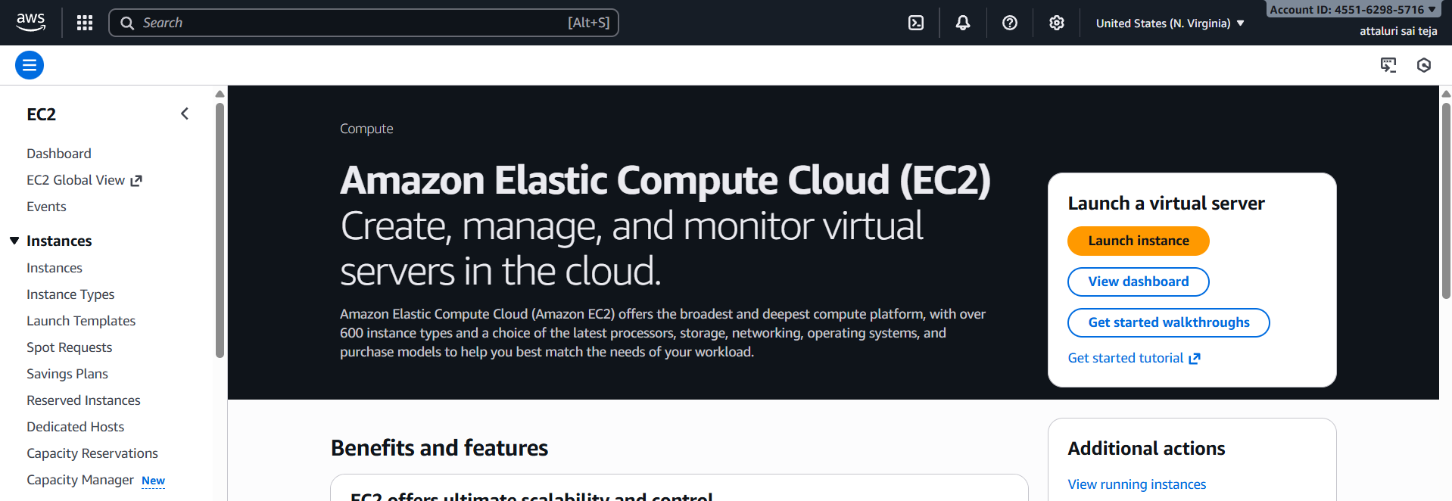
Step 2: Click on launch instance to continue
Instance has been Launched I think you’ve aware of how to launch an instance
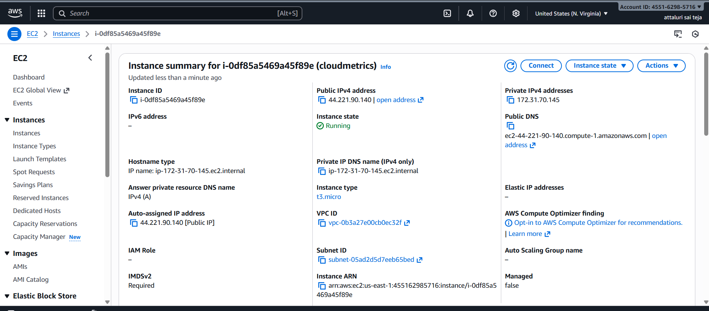
Step 3: Navigate to CLOUD Watch and Select the Metrics
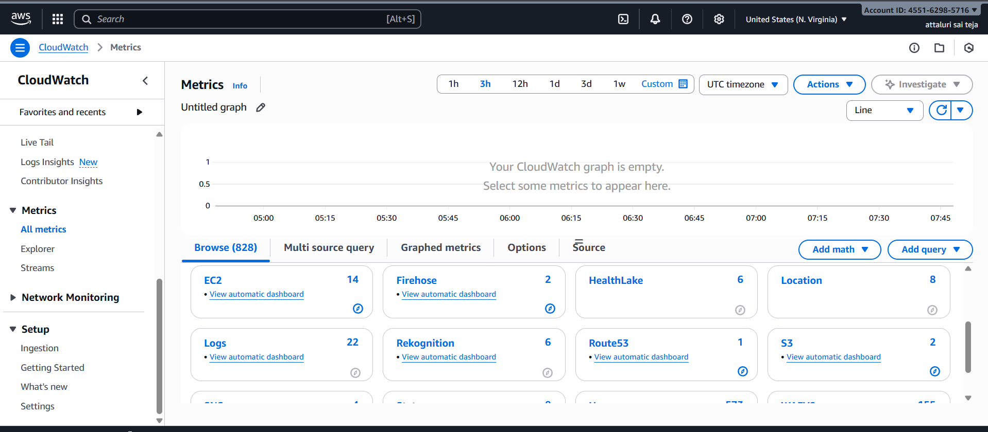
Step 4: In the Metrics Section Select the Service of CPU utilization
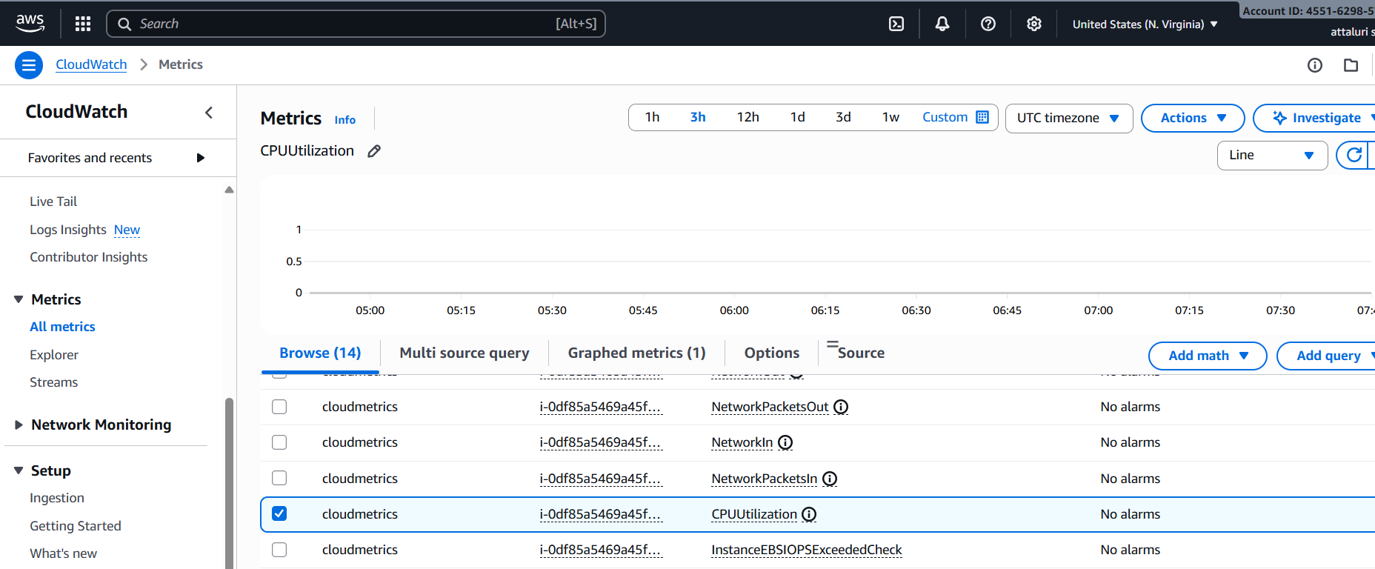
Step 5: In the actions tab Select Add to dash board that we can see a separate dashboard for our ec2 cpu utilization
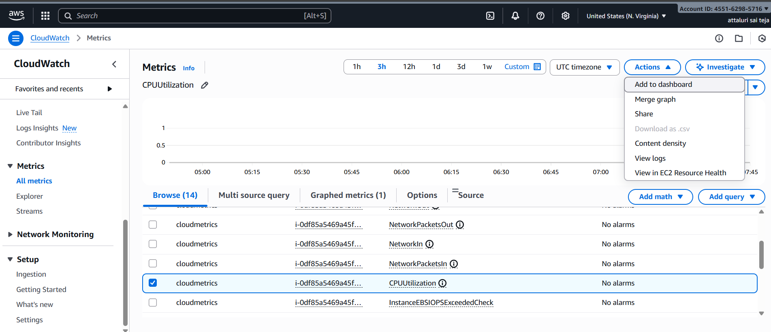
Step 6: If there is existing dashboard select it or else click on create new to create new dashboard
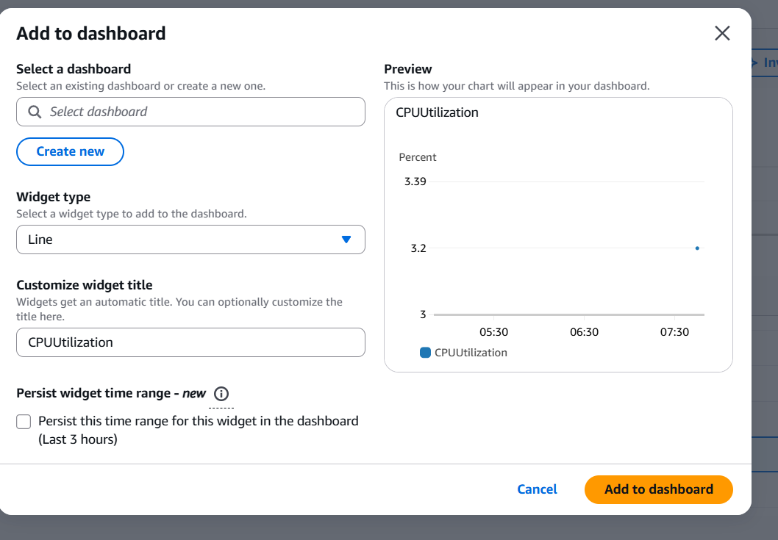
Step 7: Provide a name tag and click on create
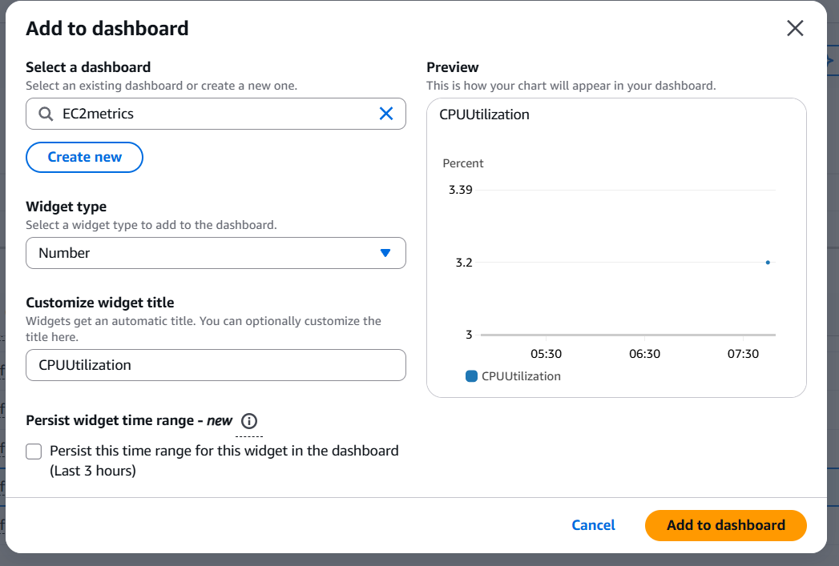
Step 8: select the widget type as number or according to you to visualize the usage of ec2 and click on add to dashboard
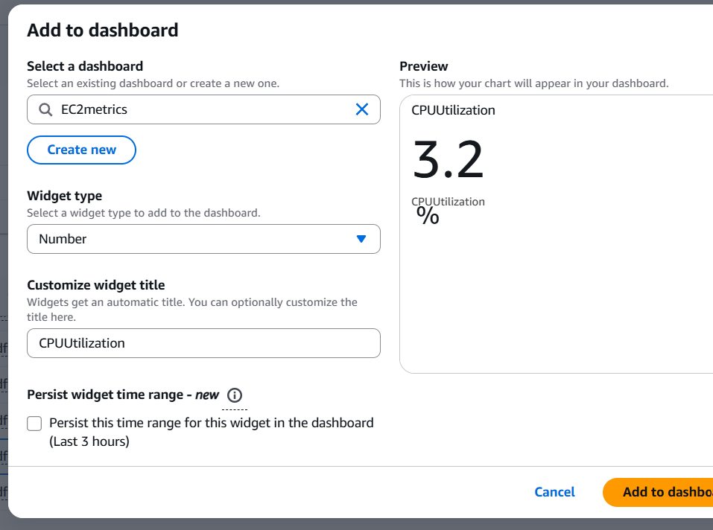
Step 9: Now a separate dashboard has been created and click on save dashboard to save and you can see my present ec2 utilization is 3.2%
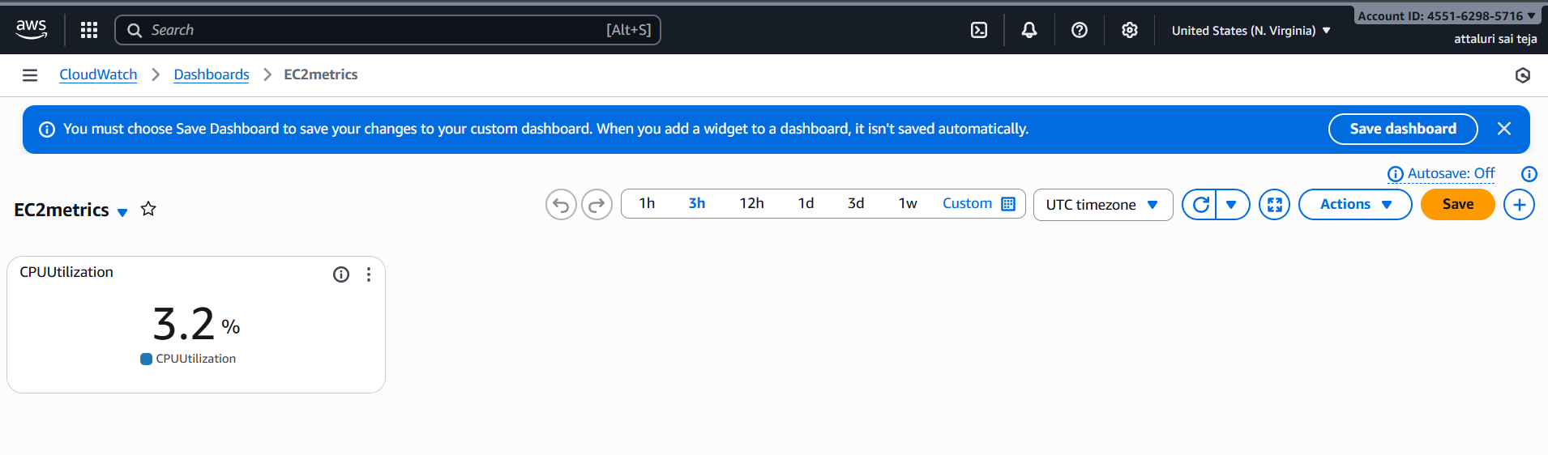

Step : in Metrics I also added some other metrics to the earlie dashboard
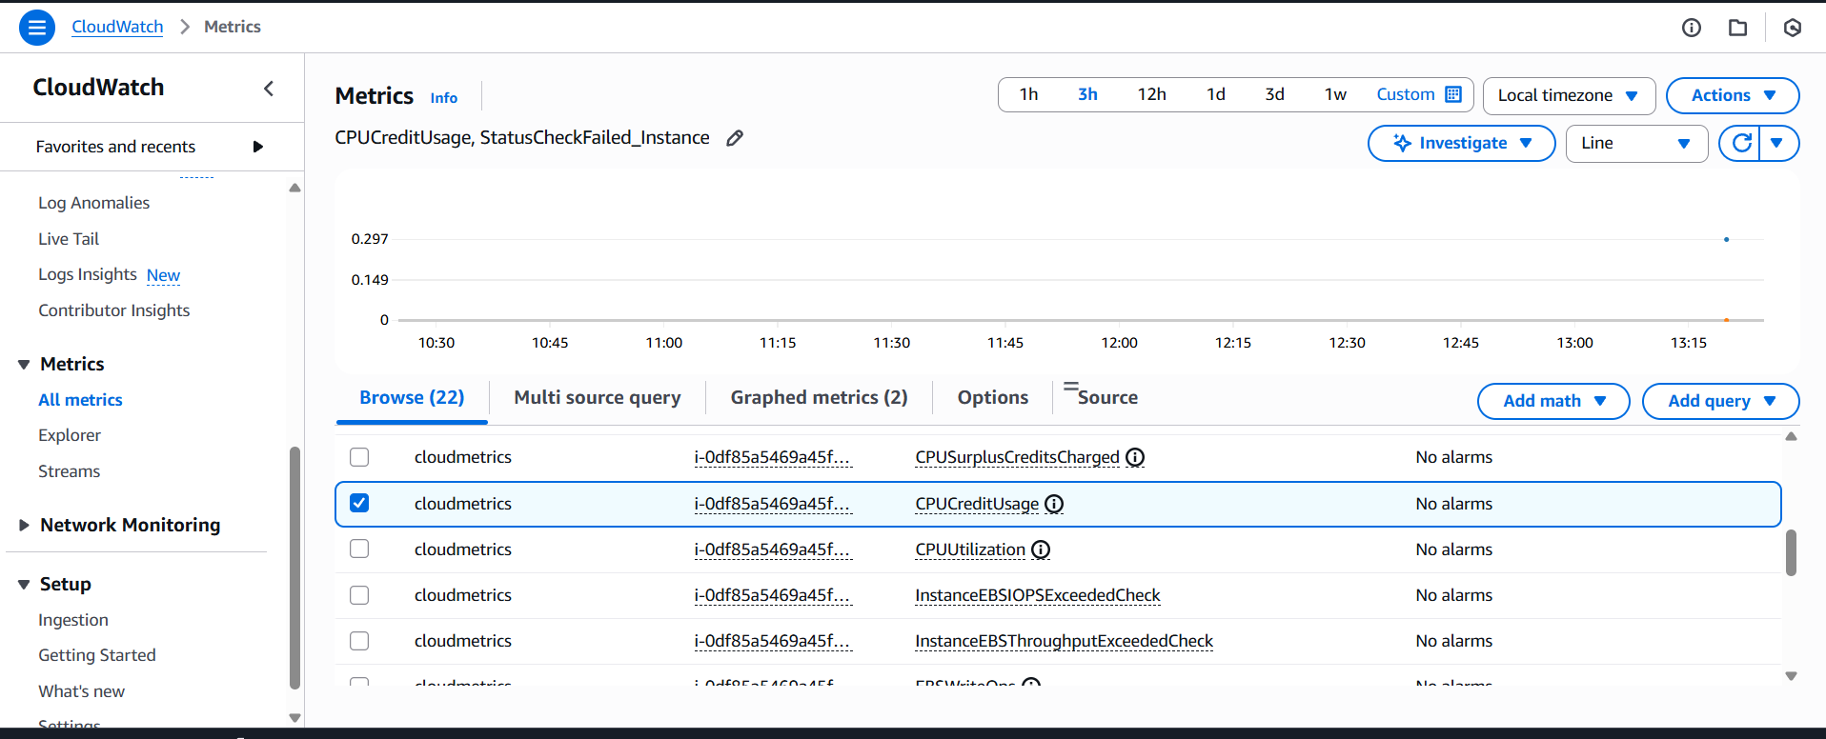
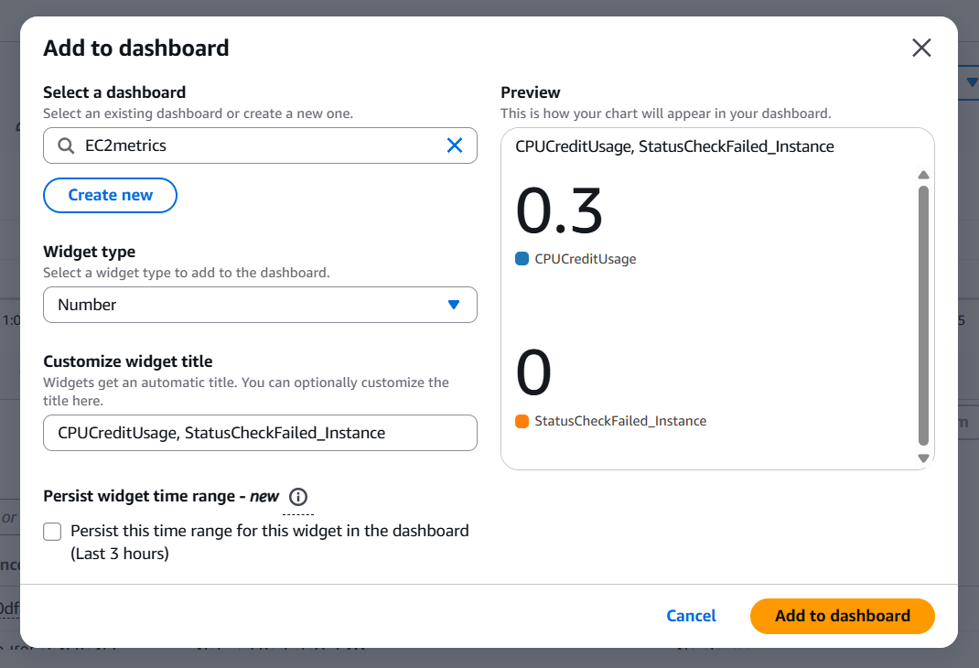
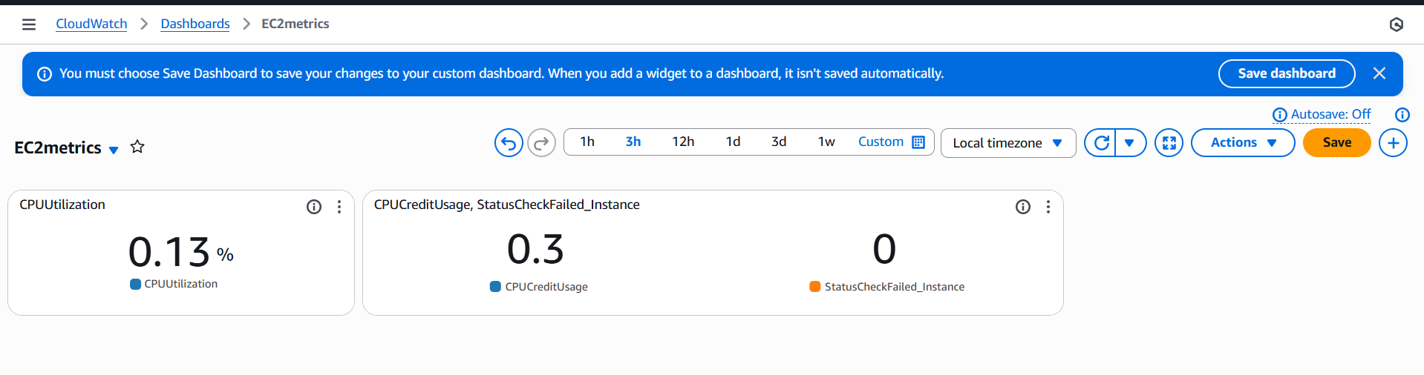
Validation Steps:
Step 1: Connect to EC2 Instance server
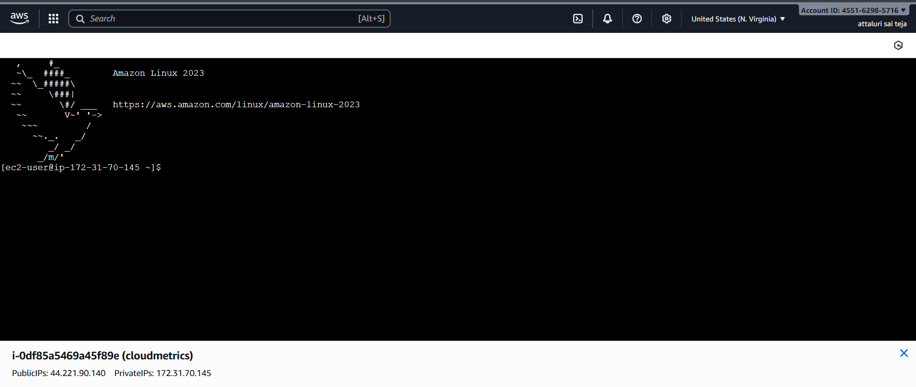
Step 2: check the CPU utilization using TOP Command
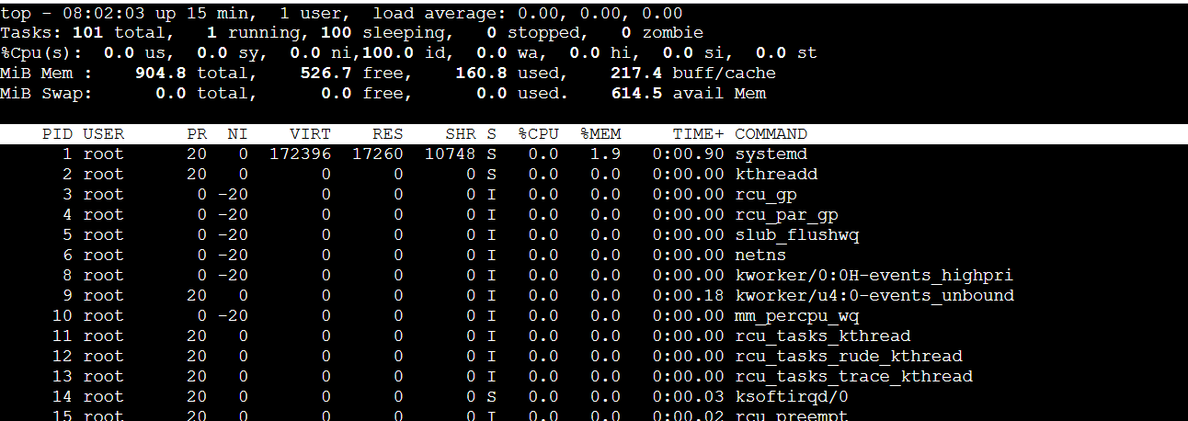
Step 3: yes > /dev/null & added the load to ec2 using the command
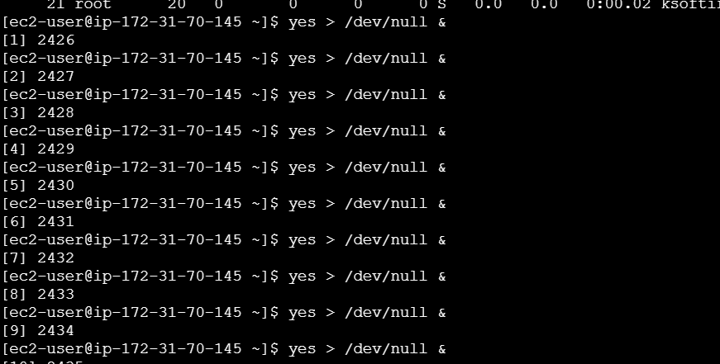
Step 4: check the usage using TOP Command and around 59% is used
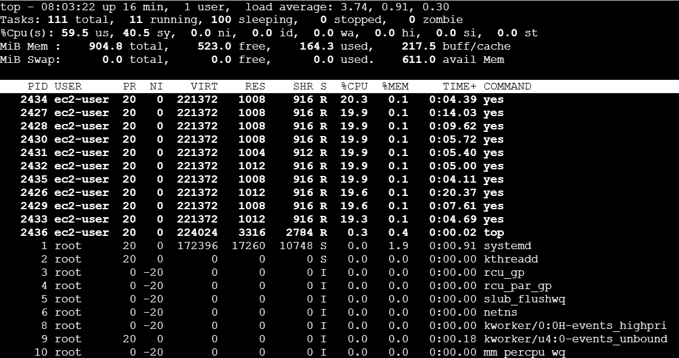
Step 5: check using the Dashboard in cloud watch and it showing around 39%
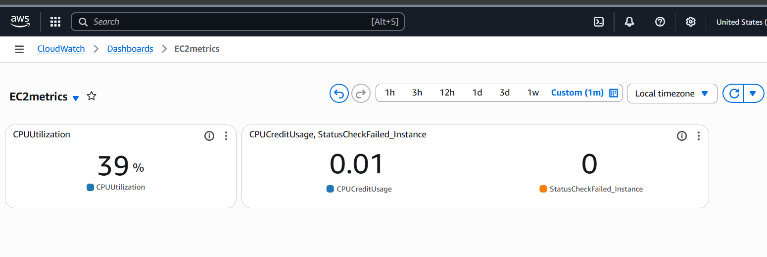
Issues Faced:
Delay in getting the information in Dashboard there is some latency

Errors:
After adding the load to the ec2 I am unable to view the same percentage on Dashboard because of timezone and time frequency


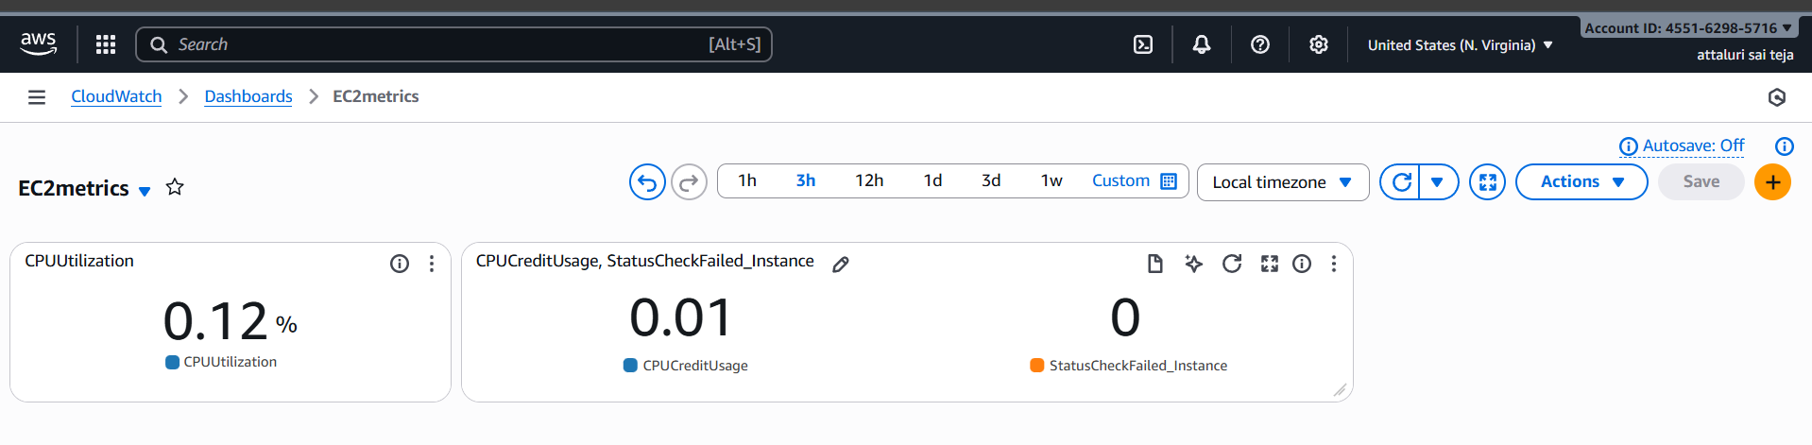
After changing the time Period it showed accurate earlier it was 5minutes and I changed it to 1 min so that error has been resloved
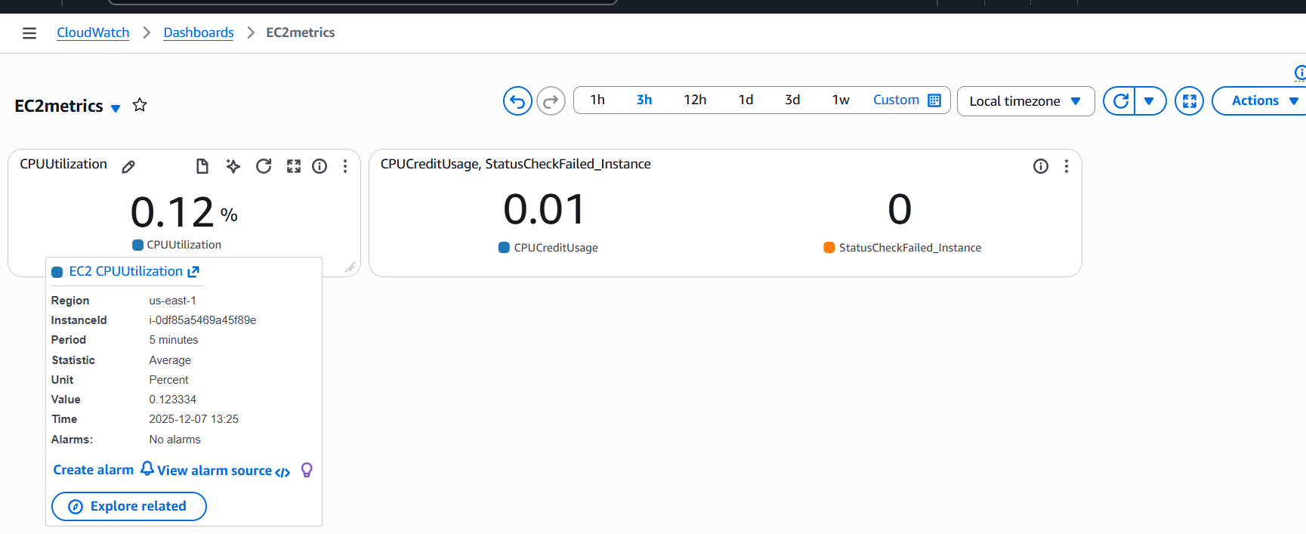

Conclusion:
By doing the above task we can witness the CPU Utilization in numerical or any other form and as of any high usage or THRESHOLD we could notice the issues and we can autoscale it
By that we get email alerts regarding high cpu usage in future

TITLE:
create one alarm to send alert to email if the cpu utilization is more than 70 percent.
Objective :
We get the email notification if cpu utilization exceeds 70% by that we can act early and solve the issues by that server is in good condition
Prerequisites:
- Email id
- Ec2
- SNS
- Cloud Watch
Step by Step Implementation:
Step 1: Navigate to Cloud watch and select alarms option and select on create alarm
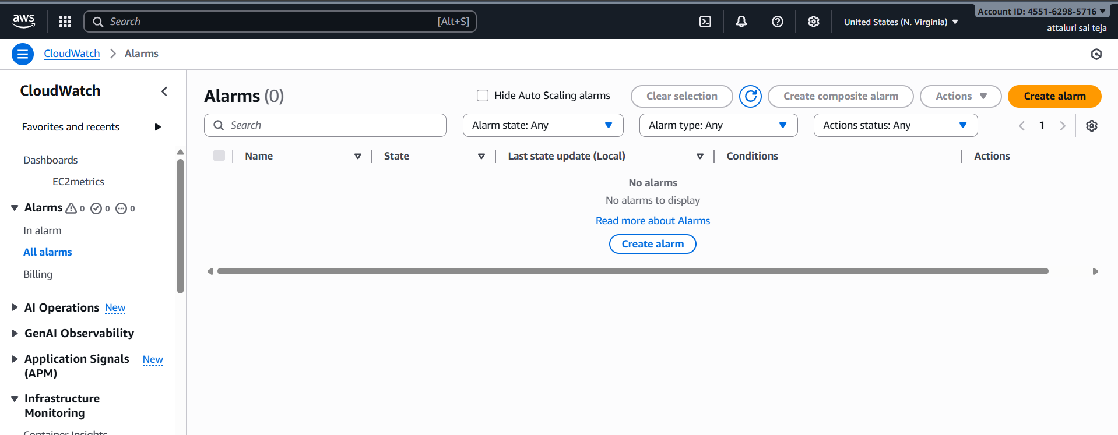

Step 2: Select Metrics by clicking on select metrics tab and continue
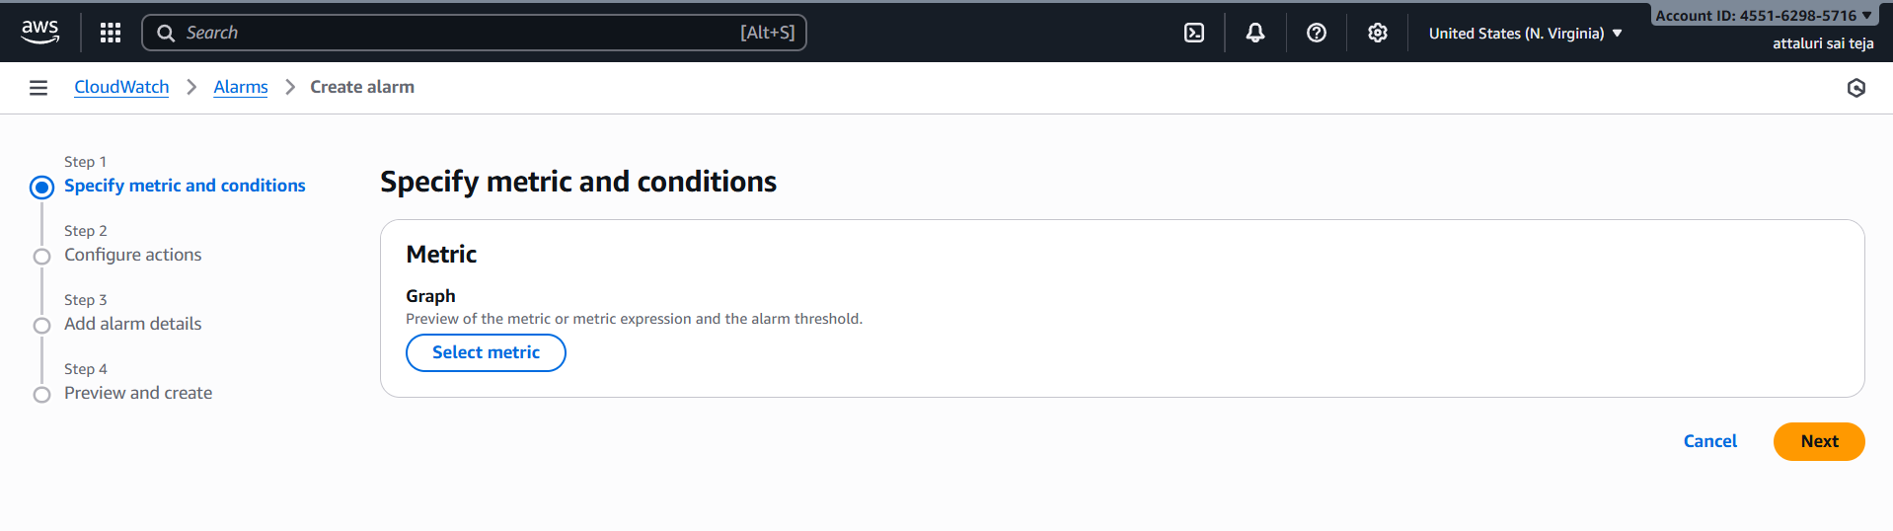
Step 3: select the cpu utilization of EC2 and click on select metric
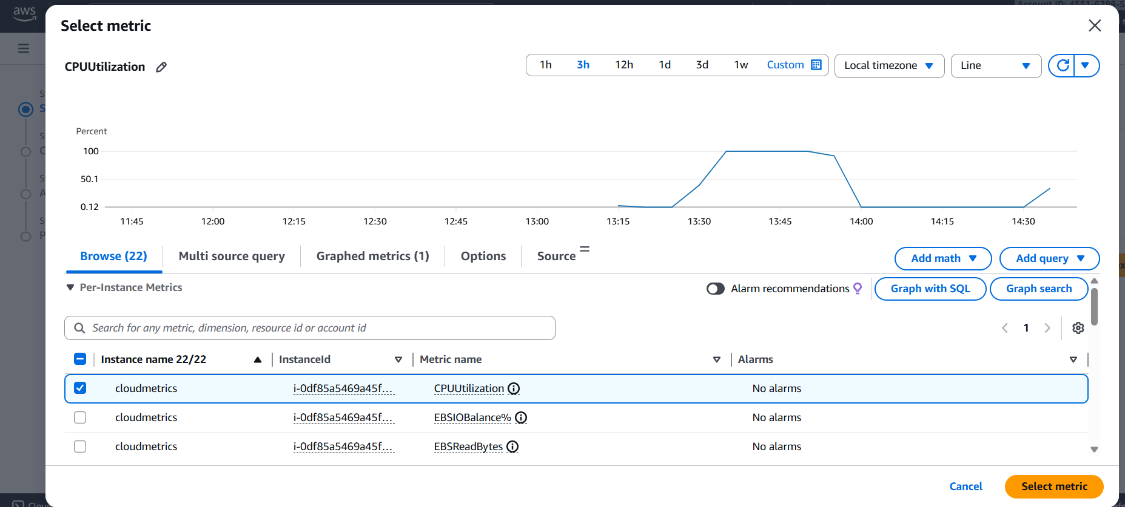
Step 4: Then Provide a name to metric and confirm the instance id to continue
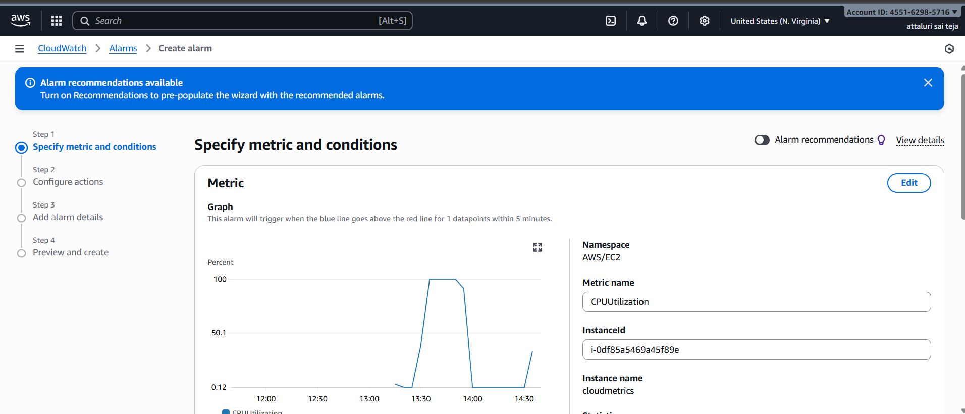

Step 5: Select Threshold type and select period time is 1 minute
And choose an option i.e greater than less than etc
And mention the percentage value as 70
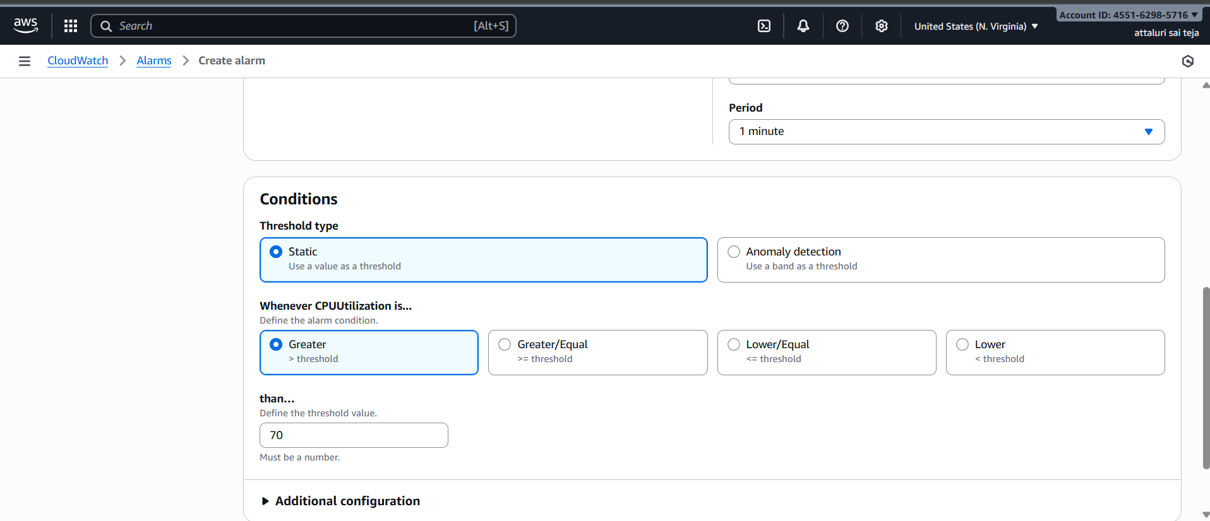
Step 6: Click on notifications tab to continue
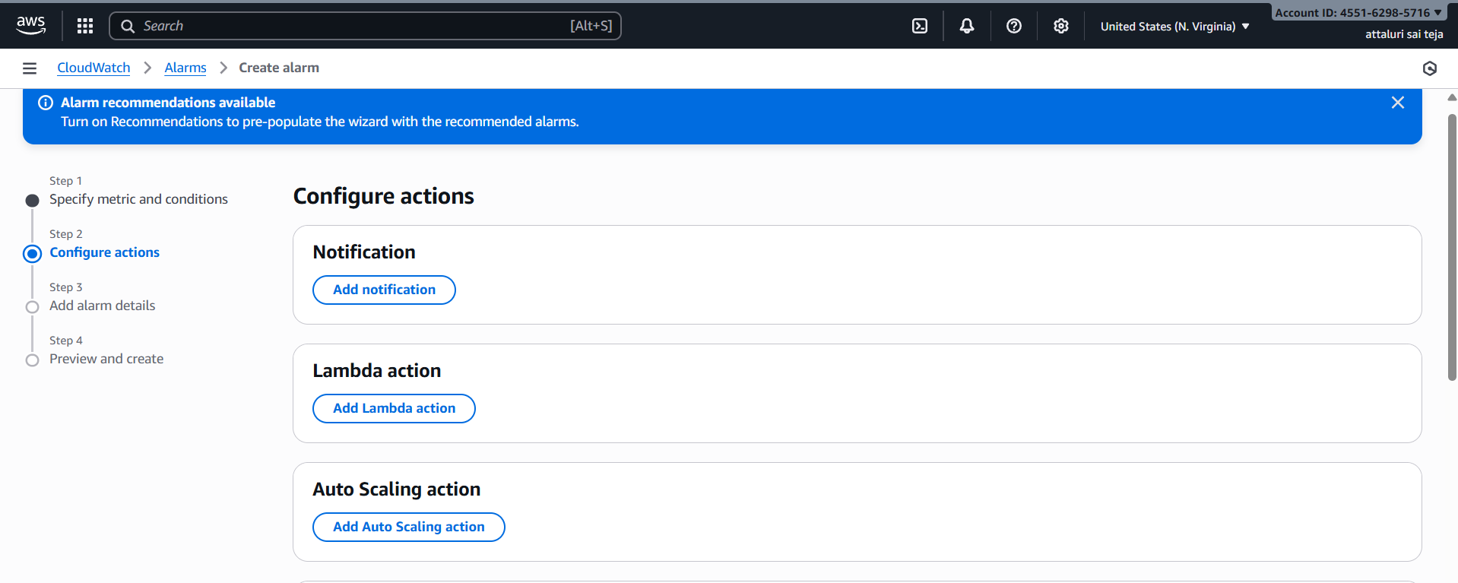
Step 7: select alarm state and select existing SNS topic and continue after verifying email id
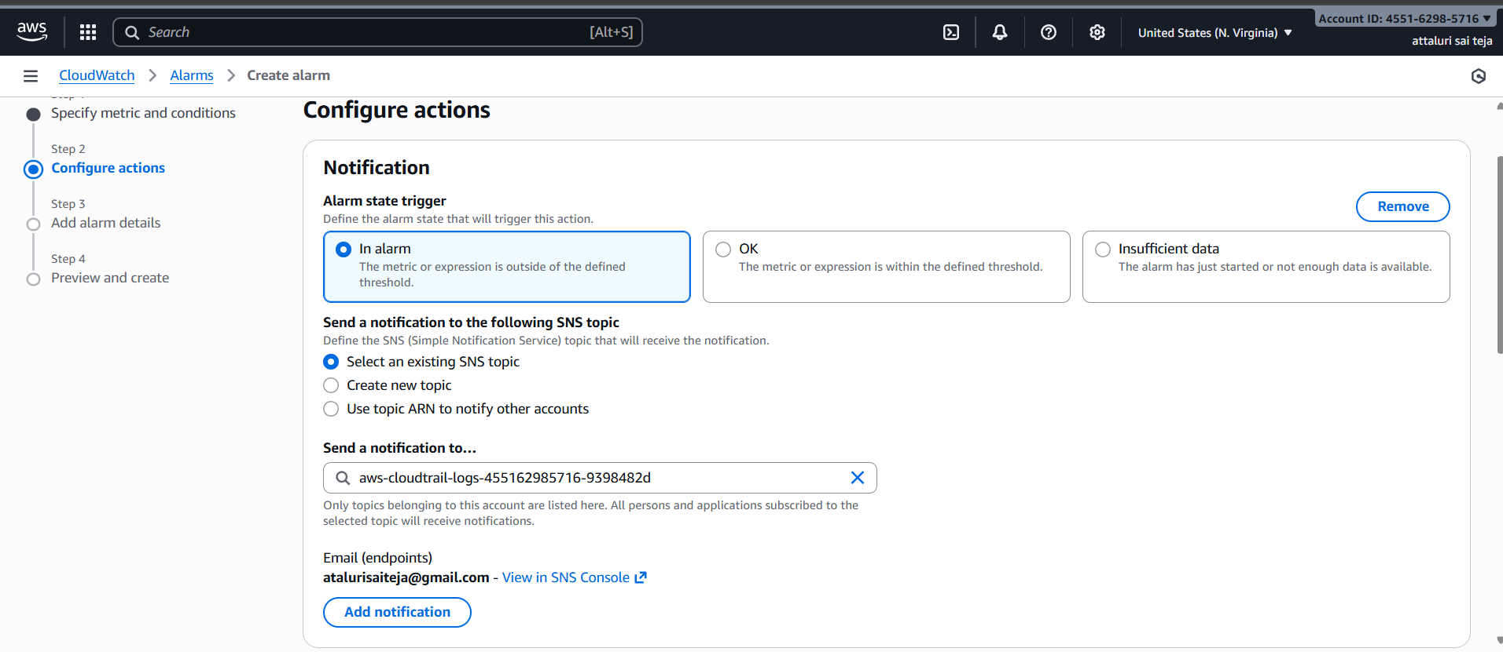
Step 8: In alarm EC2 actions tab select any configurations if you need and continue
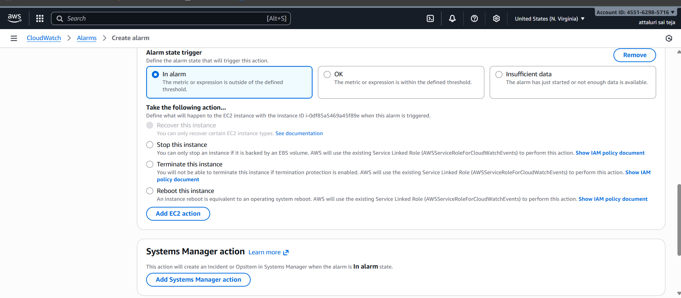
Step 9: Provide alarm name and any description if you need and continue to next
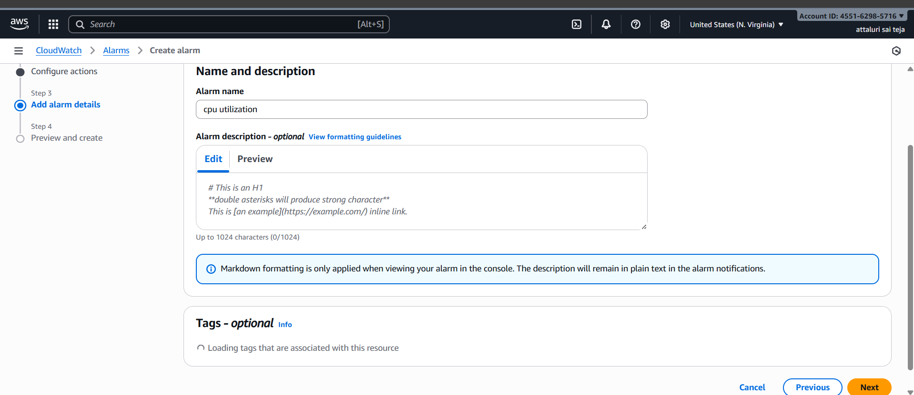

Step 10: Preview the details and submit
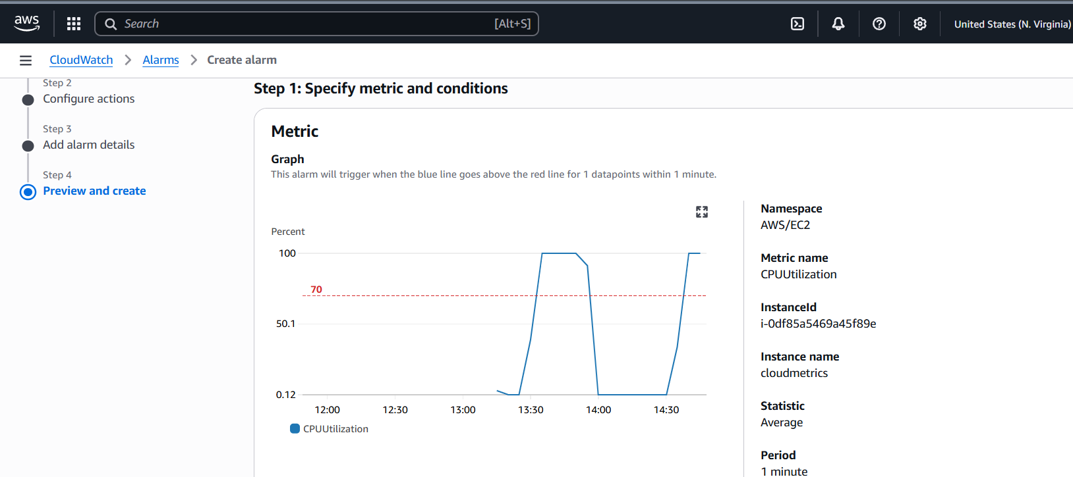
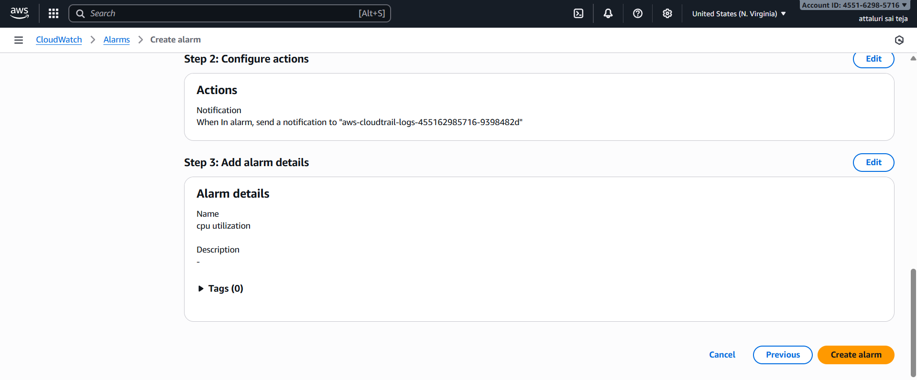
Step 11: alarm Setup has been successfully created and if you see the state is in insufficient data wait for some time it will come to ok stage
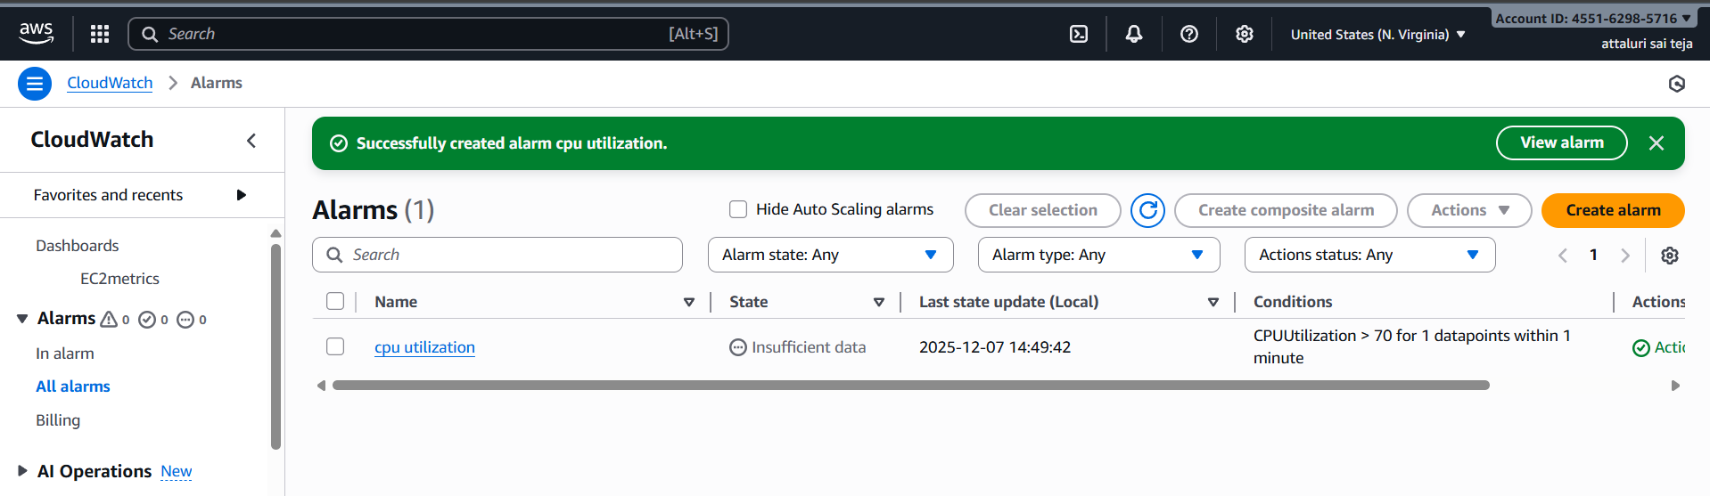

Validation steps :
Step 1: Click on alaram to view the details and check the status
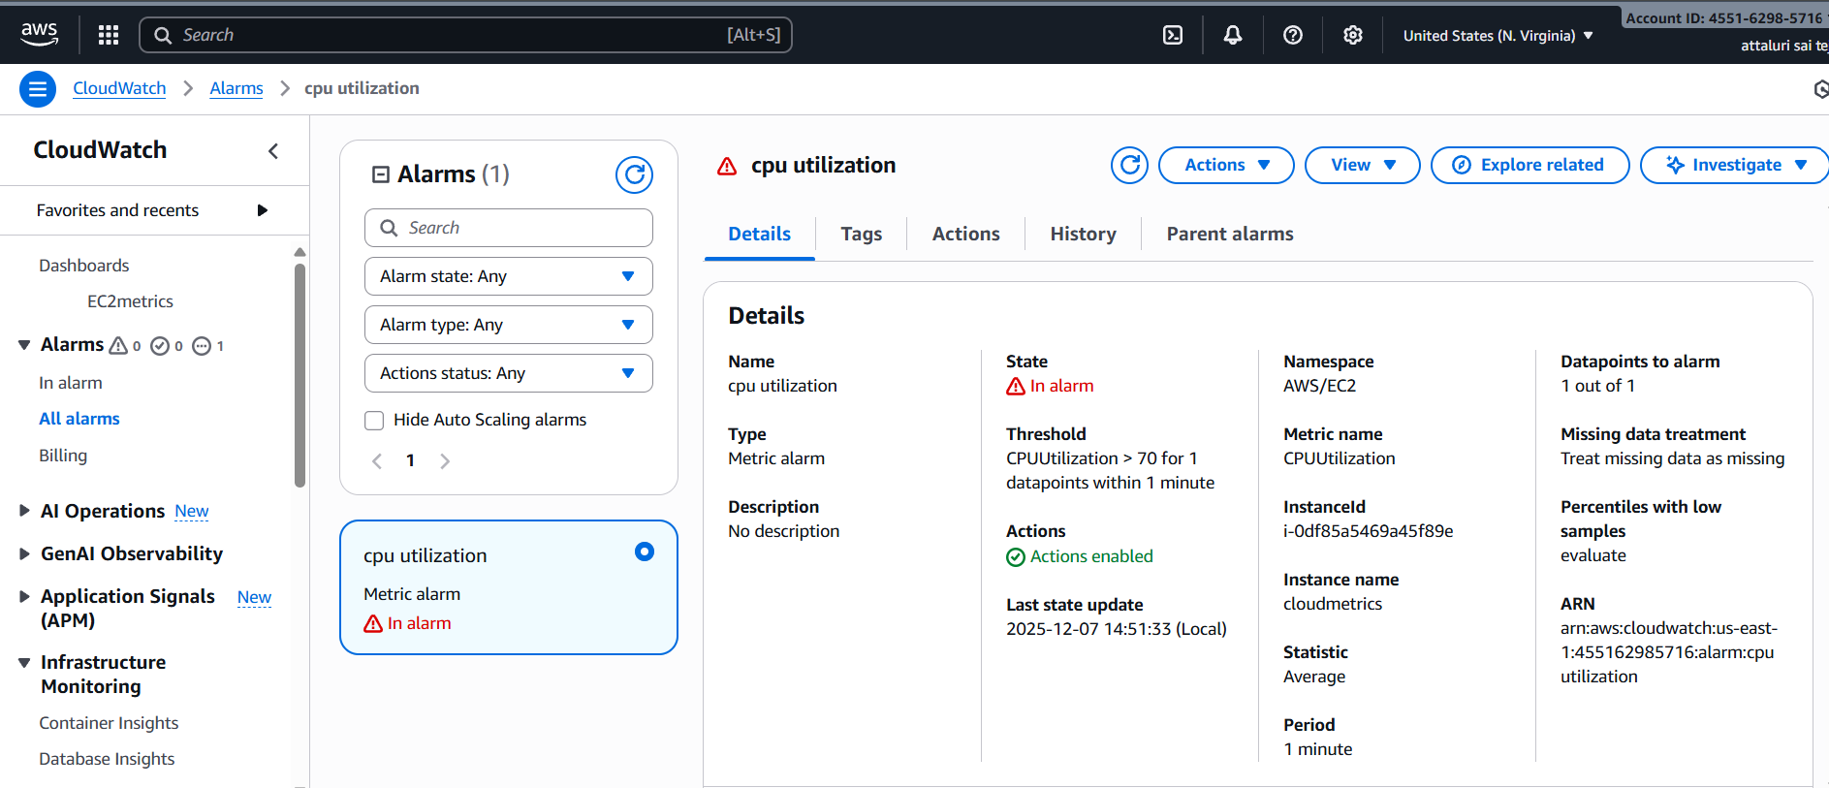
Step 2: alarm If every thing went successfully you will get an notification email
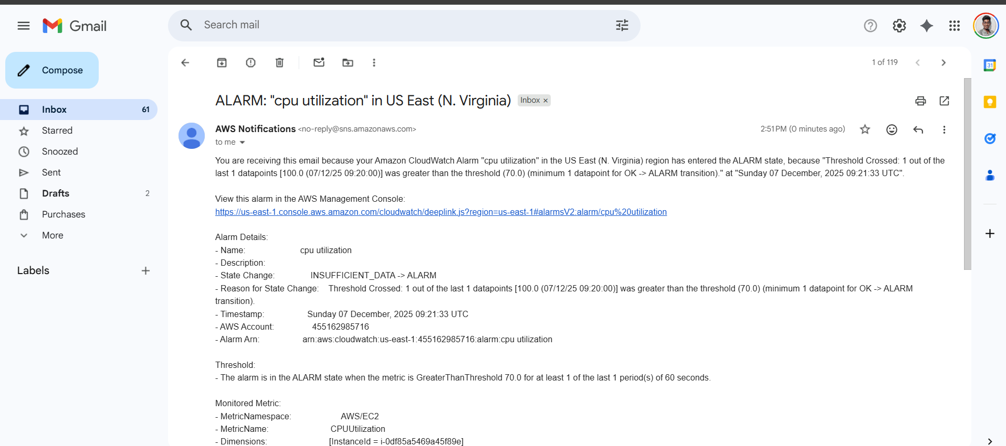
Provide details of dashboard and ec2 server for cross verification
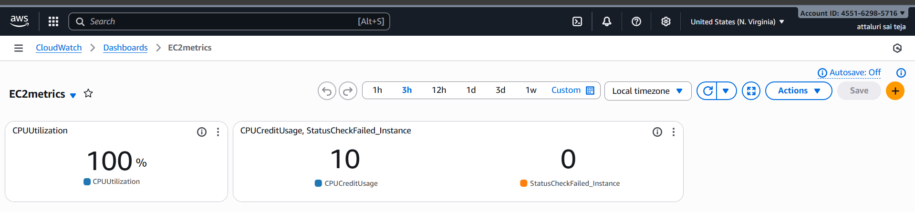
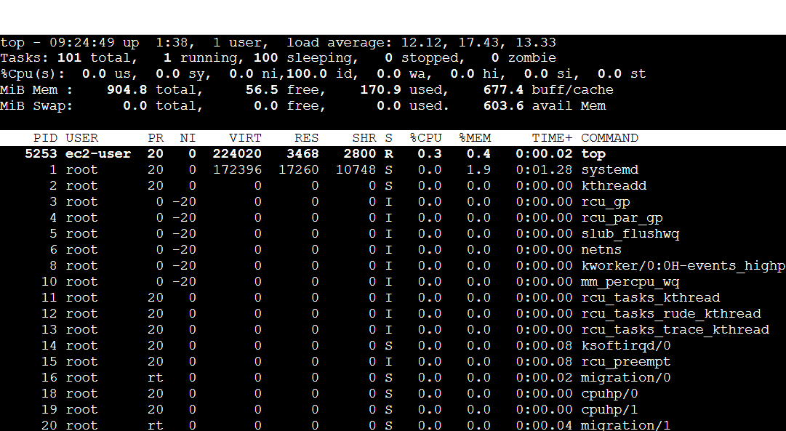
Conclusion:
When we setup the process for alarm then we can immediately resolve the issues before crash of the server

TITLE:
Create Dashboard and monitor tomcat service whether it is running or not and send the alert.
Objective:
creating a monitoring dashboard that checks whether the Tomcat service is running, and send alerts automatically if the service stops or fails.
Prerequisites :
- Tomcat service
- Java package
- EC2
- Cloud Watch
- SNS
- Alarm
- Crond package
- Bash script
Step by step Implementation :
Step 1: Connect to ec2 console and install java using
yum install java -y command
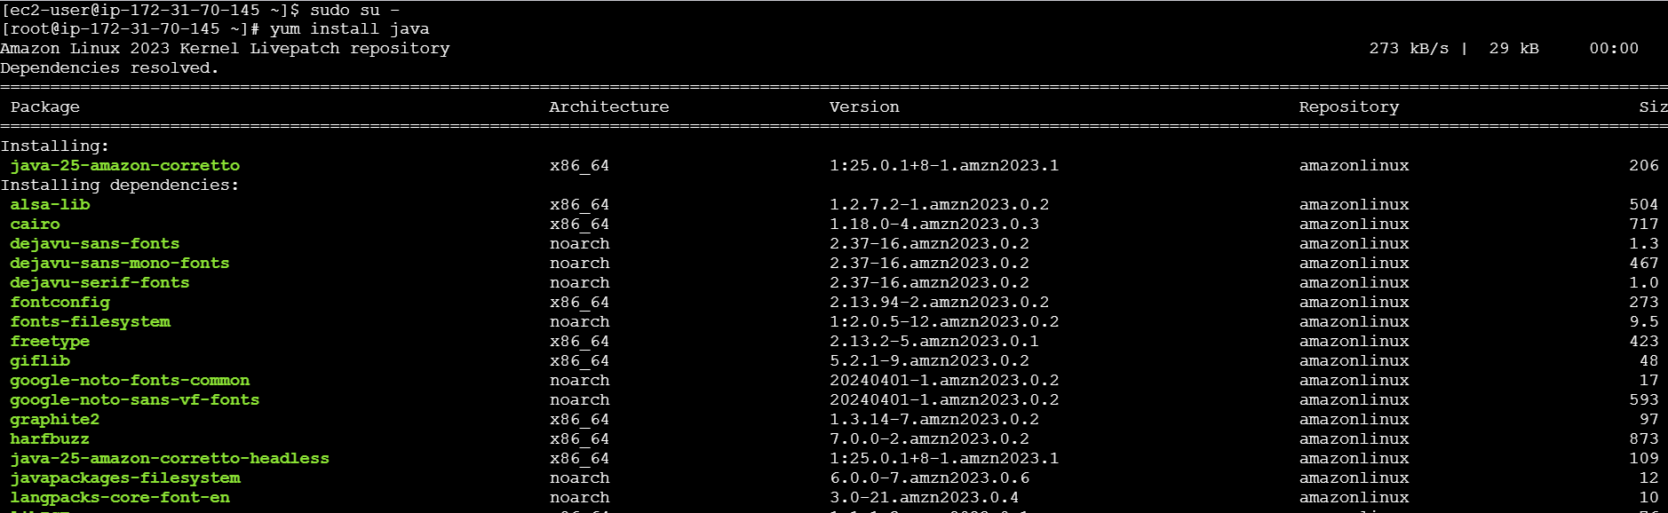

Step 2: Verifying the download whether installed or not
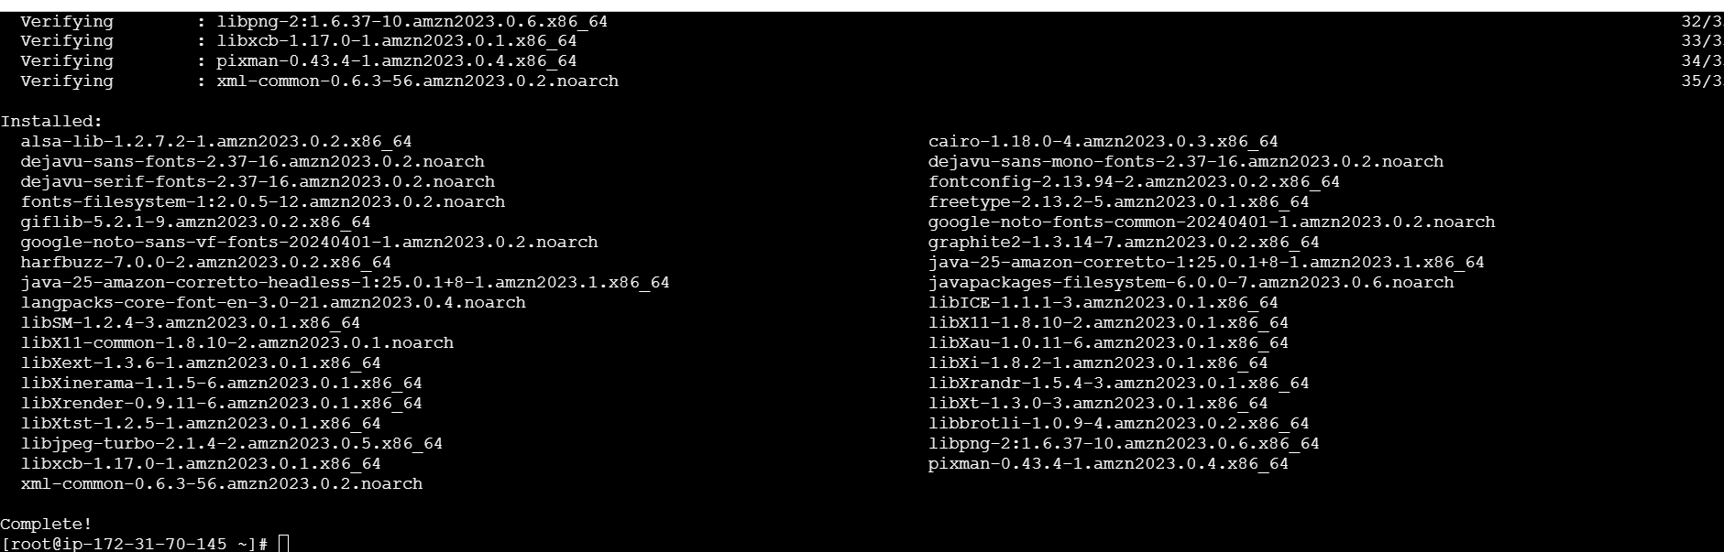
Step 3: Navigate to TOMCAT server and click on the version (applicable to you)
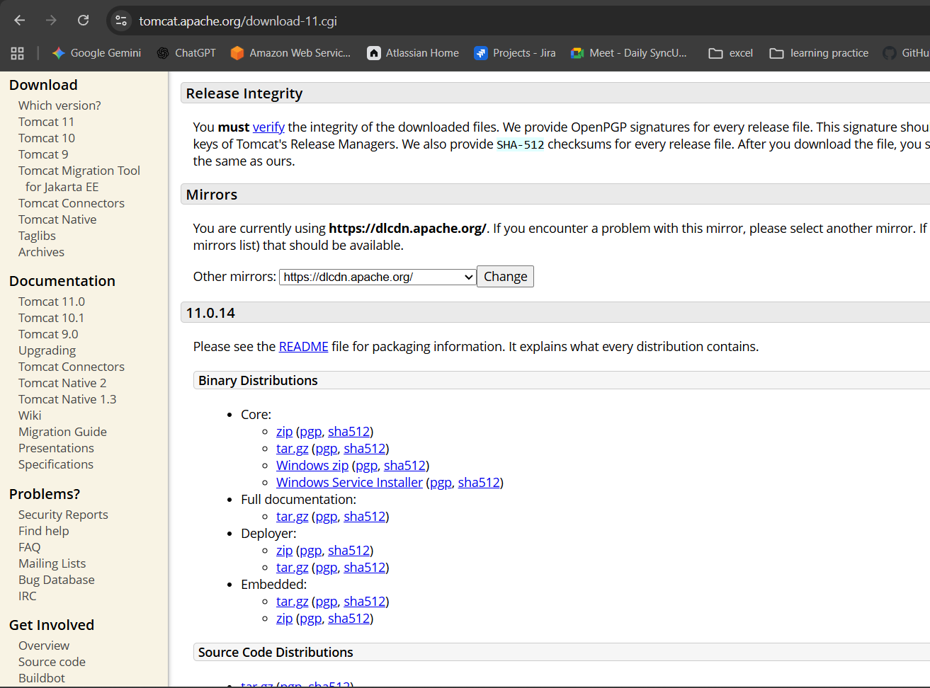

Step 4: Copy the tar.gz link as same like in below picture
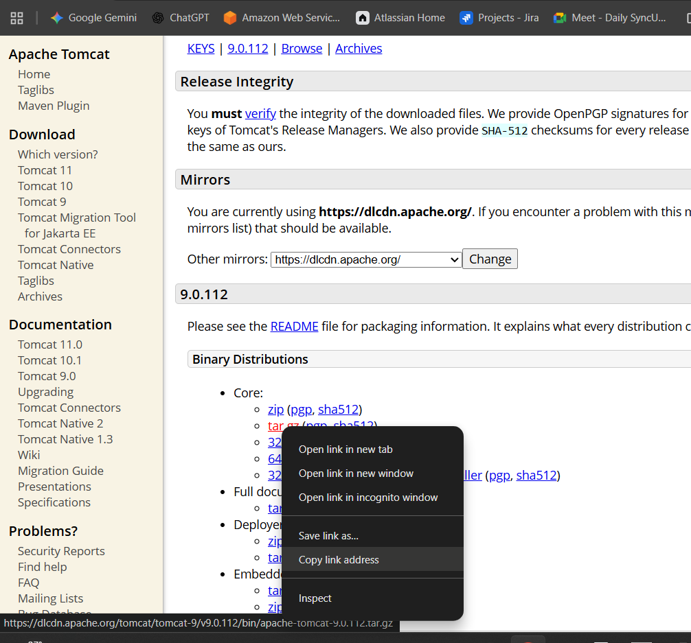
Step 5: Change the directory to cd /opt and perform the actions
Use command wget and copied link and execute
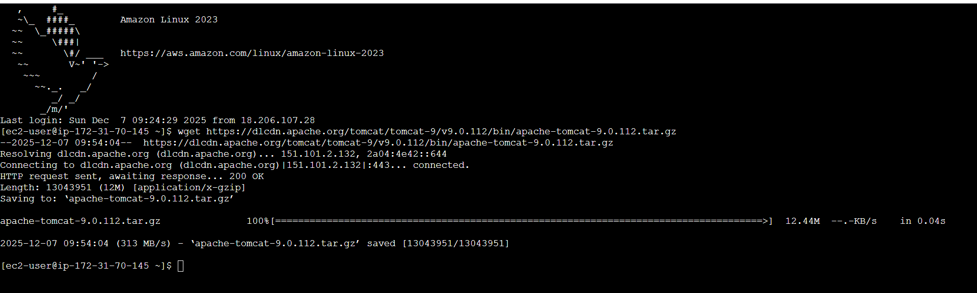
Step 6: Xtract the file using tar xvf command
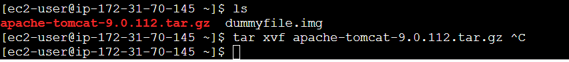
Step 7: Change the directory to apache.. and list the files
Step 8: Change the directory to bin and execute ./startup.sh to start the tomcat application
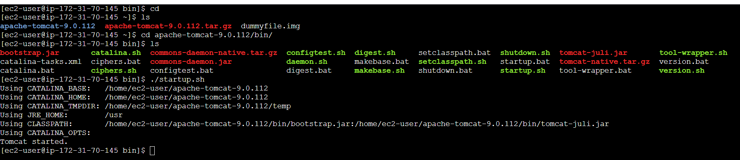
Step 9: Verifying in browser using publicip:8080 and it was running successfully
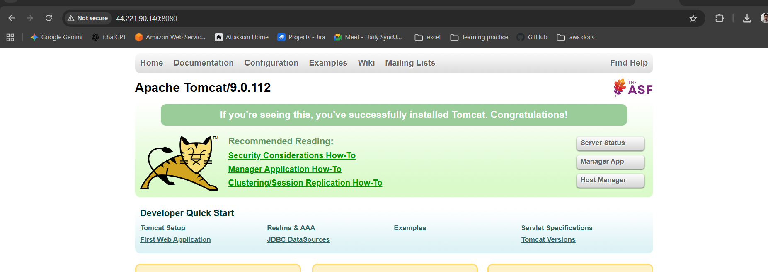
Step 10: Change the directory to root and create a script and insert the script change the region and version according to you
Script :
#!/bin/bash
# ===== Configuration =====
REGION="ap-south-1"
TOMCAT_PATH="/opt/apache-tomcat-9.0.65"
NAMESPACE="tomcat"
METRIC_NAME="tomcat_status"
# ========================

# Get Instance ID (Supports IMDSv2 and IMDSv1)
get_instance_id() {
TOKEN=$(curl -s -X PUT "http://169.254.169.254/latest/api/token" \
-H "X-aws-ec2-metadata-token-ttl-seconds: 21600")

if [ -n "$TOKEN" ]; then
INSTANCE_ID=$(curl -s -H "X-aws-ec2-metadata-token: $TOKEN" \
http://169.254.169.254/latest/meta-data/instance-id)
else
INSTANCE_ID=$(curl -s http://169.254.169.254/latest/meta-data/instance-id)
fi

echo "$INSTANCE_ID"
}

# Check if Tomcat process is running
check_tomcat_status() {
if pgrep -f "$TOMCAT_PATH" >/dev/null 2>&1; then
echo 1 # Running
else
echo 0 # Not Running
fi
}

# Main Logic
INSTANCE_ID=$(get_instance_id)
VALUE=$(check_tomcat_status)

# Push Metric to CloudWatch
/usr/bin/aws cloudwatch put-metric-data \
--region "$REGION" \
--namespace "$NAMESPACE" \
--metric-name "$METRIC_NAME" \
--value "$VALUE" \
--dimensions Name=InstanceId,Value="$INSTANCE_ID"
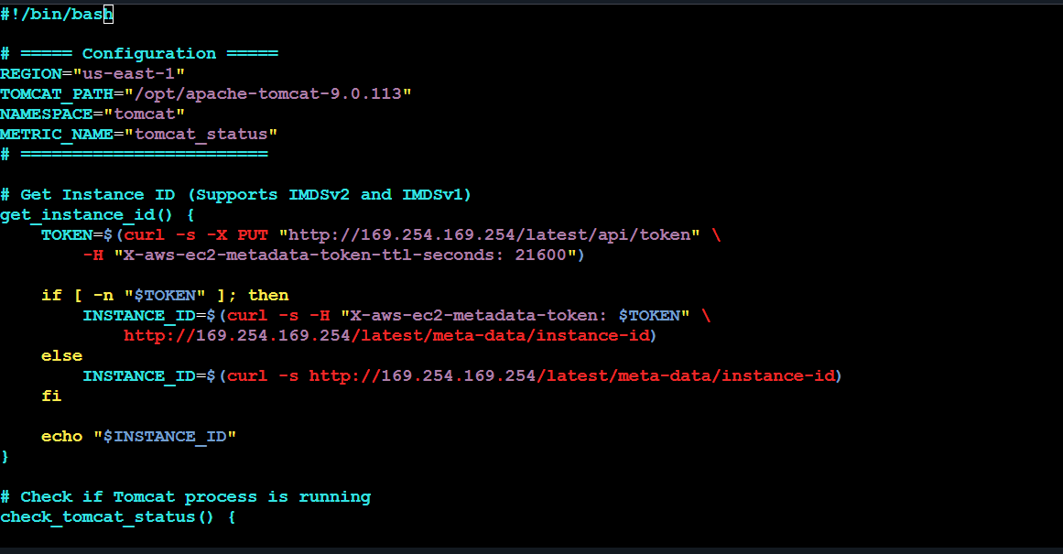
Step 11 : Change the file permission using chmod command and execute the script then I faced an error to configure the aws cli
I created the access key from console and configured aws cli and executed the script
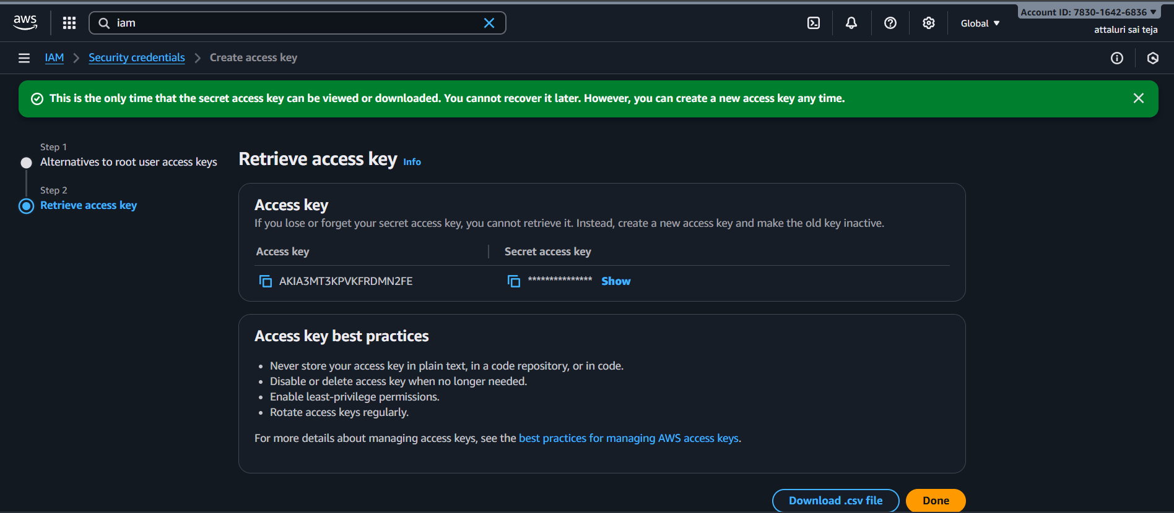

To enable cron jobs we need a package called crond
Using command yum install crond -y to install
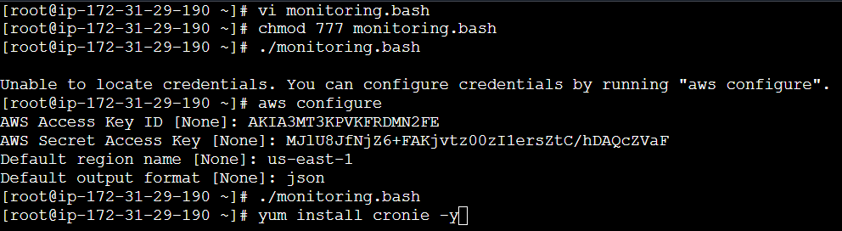
Cron job I used:
* * * * * /bin/bash /root/tomcatmonitor.bash >> /var/log/monitoring.log 2>&1
Step 12: Need to setup a role navigate to iam role and continue by providing name and entity type
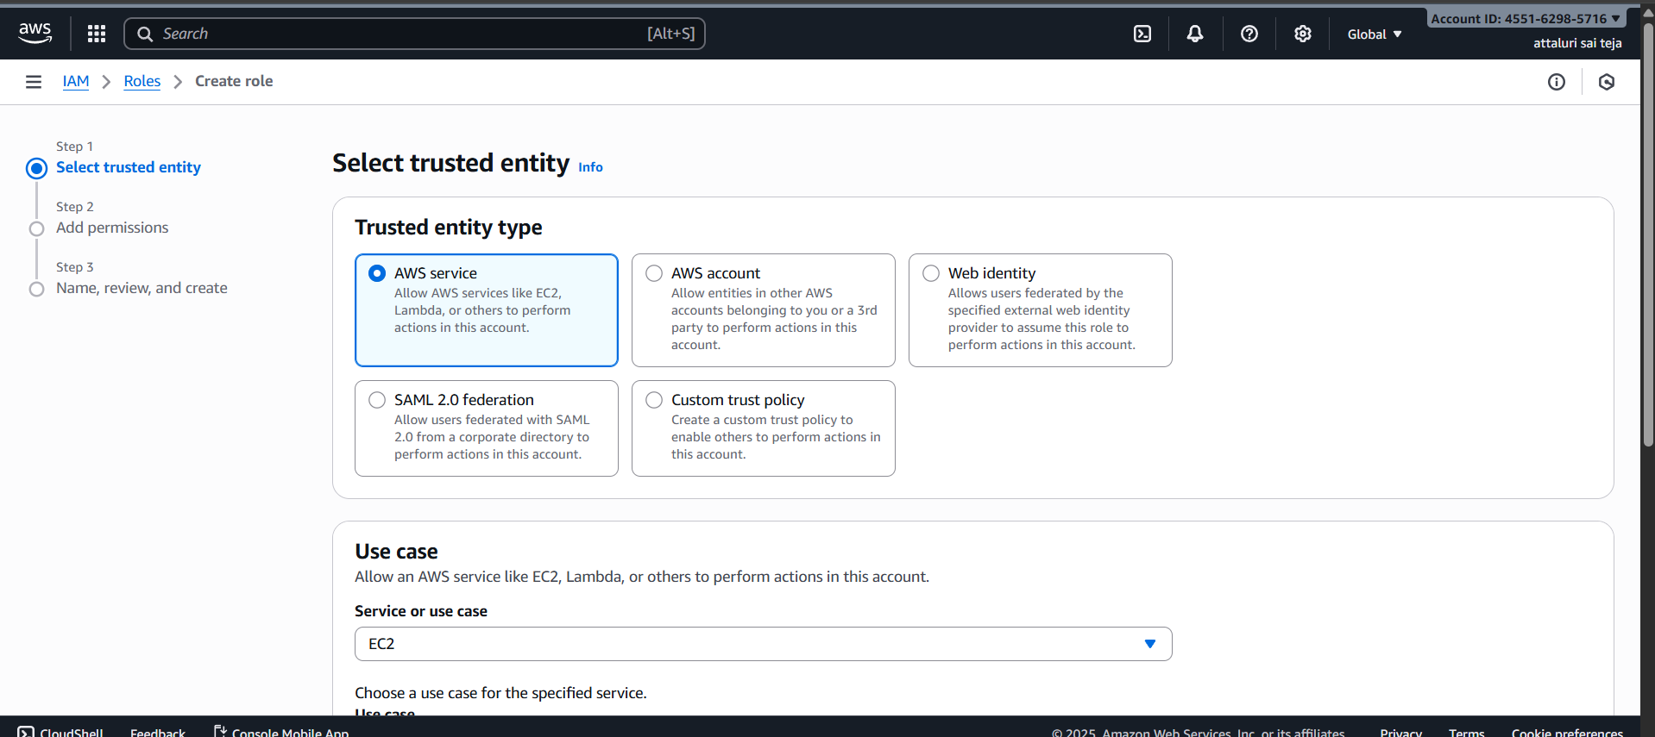
Step 13: Select use case and continue and select the required policies
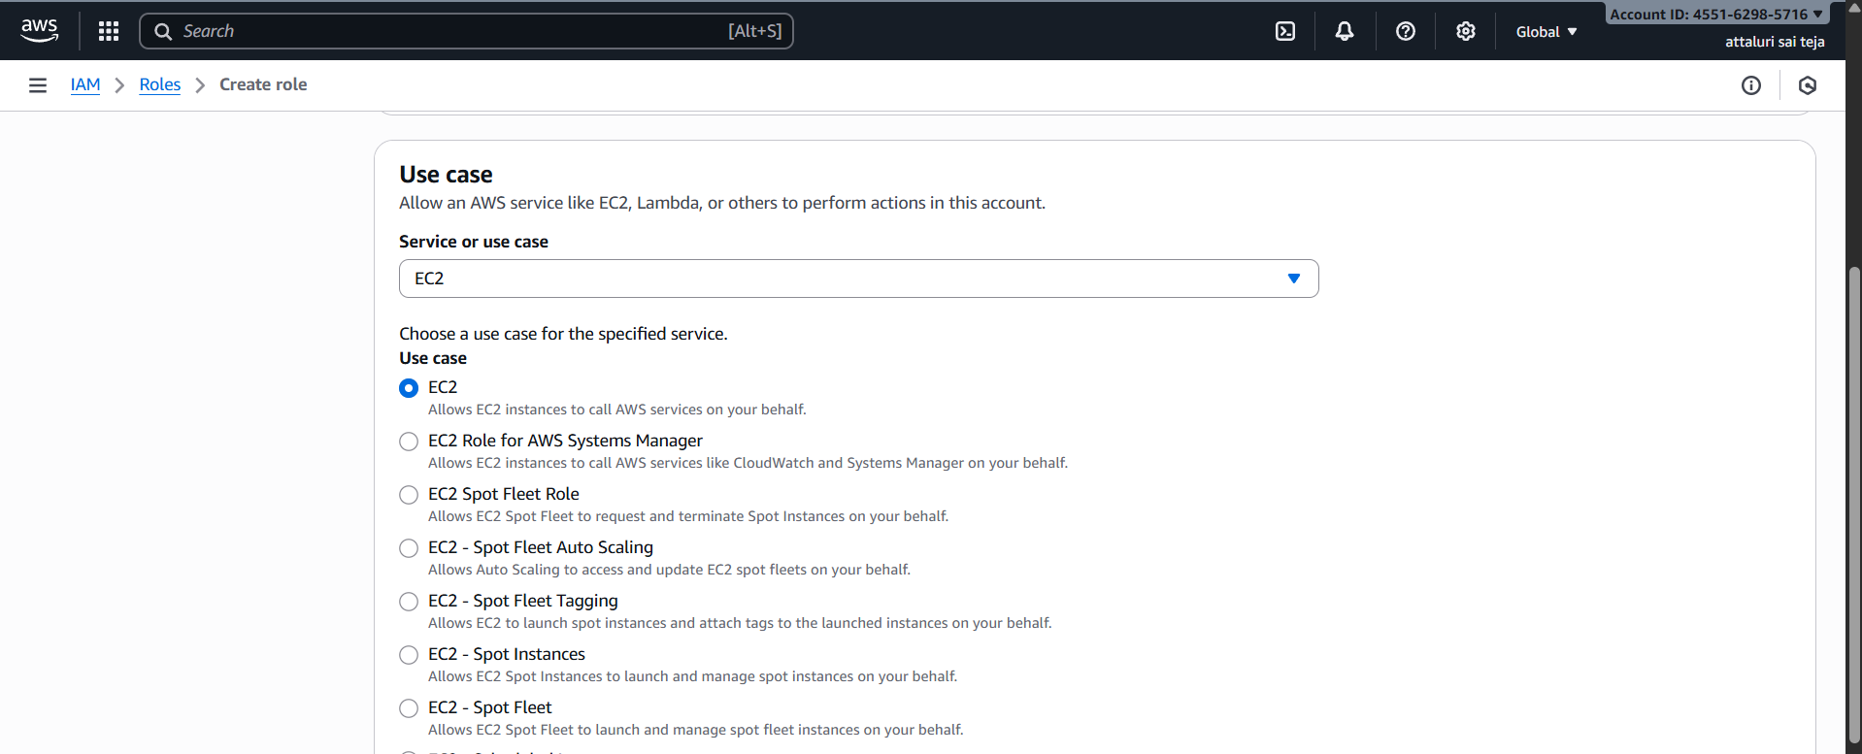
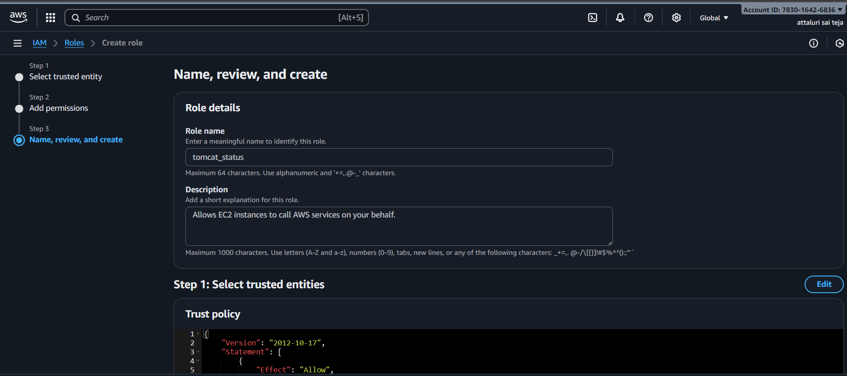
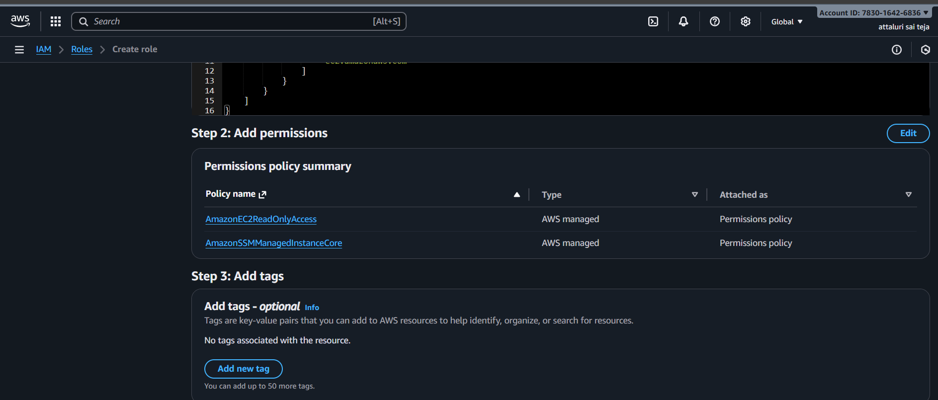
Role has created successfully
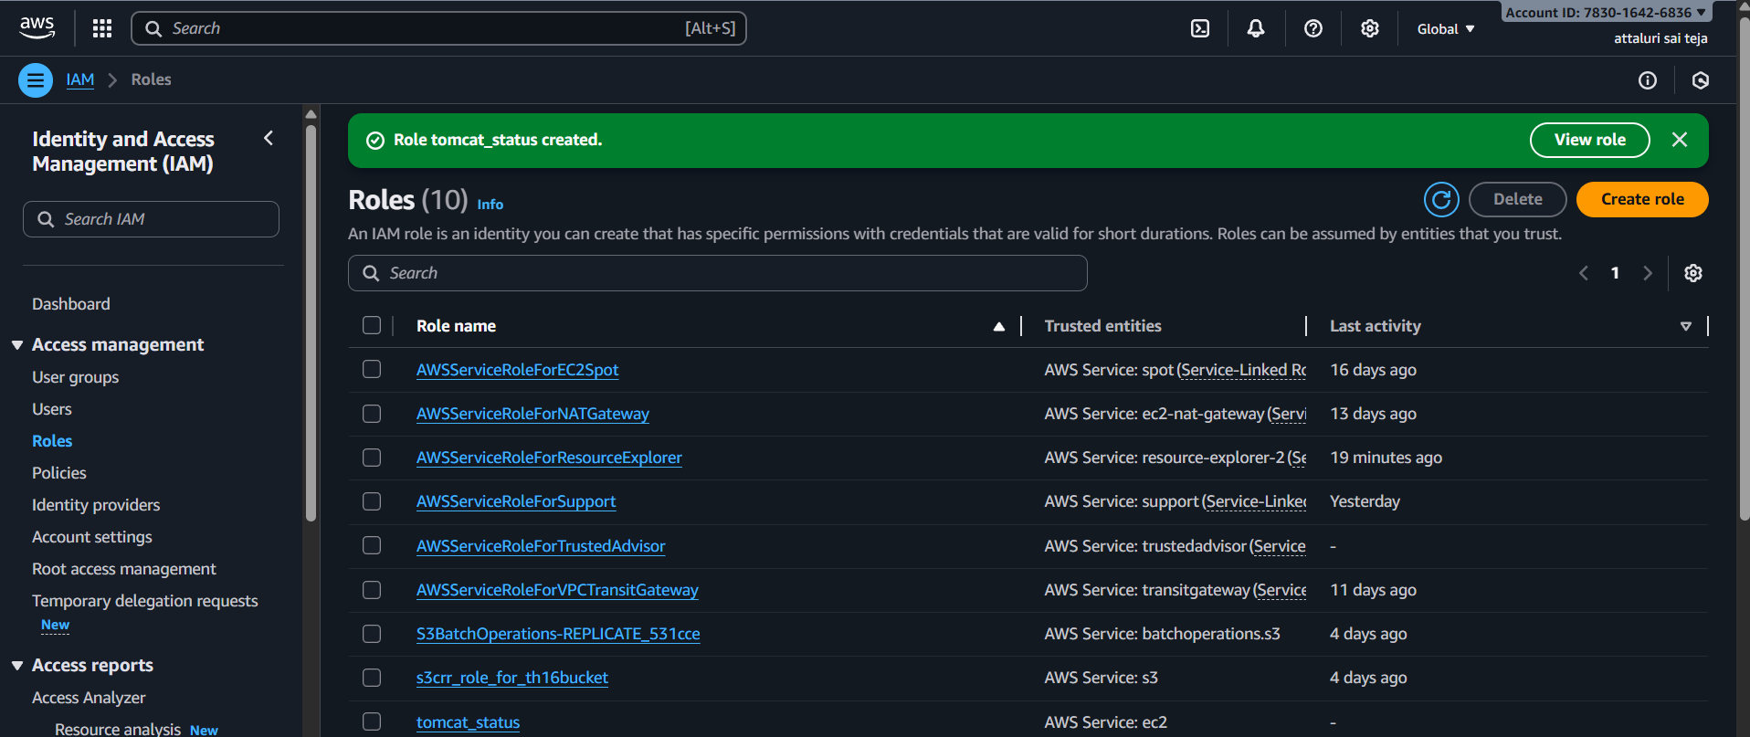

Step 14: Navigate to EC2 instance then click on actions tab and select modify IAM role and attach it
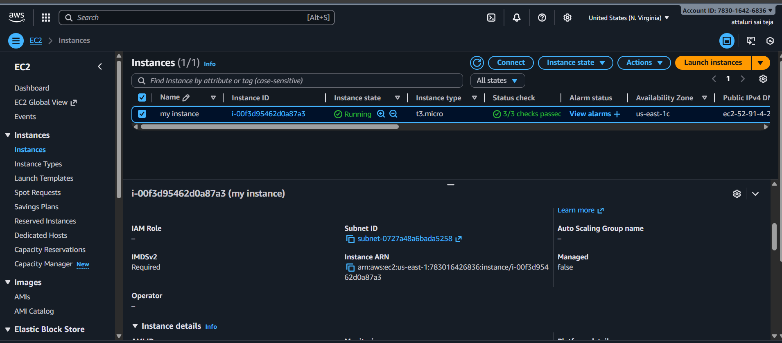
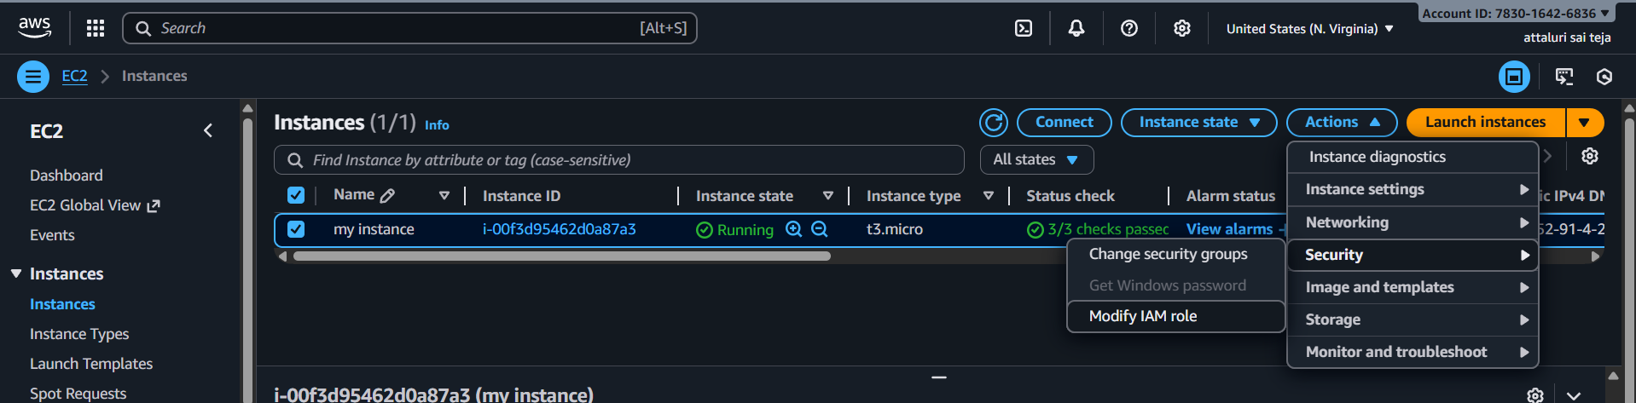
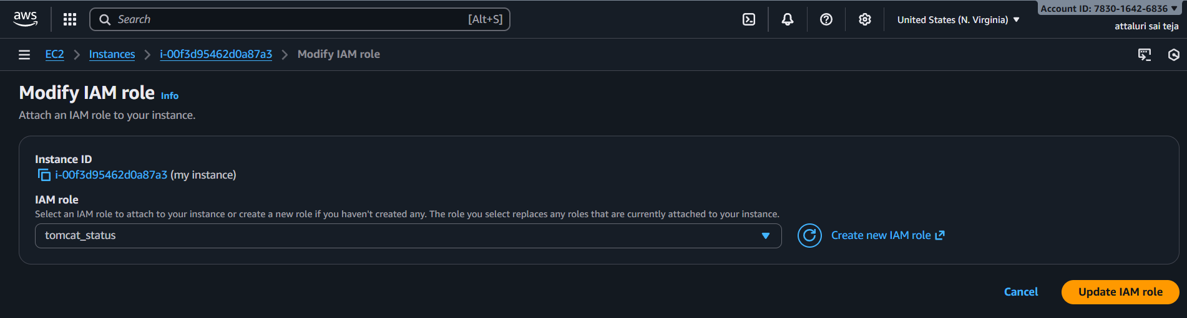
Successfully attached IAM role
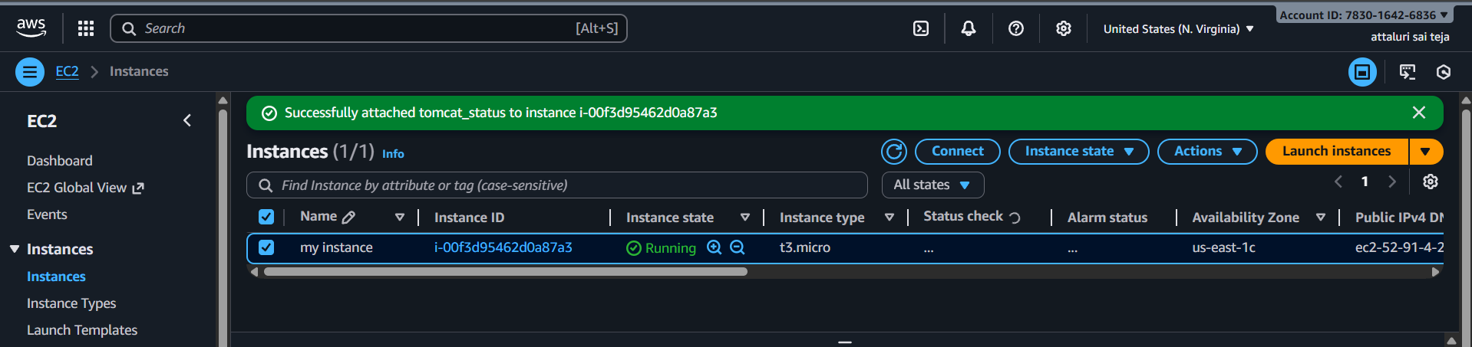

Step 15: Navigate to Cloudwatch resource and select dashboard and select tomcat and save
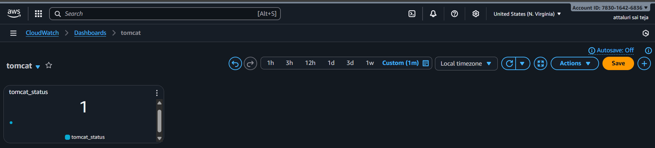
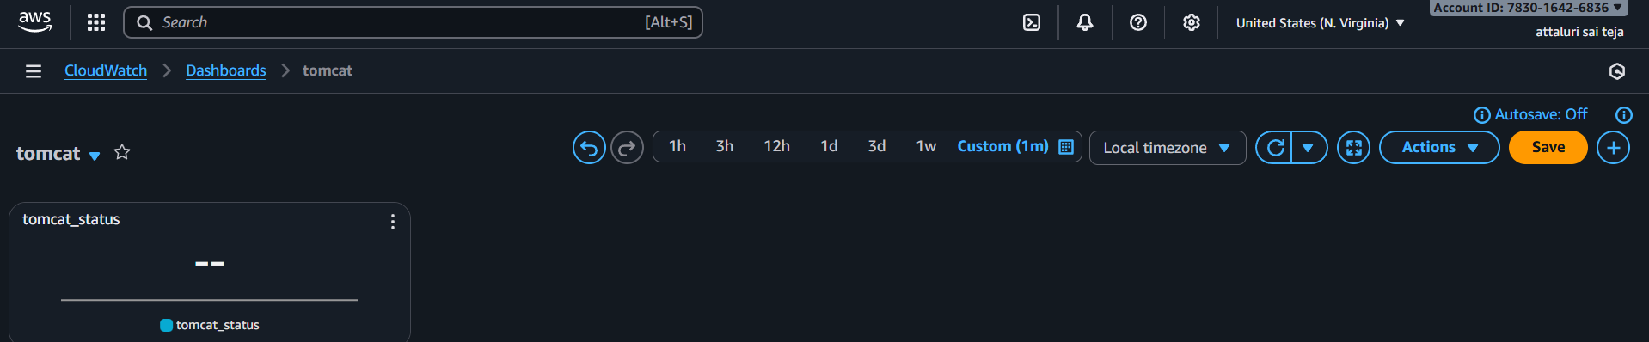
Step 16: Navigate to Metrics in cloudwatch and select tomcat and continue by creating an alarm
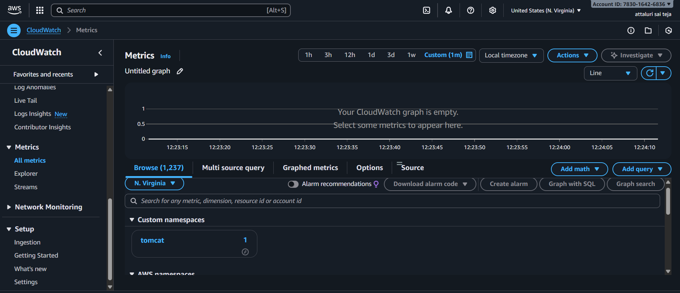

Navigate into alarm sections and select appropriate options and continue in my case 1== working::: 0== not working
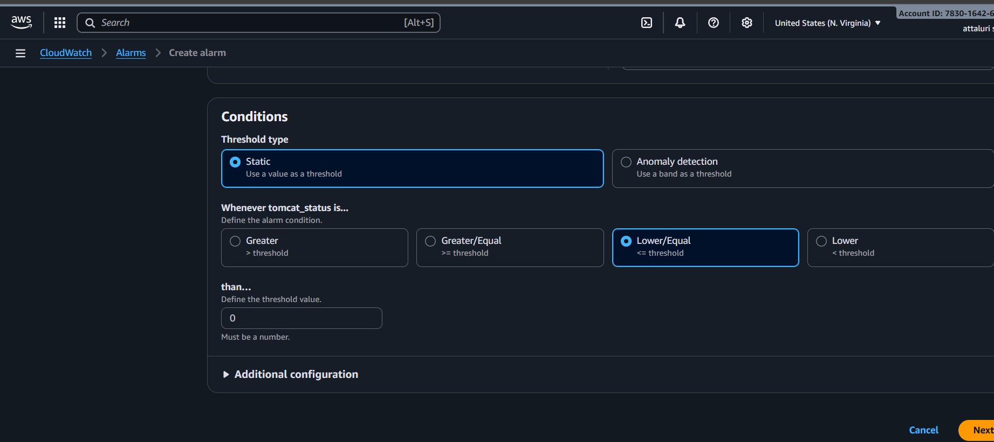
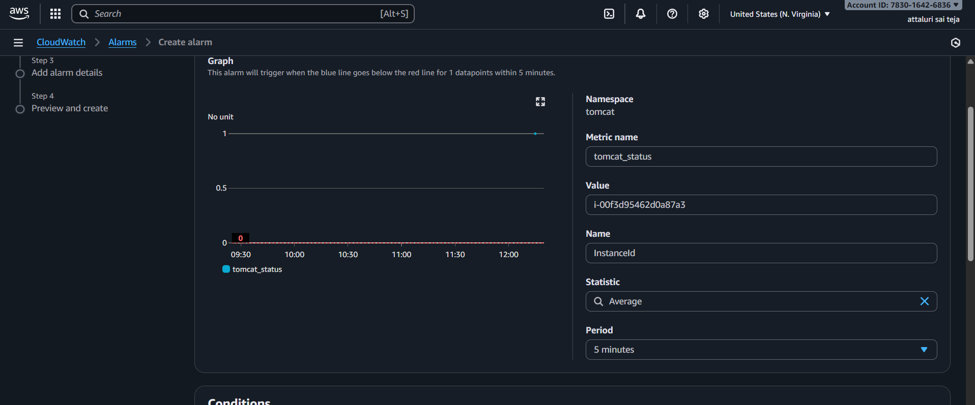
Select any existing SNS topic or create one
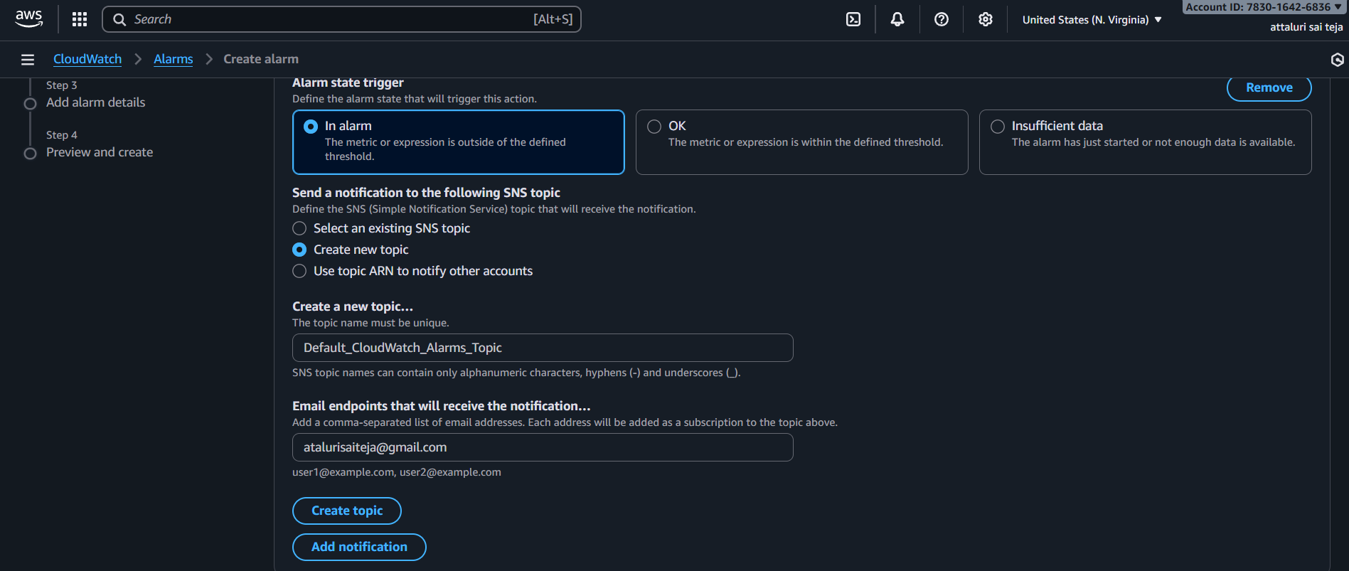
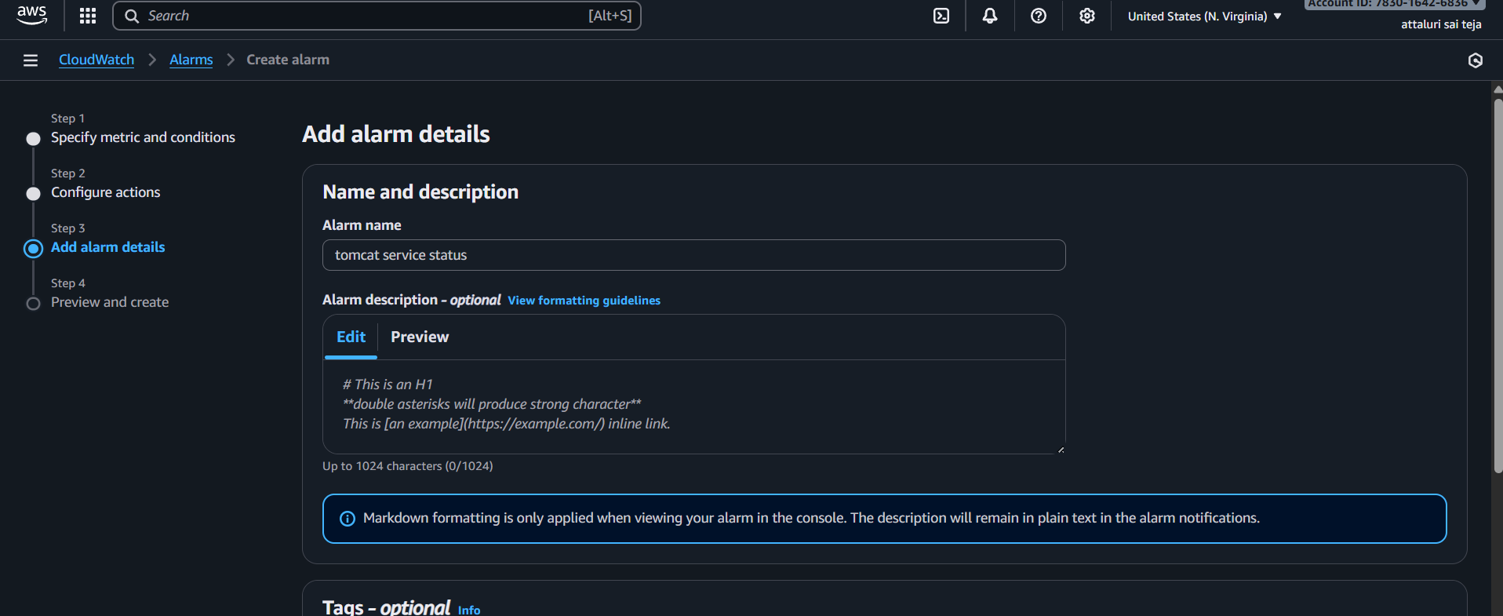
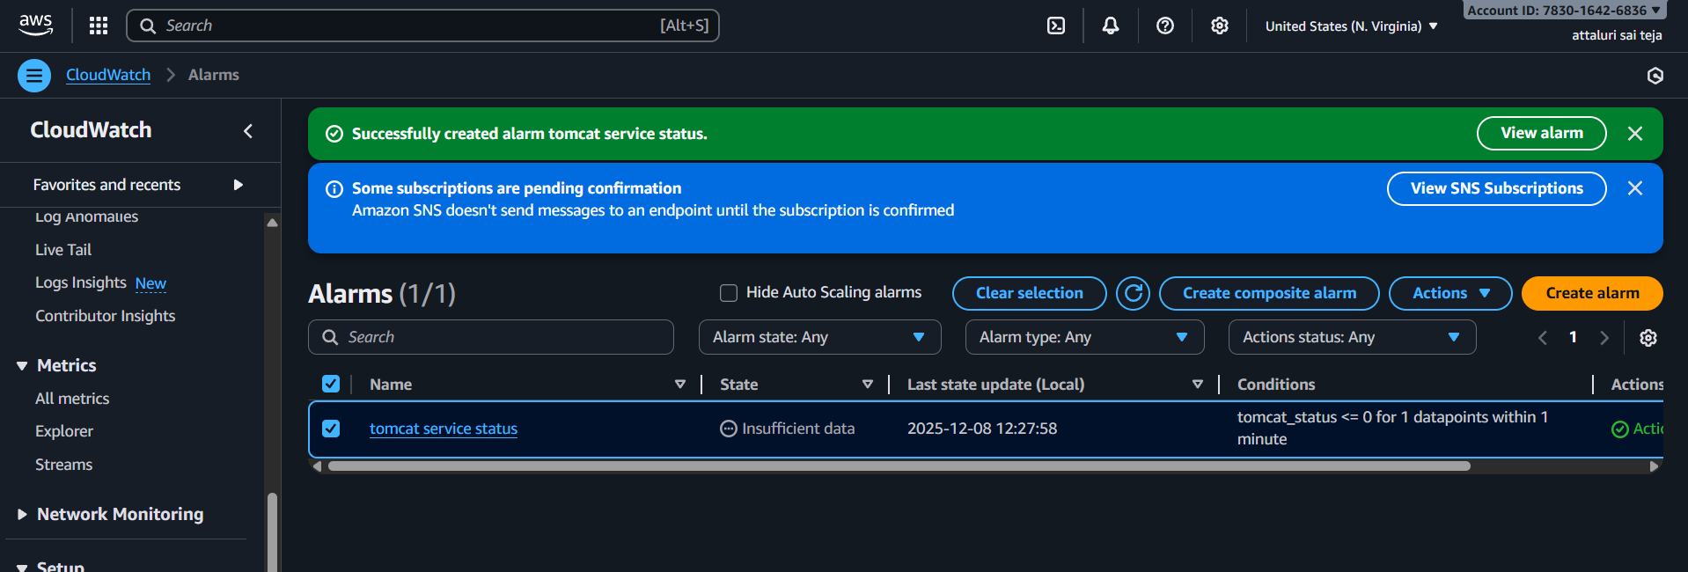
Navigate to email id and confirm the subscription
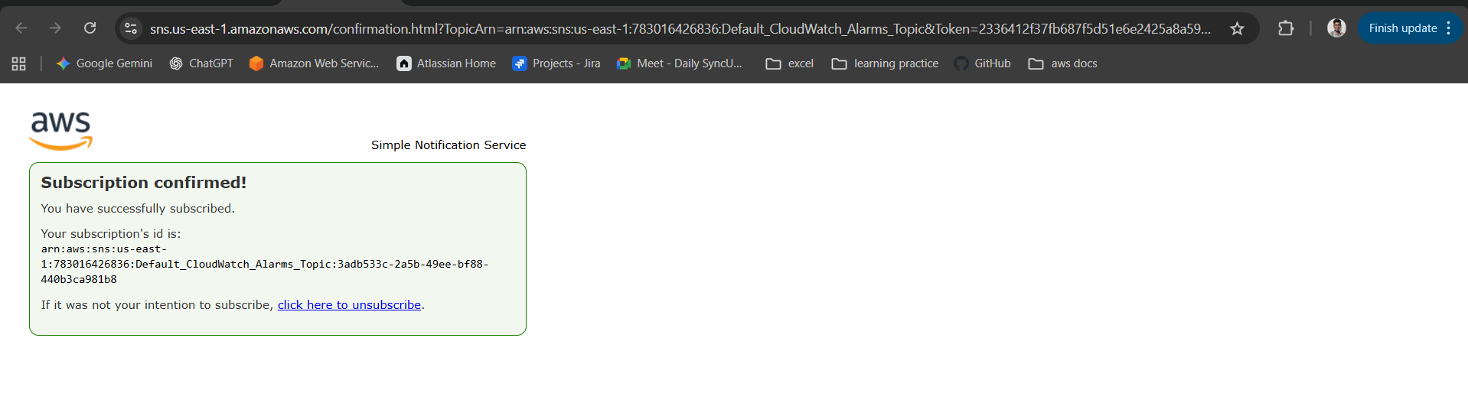
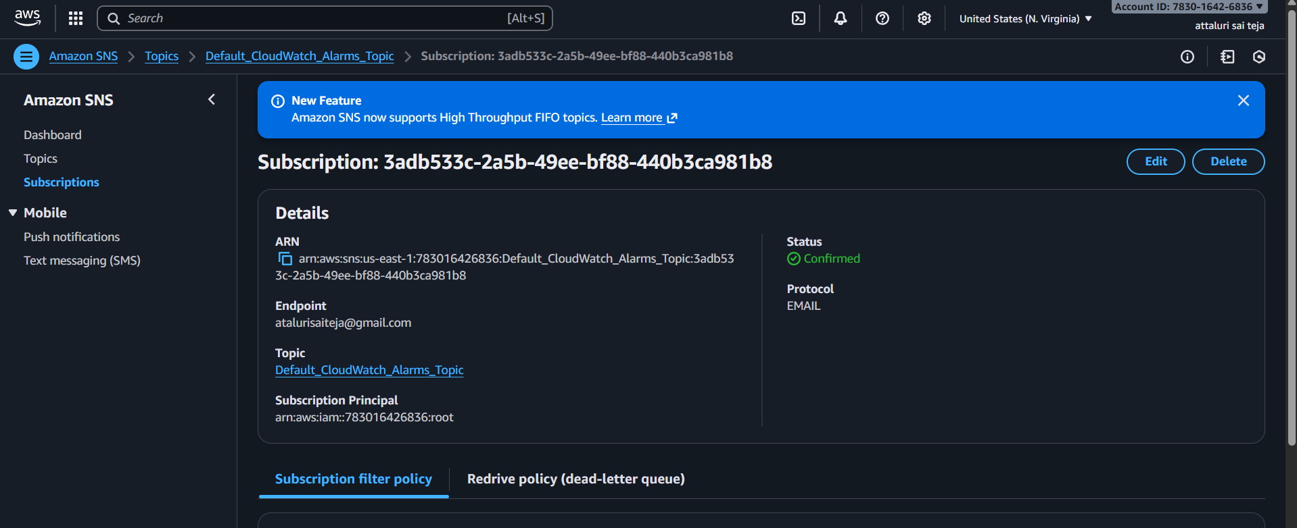
Validation part
Navigate to web browser and verified tomcat is working properly
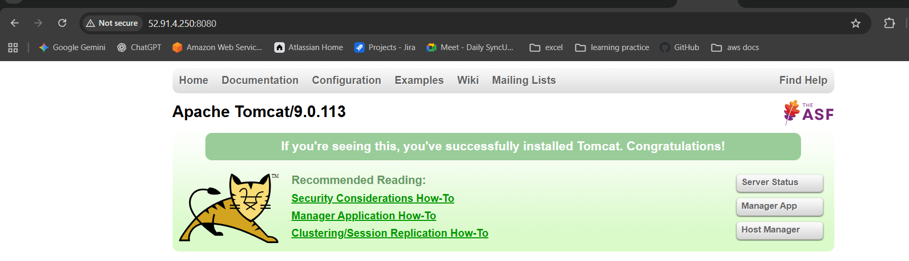
Navigate to cloud watch dashboard and see the status
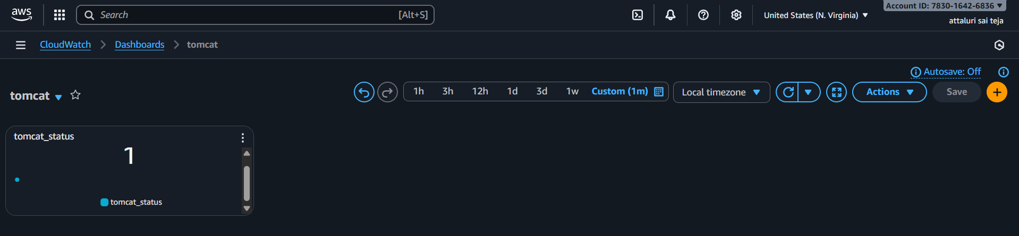
Stopping the tomcat service and again verify the status
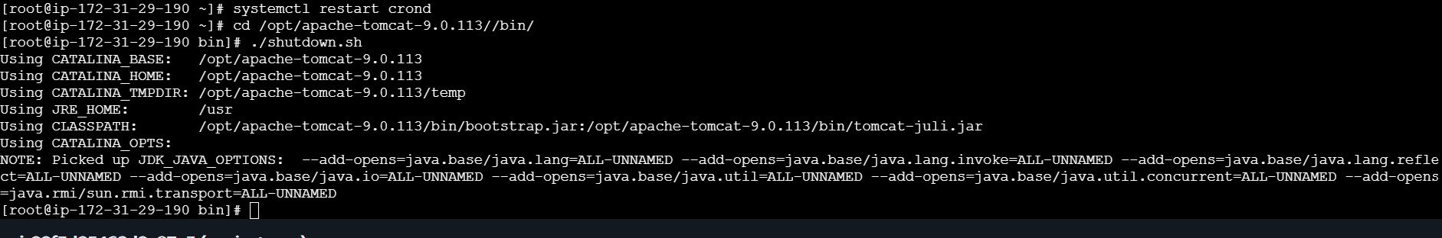
In webserver not working
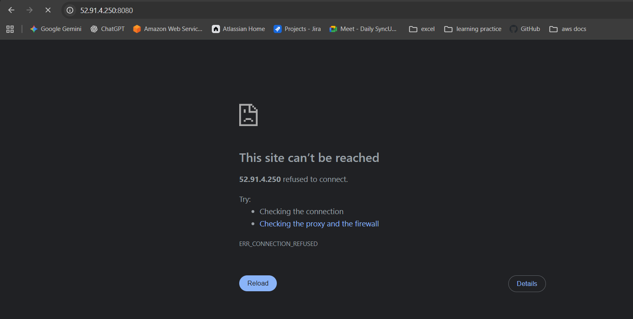
Checking in dashboard
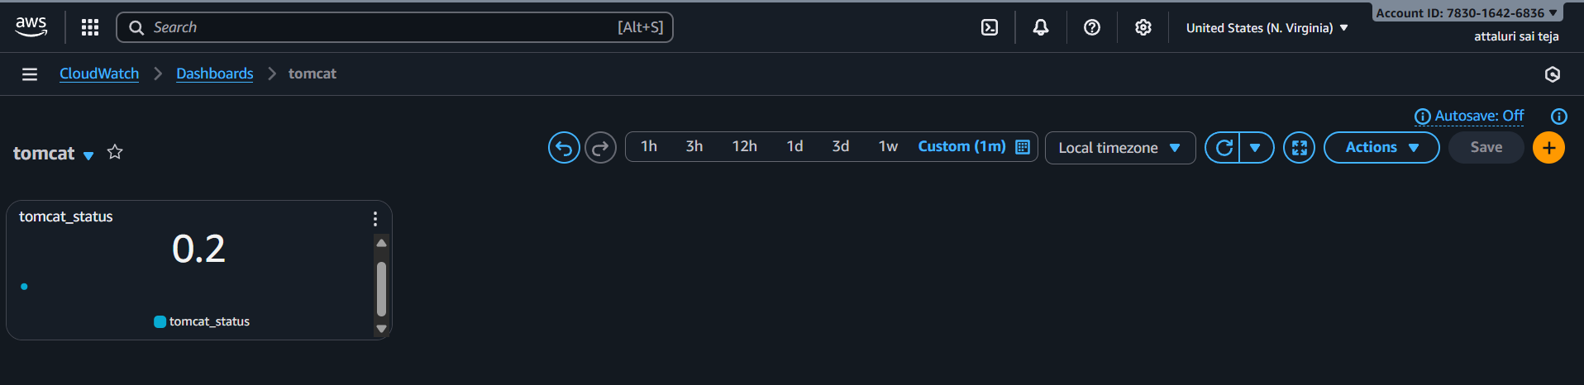
Email has been received
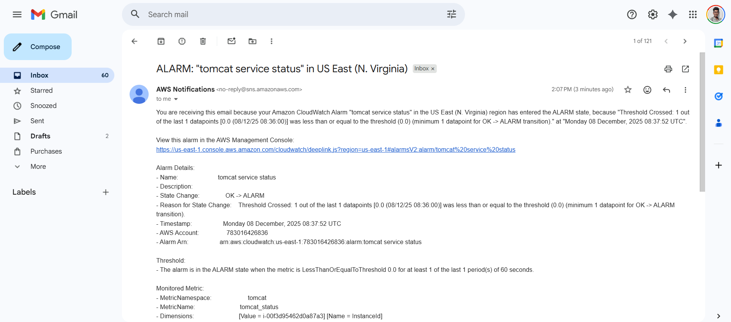

Issues Faced:
Faced a Latency in status of tomcat in dashboard
Errors :
While executing the script I faced an error
So that I updated the script and tried again and it got worked
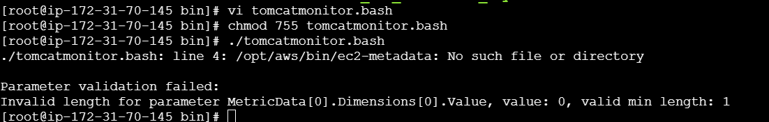

Title:
Create Dashboard and monitor nginx service to send the alert if nginx is not running.
Objective:
creating a monitoring dashboard that checks whether the Nginx service is running, and send alerts automatically if the service stops or fails.
Prerequisites:
- Nginx Package
- SNS
- CLOUDWATCH
- EMAIL
- ALARM
Step by Step Implementation:
Step 1: Login to EC2 Console and install Ngnix service
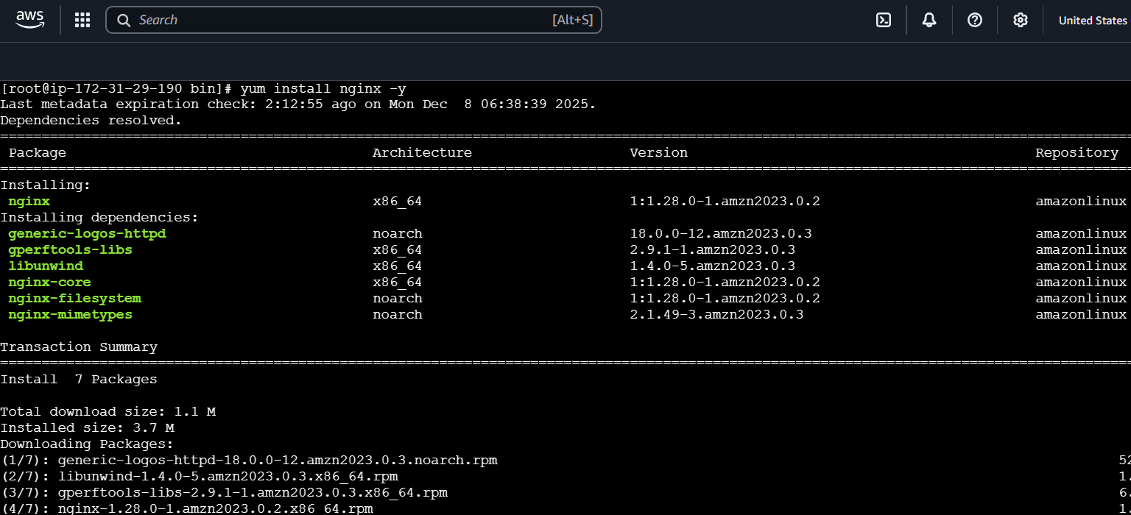
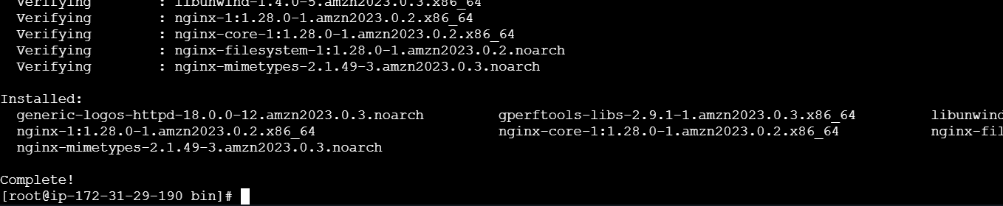
Step 2: Check the status of the service and if not running then start the service
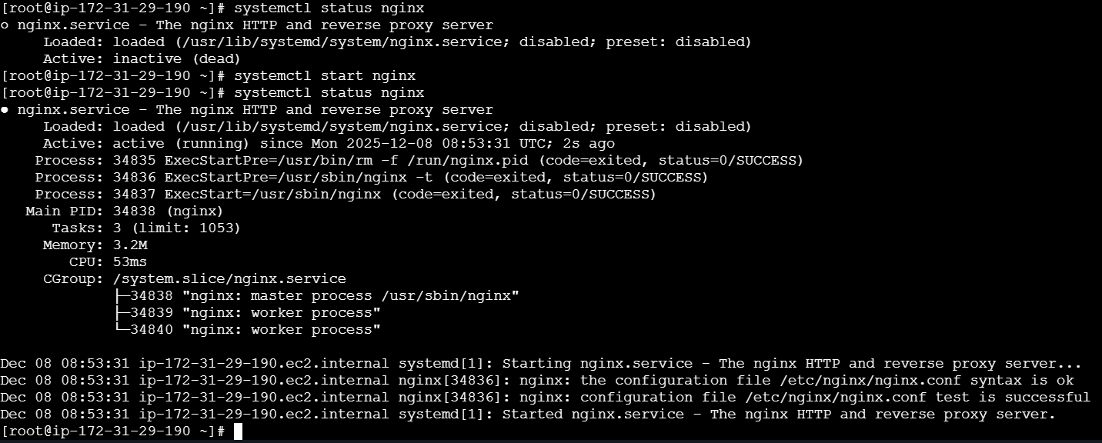
Step 3: Check in webserver by providing publicip:80
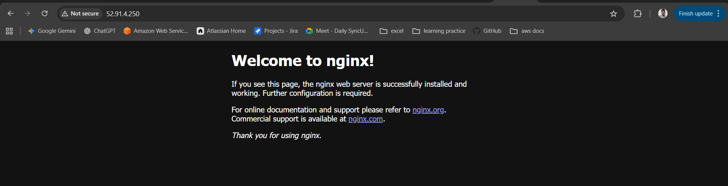
Step 4: Create a bash script and execute the script
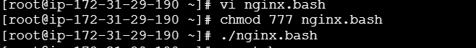

Script:
#!/bin/bash
# ===== Configuration =====
REGION="ap-south-1" # Change if needed
NAMESPACE="nginx" # CloudWatch namespace
METRIC_NAME="nginx_status" # Metric name
SERVICE_NAME="nginx" # systemd service name
AWS_CLI="/usr/bin/aws" # Path to aws CLI (check with `which aws`)
# =========================

# Get Instance ID (supports IMDSv2 and IMDSv1)
get_instance_id() {
TOKEN=$(curl -s -X PUT "http://169.254.169.254/latest/api/token" \
-H "X-aws-ec2-metadata-token-ttl-seconds: 21600")

if [ -n "$TOKEN" ]; then
INSTANCE_ID=$(curl -s -H "X-aws-ec2-metadata-token: $TOKEN" \
http://169.254.169.254/latest/meta-data/instance-id)
else
INSTANCE_ID=$(curl -s http://169.254.169.254/latest/meta-data/instance-id)
fi

echo "$INSTANCE_ID"
}

# Check if nginx service is running
check_nginx_status() {
if systemctl is-active --quiet "$SERVICE_NAME"; then
echo 1 # running
else
echo 0 # not running
fi
}

# -------- MAIN --------
INSTANCE_ID=$(get_instance_id)
VALUE=$(check_nginx_status)

# Push metric to CloudWatch
$AWS_CLI cloudwatch put-metric-data \
--region "$REGION" \
--namespace "$NAMESPACE" \
--metric-name "$METRIC_NAME" \
--value "$VALUE" \
--dimensions Name=InstanceId,Value="$INSTANCE_ID"
Step 5: Create a cron job for nginx service
Command to add crontab -e and save it
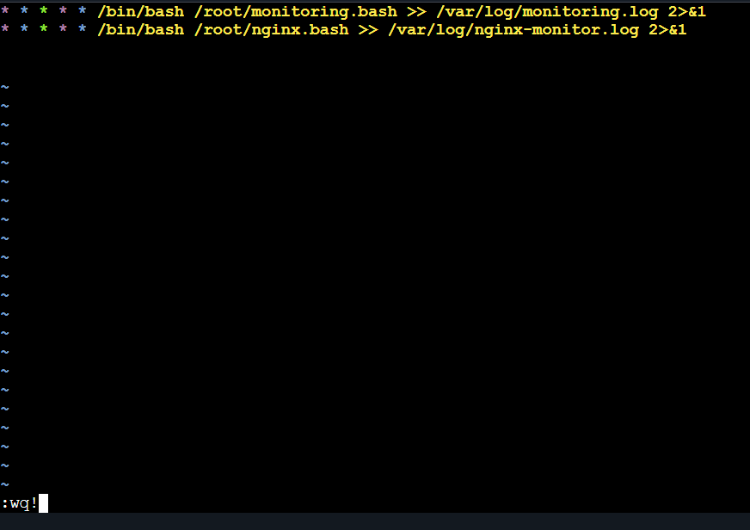
Step 6: Navigate to Cloudwatch and create a dashboard for nginx
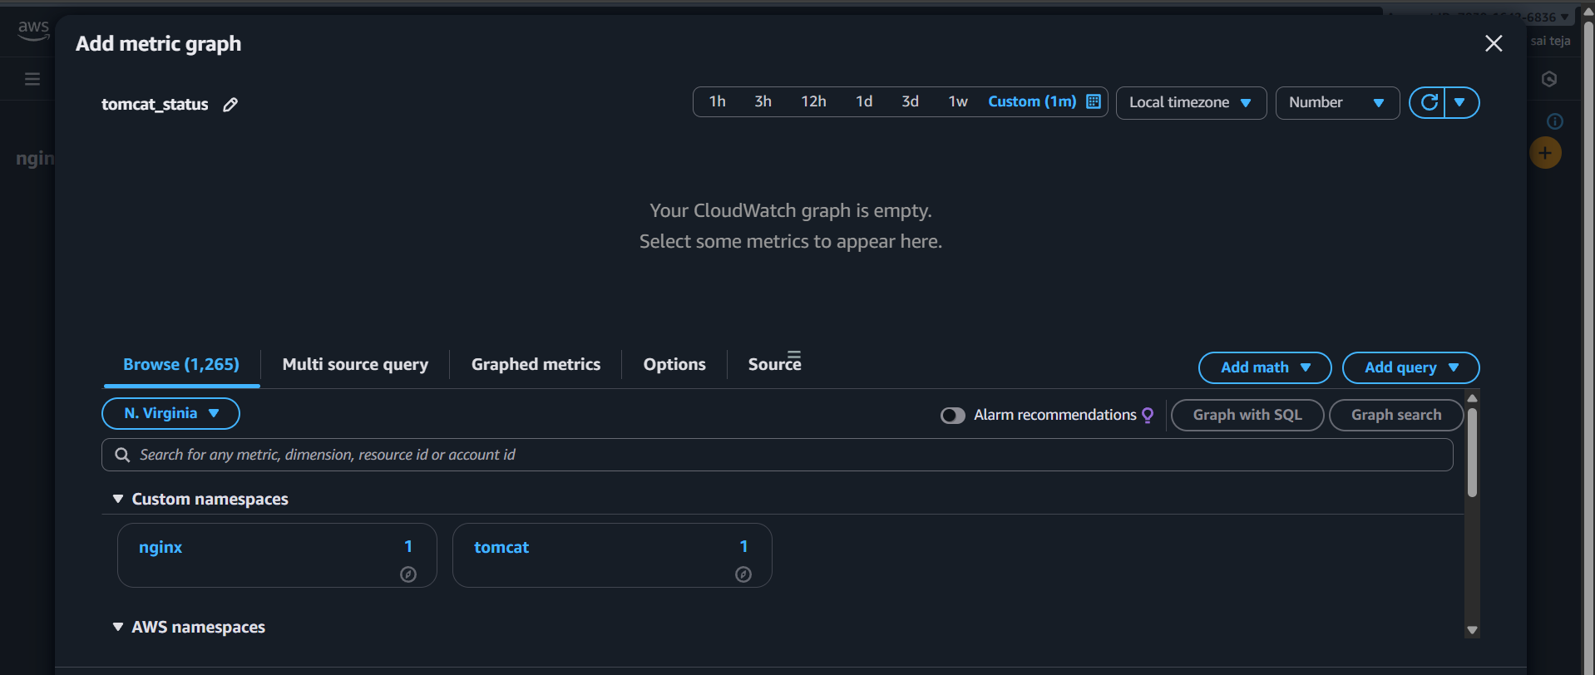
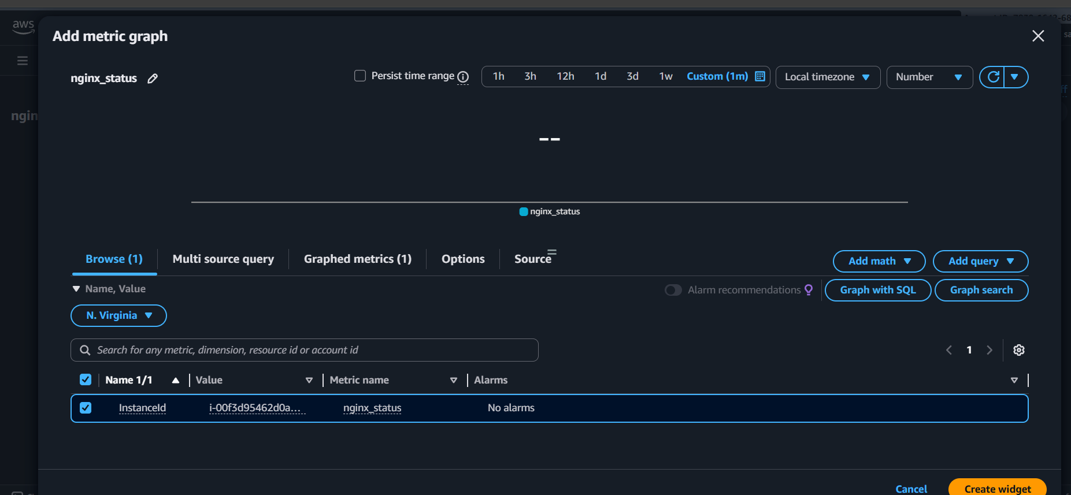
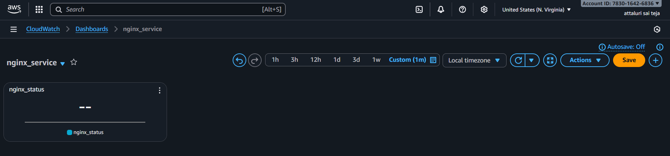
After some time around 5min it will show the status
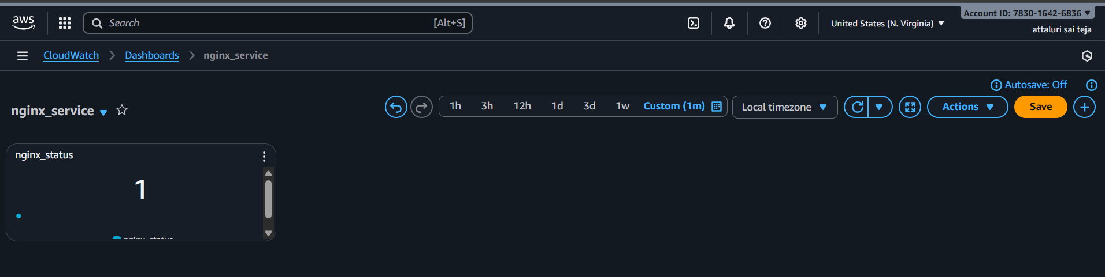
Step 7: Navigate to cloud watch metrics and create a alarm for nginx
Same process as done in tomcat
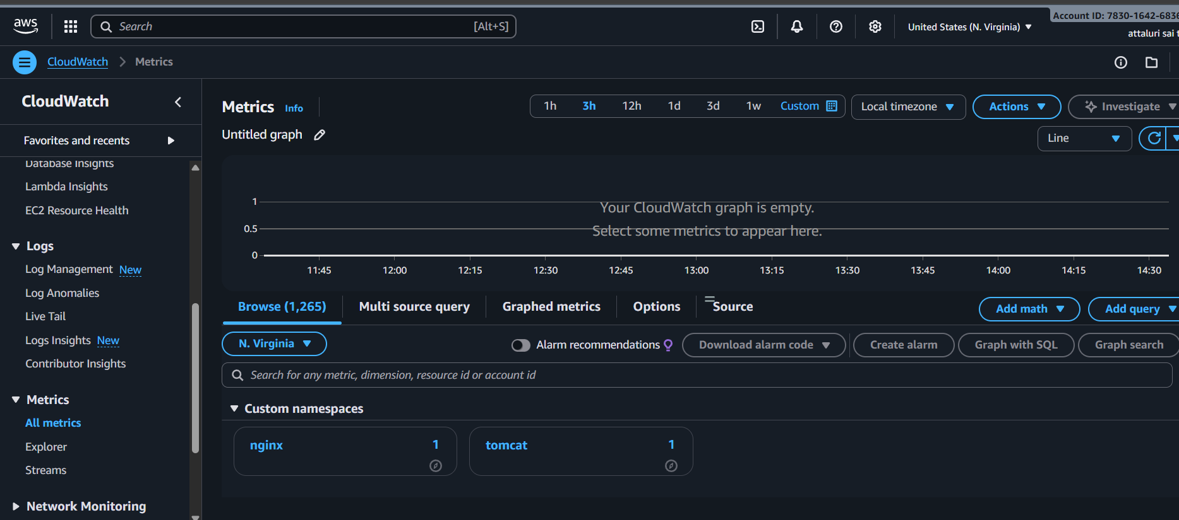
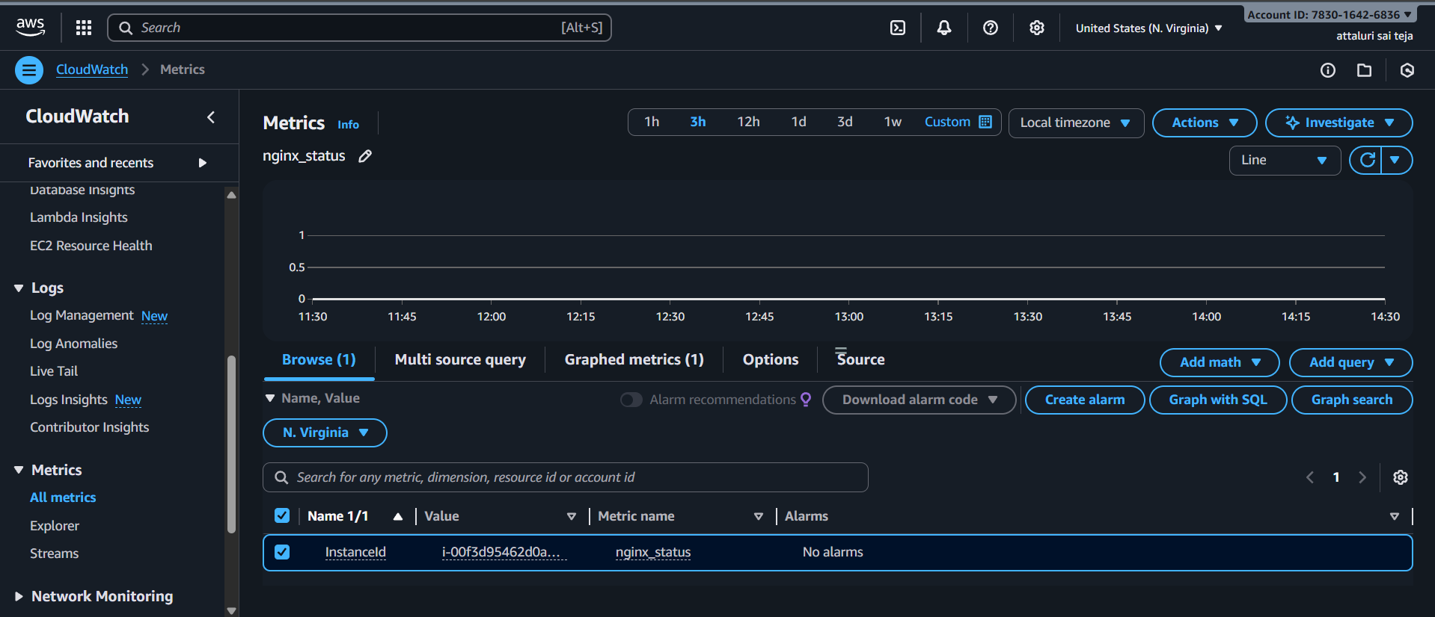
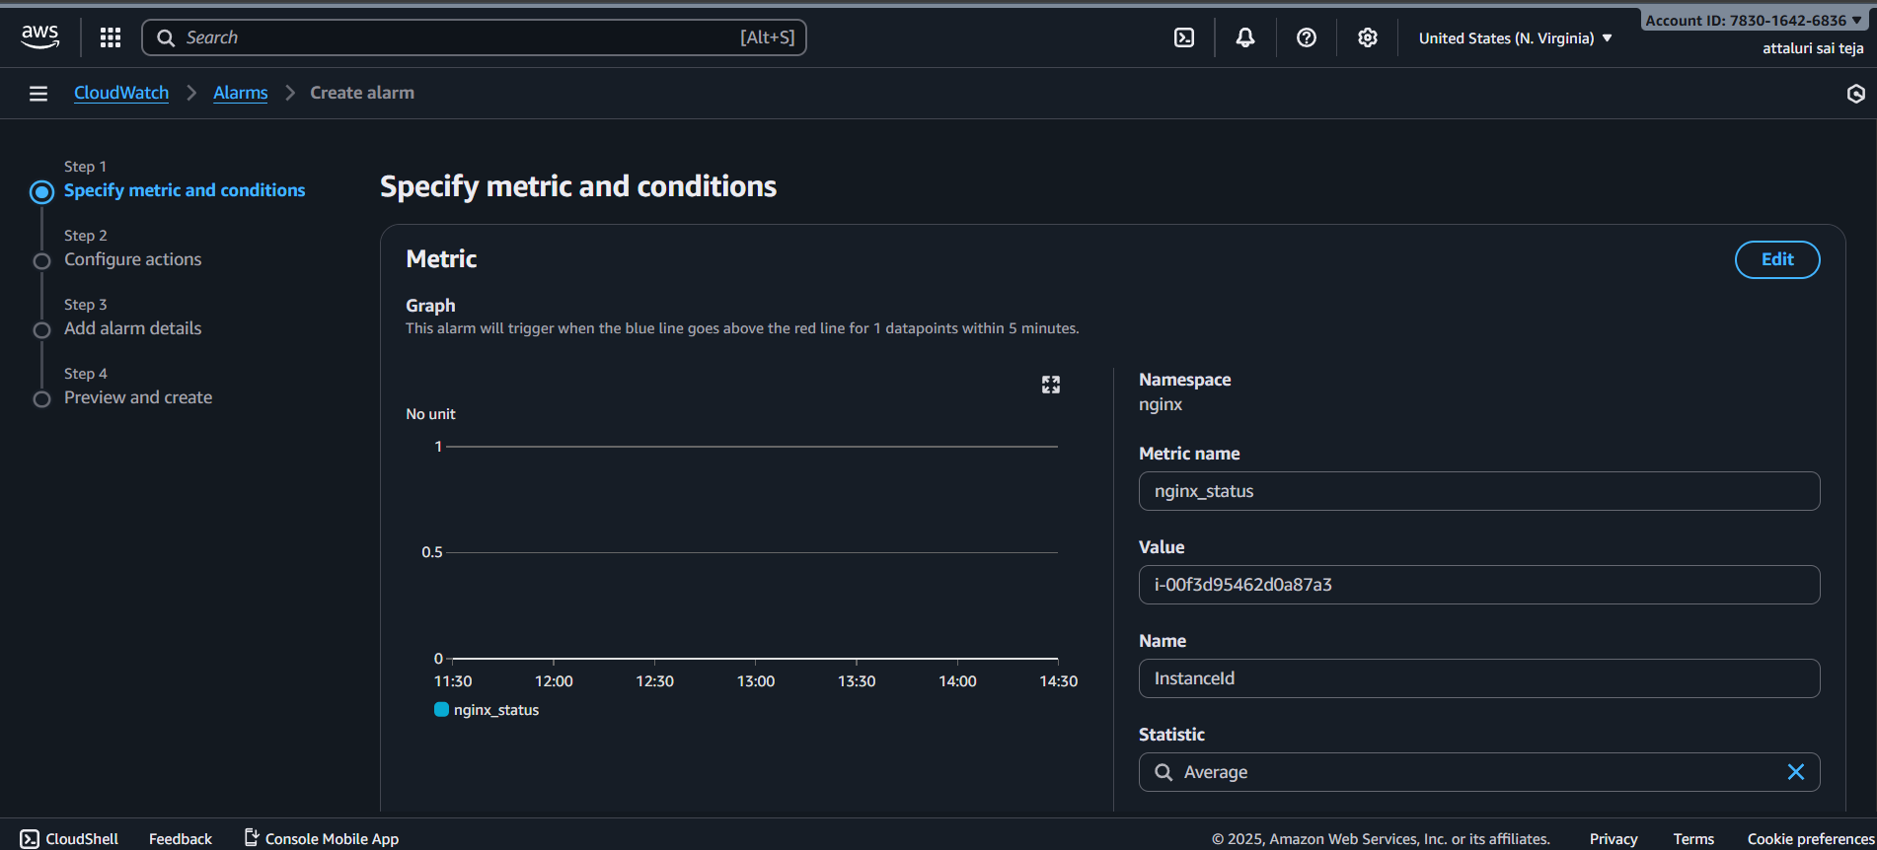
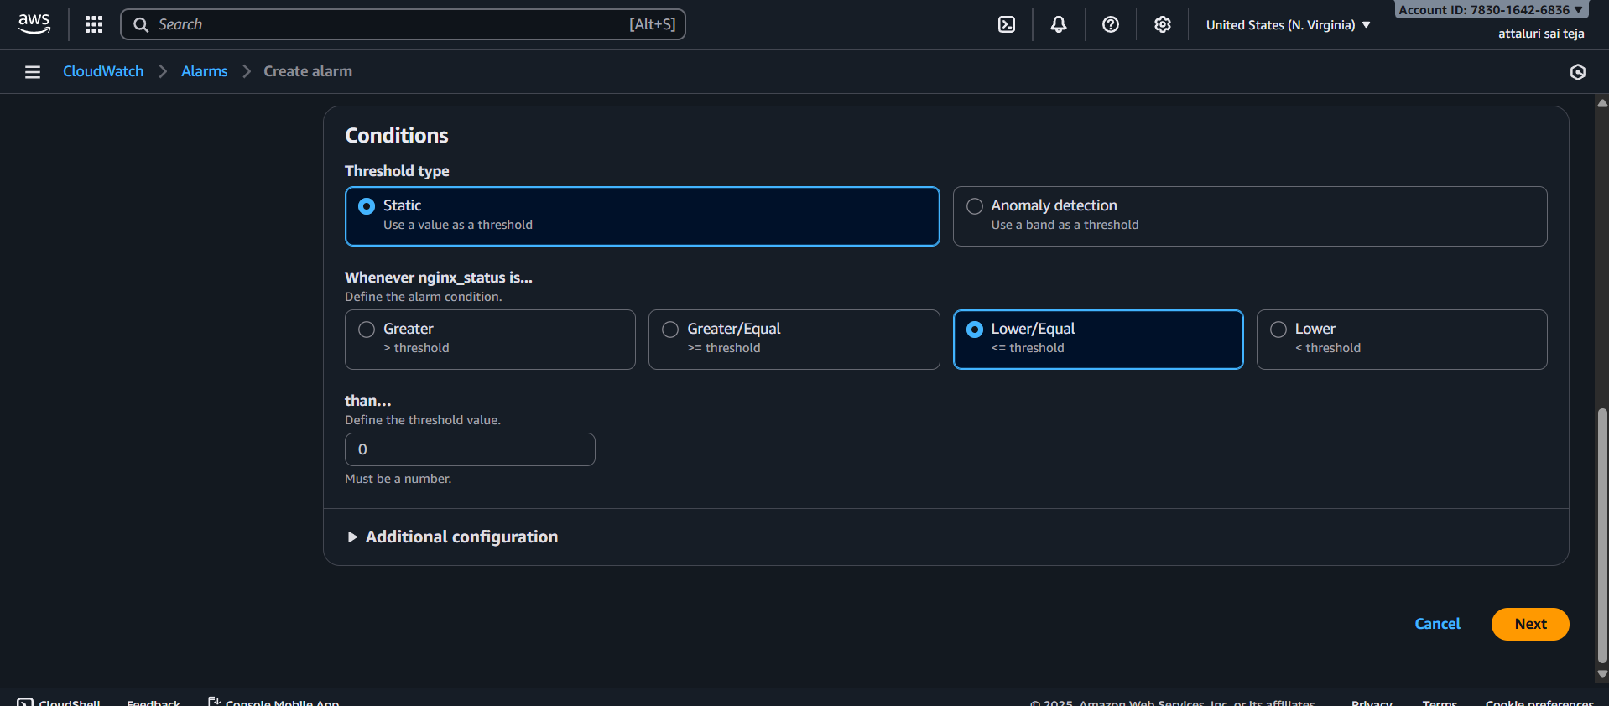
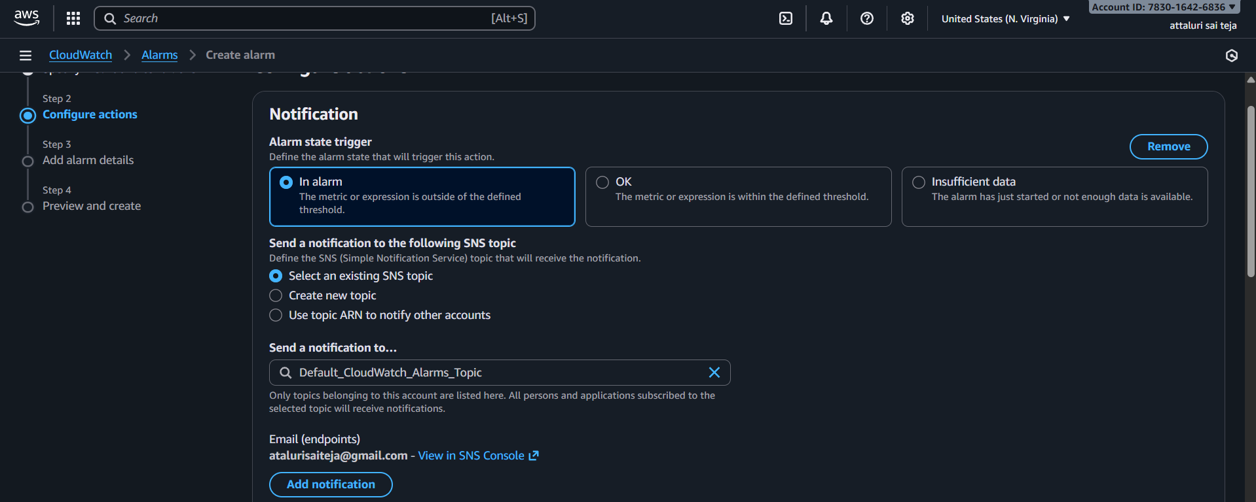
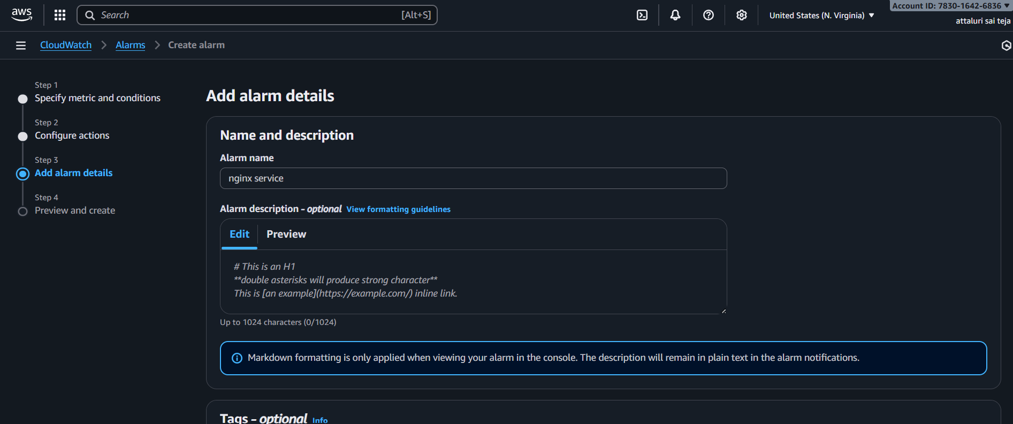
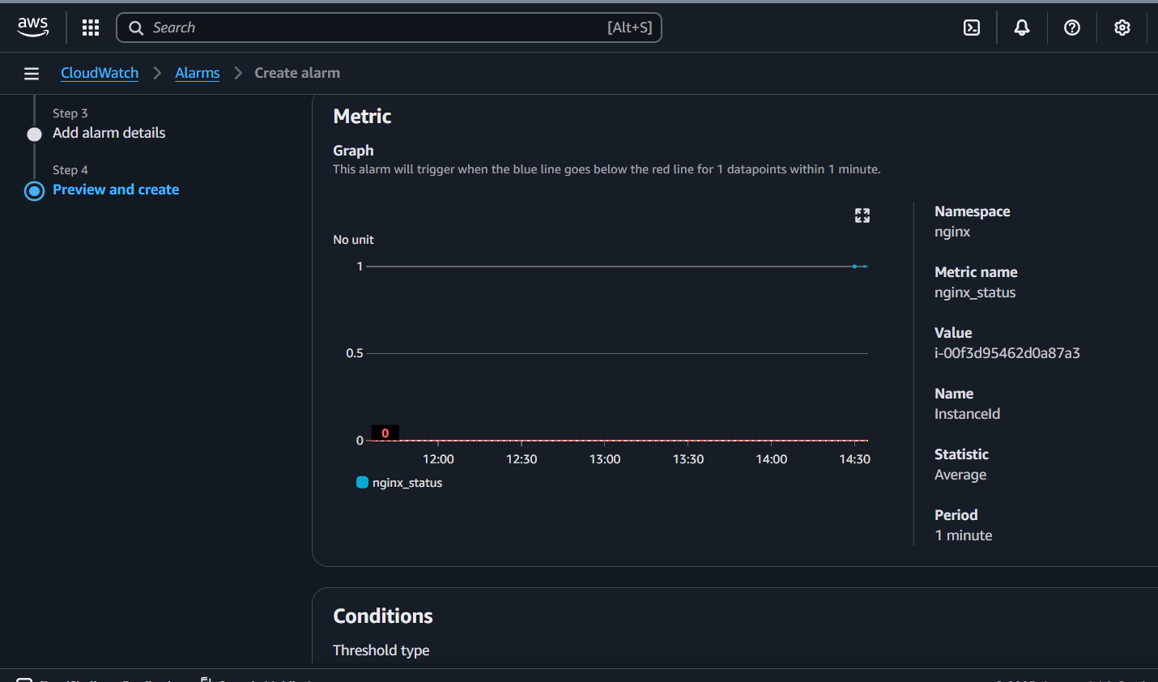
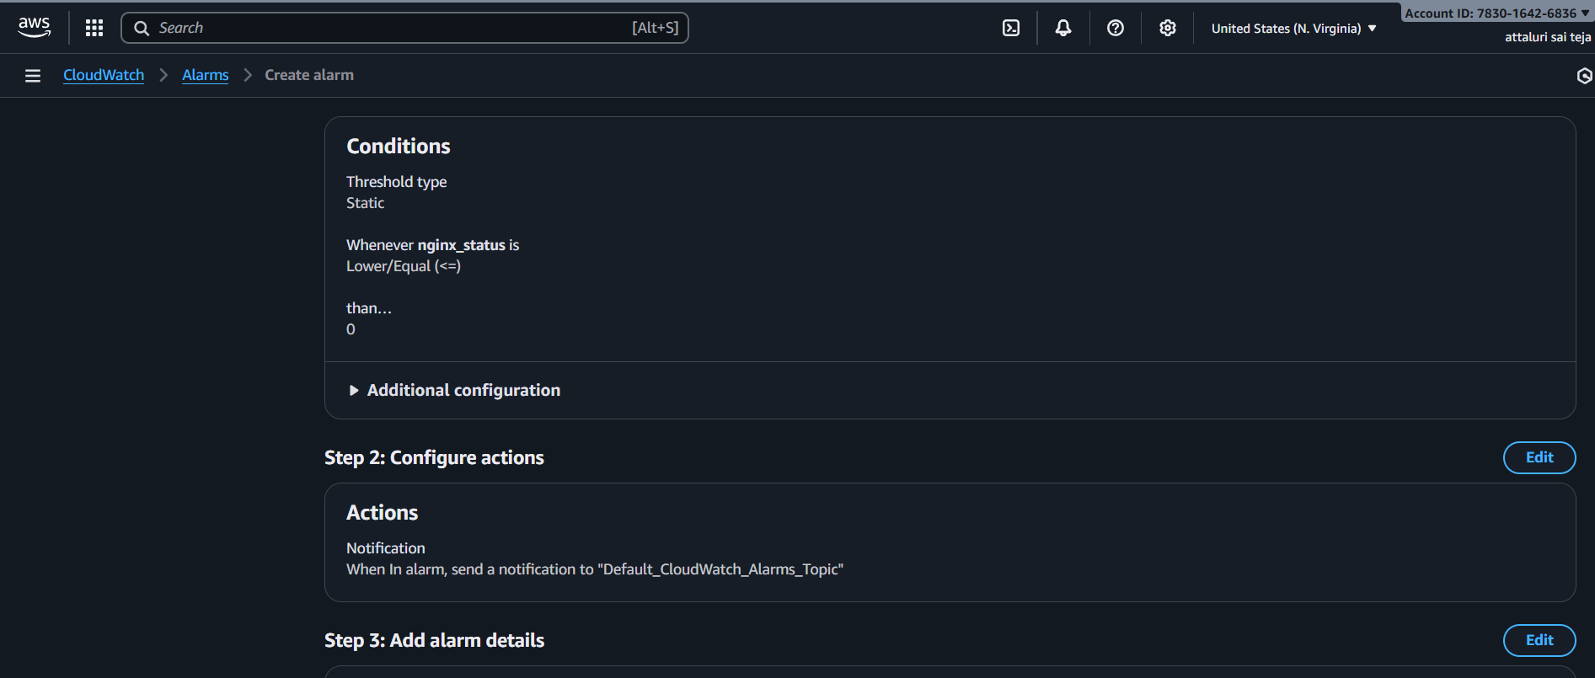
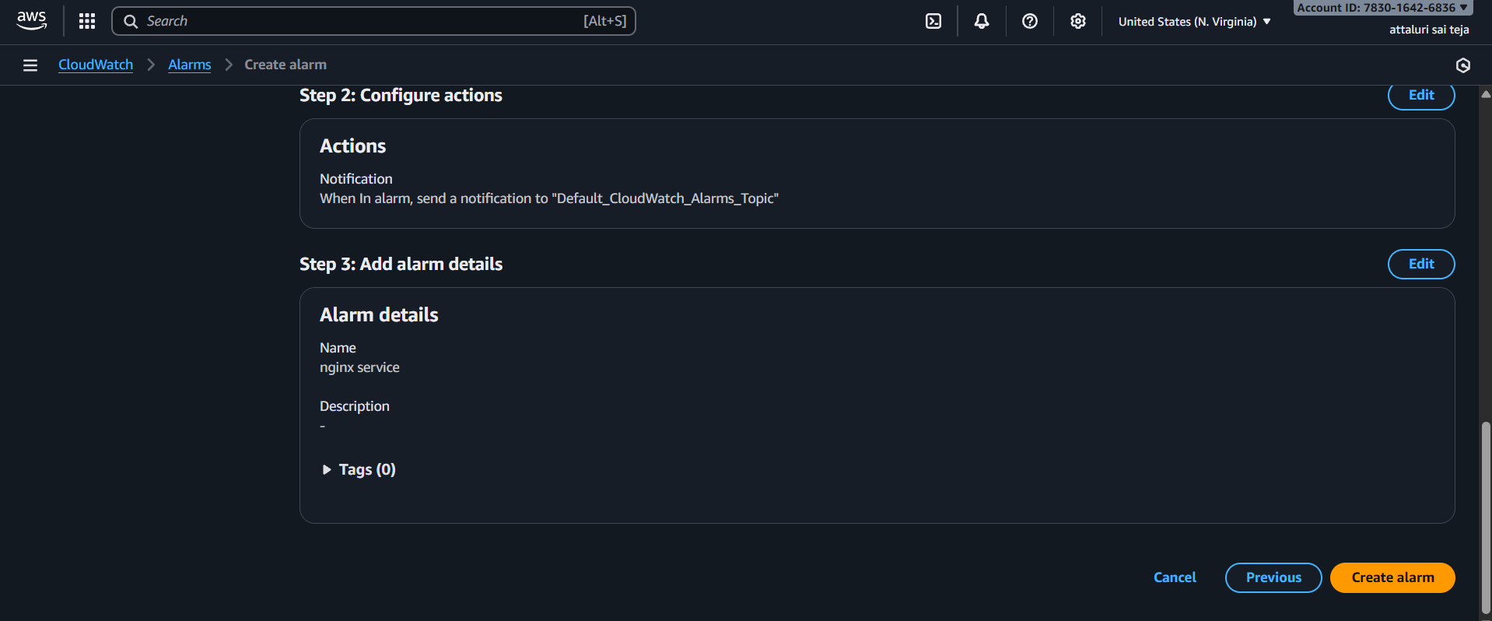
Alarm setup has been successfully created
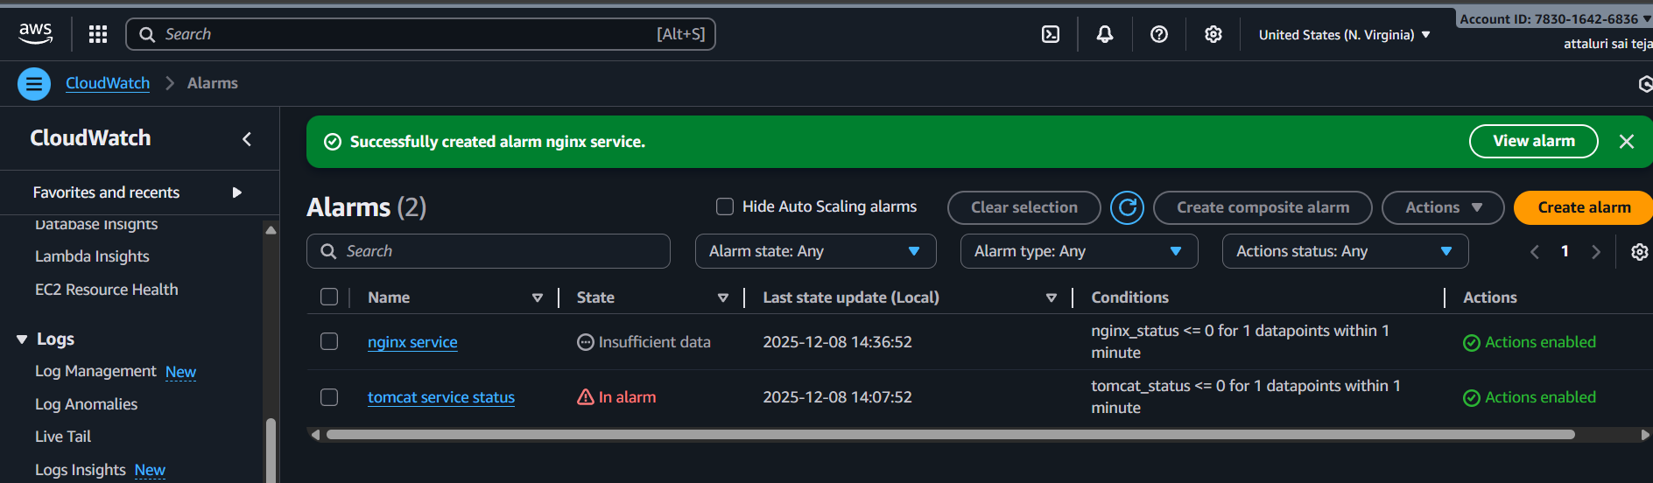
Wait for some time to get OK state of nginx.
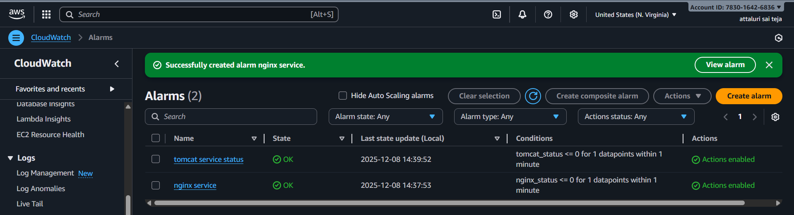
Validation part:
Navigate to cloud watch and watched the status it was running successfully
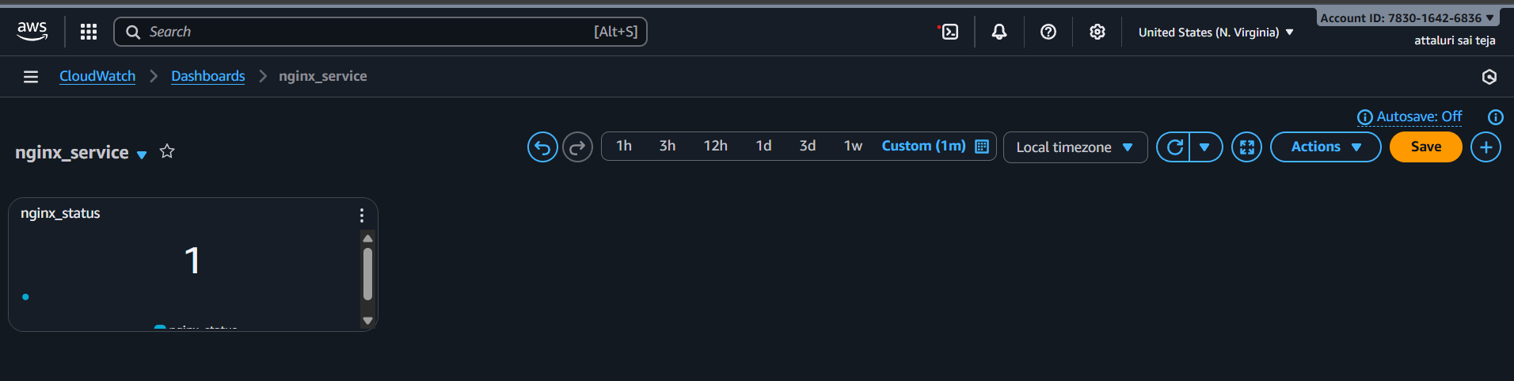
Stopping the service : in EC2 using command systemctl stop nginx
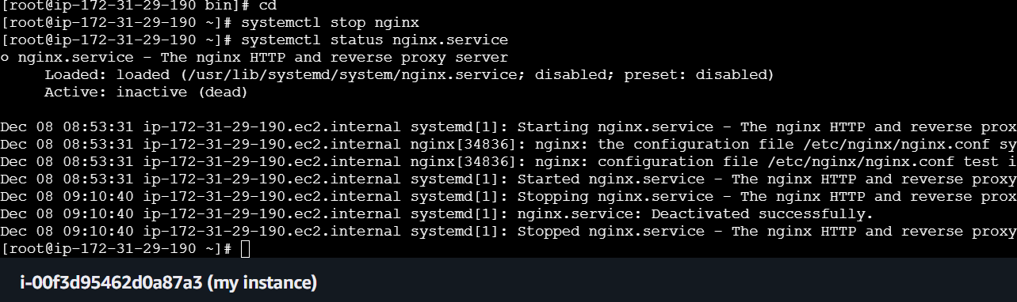
Verified in browser
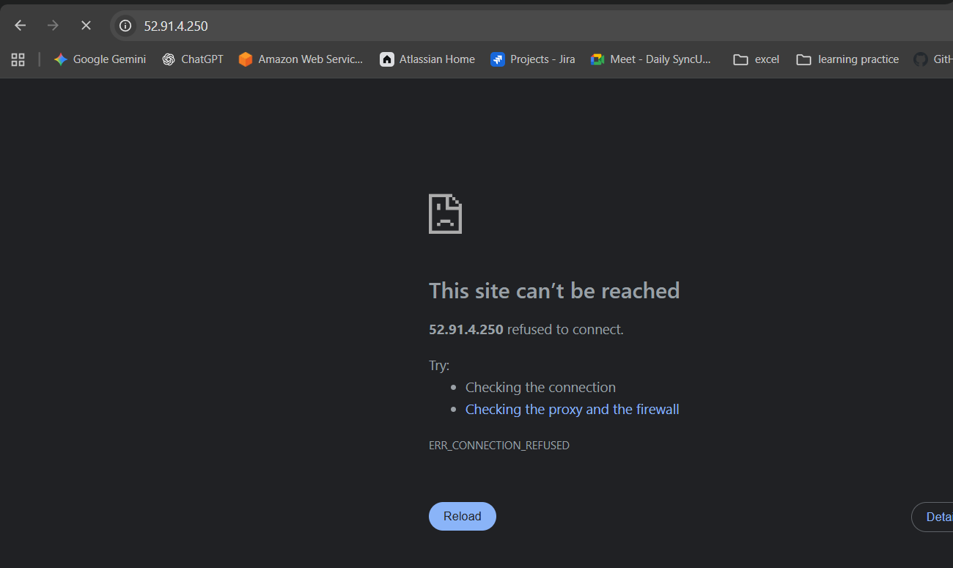
Verified in dashboard:
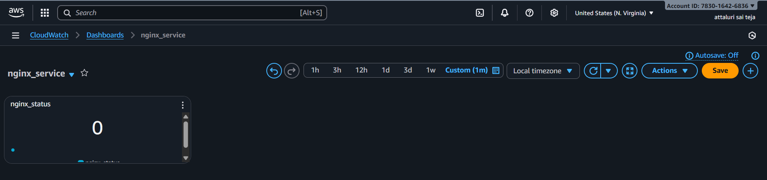
Verifying the email i.e email received or not
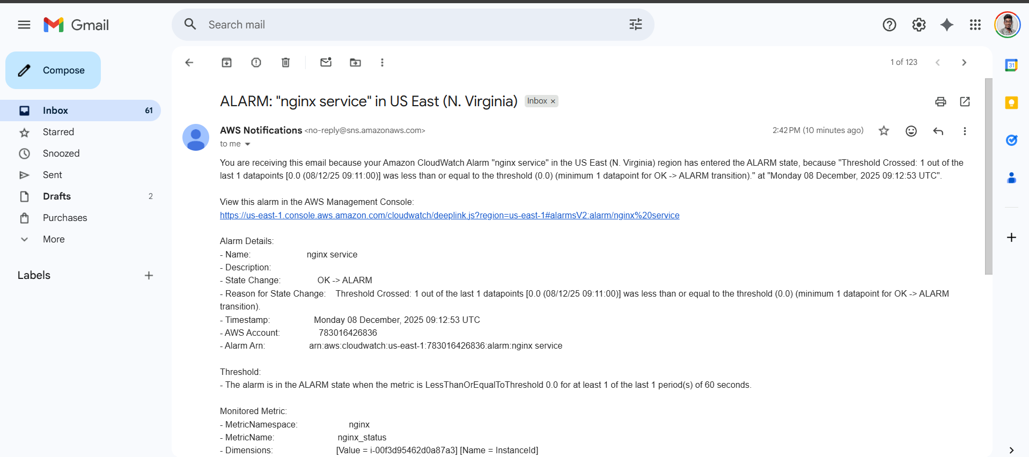
Conclusion :
We set up monitoring for the Nginx service so that CloudWatch continuously checks whether it is running. If Nginx stops, an alert is sent through SNS. This helps us quickly know when the service is down and take action to fix it.

